September 2020

Dear Parent

GCSE Examinations November 2020

Firstly, I hope that you and your family remain well in these challenging times. As you are aware all of our Year 11 learners were awarded a Centre Assessed Grade for their GCSE subjects in August. All learners who left the academy in the summer are eligible to sit any of their GCSE qualifications again during November 2020.

This opportunity may give learners the chance to improve the grade that they were awarded for any of their subjects in August. I fully appreciate that your child has now started the next steps in their education journey and, therefore, they may not wish to re-take any of their examinations. This is entirely optional and we would encourage you to discuss this with your child.

The examinations will take place in the academy between 2 and 20 November 2020, and will follow normal examination protocols and procedures. Exact details of the dates of individual examinations will be published in due course.

If you would like your son/daughter to be entered for any of these examinations please email the academy on: exams@thelinkacademy.org.uk or telephone the academy and ask to speak to our Examinations Officer,
Mr Fellows. In the meantime, if you have any other queries please contact Mr Szygowski in school on
01384 816500.

Please note that due to our COVID-19 Risk Assessment we are currently restricting visitors to the academy site, therefore we respectfully ask that you contact us by the email or phone number given.

Yours faithfully

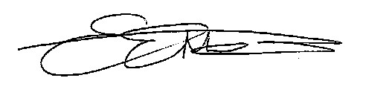
Mrs E. Edwards-Morgan
Principal

