EEMApr2020/Y7-9
April 2020

Dear Parent/Carer

Distance Learning Updates – Years 7, 8 and 9.

Firstly, I hope you and your families are keeping well in these very challenging and concerning times. I know that many of our families have front line workers and I think that I speak on behalf of all of The Link Community when I thank you all for your service and support for us all during the Covid-19 pandemic.

I also would like to thank you for your support in helping your child/children during their distance learning. I am very proud of how The Link Academy staff have risen to the challenge of setting engaging, varied and supportive work for all of our learners during this time. I know that a huge number of our learners have been in fantastic dialogue by email and SMHW to keep in touch with teaching and support staff. Having my step-children to support I fully appreciate that it isn’t always easy to juggle your home life and work commitments with supporting your child. Nevertheless, this is an important time for your child and it is of upmost importance that they establish and maintain an effective and regular pattern for their distance learning. Our ‘video lessons’ for English, maths and science have added a more personalised approach to learning and early feedback suggests that our learners are enjoying this style of work. The below graphic outlines some tips that I have personally found helpful as a parent to establish a good routine at home (believe me, I understand how hard it can be and there is no advantage when you are a teacher!):

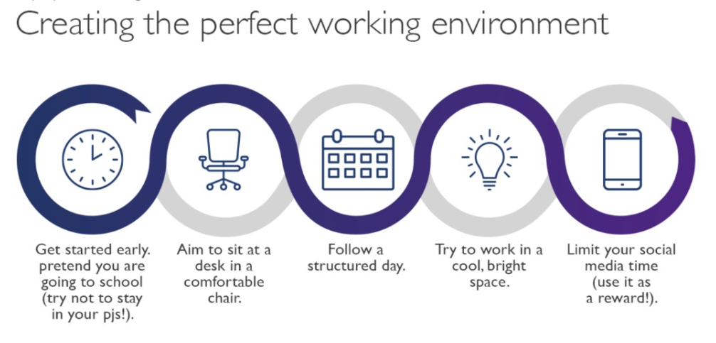

We are running reports weekly to check on learner engagement and it is therefore really important that your child submits any work that the teacher requests so that SMHW can then be marked as ‘submitted’. We will then be able to award Amazon Vouchers and prizes to learners for high effort and also improving their work. As always our social media platforms: Facebook, Instagram, Twitter and YouTube are promoting learner efforts and rewards as well as keeping our community connected at this time.

We have also been supporting families with ICT access where possible; we do only have limited resources and as I am sure you can understand we have had to prioritise learners that are currently in Year 10. We are hoping that next week the government will release further details of their ICT device scheme. I realise that during this difficult time, personal circumstances may well change. Please do reach out to us if we can help in anyway by emailing info@thelinkacademy.org.uk; you will also find information on our Academy website with regards to changes to the FSM eligibility criteria.

Learners will hugely benefit from remaining focussed on their distance learning, submitting their work via SMHW and liaising directly with their teachers where necessary. If, of course, you are able to build in your own small rewards at home, this really does help children to keep their momentum going. Sending good wishes to you and your family to stay safe and well during this time.

Yours faithfully


Mrs Emma Edwards-Morgan
Principal

