Calculating Missing Angles using the Sine Rule
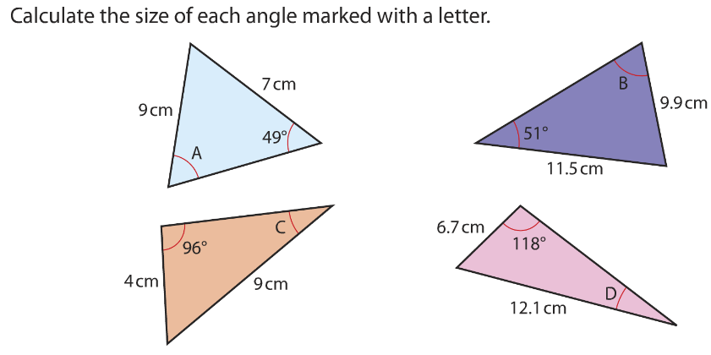
Give you answers to 1 decimal place.

Calculating Missing Angles using the Sine Rule
Give you answers to 1 decimal place.

