How do I. . . Analyse a photographers work?

ALL students should answer the green questions, MOST students should answer the orange questions and SOME students | AO1
might answer the blue questions.
1. Basic Information
The name of the photographer
What country are they from? (This is important as it puts the work into context)
The name and date of the photographs or project
What is the image/project about? (This could be researched and your own opinion)
2. Visual Qualities (select one photo to write about in detail)
What does the photograph show?
What is the main focus/ where is your eye drawn to?
What do you like about the image?
What composition style have they used? leading lines, framing, the rule of thirds...etc
How have they used the lighting in the image?
If they have used people in their photos can you read any body or facial language?
Can you talk about any of the formal elements that are shown? Line, Colour, Shape, Form, Texture, Pattern, Tone...
How has the photographer achieved the meaning, concept or message in the image?
3. Camera Settings
Where have they focused the camera?
Discuss the aperture settings used? Shallow/long depth of field
What shutter speed do you think they have they used?
4. Relate to your own work
This is VERY important so do not leave it out! By answering this question you will be explaining to the examiner just how you intend to use
this investigation work to inspire your own work.
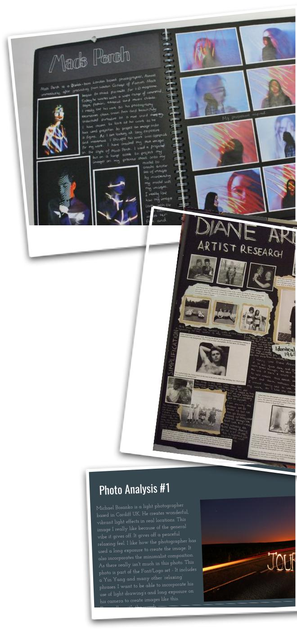

How will you be influenced by this photographer work when planning and taking your own photos? Bullet point possible ideas

