Drama Edexcel - Year 11 2020
Home Learning Tasks

TASK 1 - DEEPENING KNOWLEDGE AND UNDERSTANDING

Re-Read the play

TASK 2 - UNDERSTANDING PLOT DEVELOPMENT

Plot out each of the scenes - ensuring you cover the following information
NB. This should be broken up by each time there is a location change, rather than a scene change.

Good Progress  You are able to understand and record plot information and overviews of plot and character journeys. | Outstanding Progress  You are able to identify key moments for different characters and find quotes to support your understanding.

Pages: 235-236 | Location : A Street
Characters in this section:

Key moments in this section

Key interactions between characters

Important quotes to support plot/character development or key interactions

Additional notes

Pages: 236-238 | Location : A Field
Characters in this section:

Key moments in this section

Key interactions between characters

Important quotes to support plot/character development or key interactions

Additional notes

Pages: 238-249 | Location : A Wood
Characters in this section:

Key moments in this section

Key interactions between characters

Important quotes to support plot/character development or key interactions

Additional notes

Pages: 249-252 | Location : A Field
Characters in this section:

Key moments in this section

Key interactions between characters

Important quotes to support plot/character development or key interactions

Additional notes

Pages: 252-253 | Location : A Street
Characters in this section:

Key moments in this section

Key interactions between characters

Important quotes to support plot/character development or key interactions

Additional notes

Pages: 253-256 | Location : A Field
Characters in this section:

Key moments in this section

Key interactions between characters

Important quotes to support plot/character development or key interactions

Additional notes

Pages: 256-262 | Location : Woods
Characters in this section:

Key moments in this section

Key interactions between characters

Important quotes to support plot/character development or key interactions

Additional notes

Pages: 263-265 | Location : A Field
Characters in this section:

Key moments in this section

Key interactions between characters

Important quotes to support plot/character development or key interactions

Additional notes

Pages: 265-266 | Location : A Street
Characters in this section:

Key moments in this section

Key interactions between characters

Important quotes to support plot/character development or key interactions

Additional notes

Pages: 266-269 | Location : A Field
Characters in this section:

Key moments in this section

Key interactions between characters

Important quotes to support plot/character development or key interactions

Additional notes

Pages: 269-279 | Location : A Wood
Characters in this section:

Key moments in this section

Key interactions between characters

Important quotes to support plot/character development or key interactions

Additional notes

Pages: 279 | Location : A Field
Characters in this section:

Key moments in this section

Key interactions between characters

Important quotes to support plot/character development or key interactions

Additional notes

Pages: 279-280 | Location : A Street
Characters in this section:

Key moments in this section

Key interactions between characters

Important quotes to support plot/character development or key interactions

Additional notes

Pages: 280-283 | Location : A Field
Characters in this section:

Key moments in this section

Key interactions between characters

Important quotes to support plot/character development or key interactions

Additional notes

TASK 3 - QUICK QUIZ

Read this and answer the questions... https://www.educationquizzes.com/gcse/english-literature/dna-character/

TASK 4 - SET DESIGN

Design a stage/set for each location: Field, Wood, Street.
NB. This is a diagram not a picture - label it with detail.
- Consider how you can be creative or symbolic - think about how you can represent any of the following themes:
- Group / Mob behaviour (Gang behaviour)
- Social responsibility
- Humanity vs Animalistic traits (Chimps/Bonobos)
- Morality
- Leadership

- Consider how you can symbolise any key features of the characters in your set.
- Ensure you have included any necessary features for the plot.
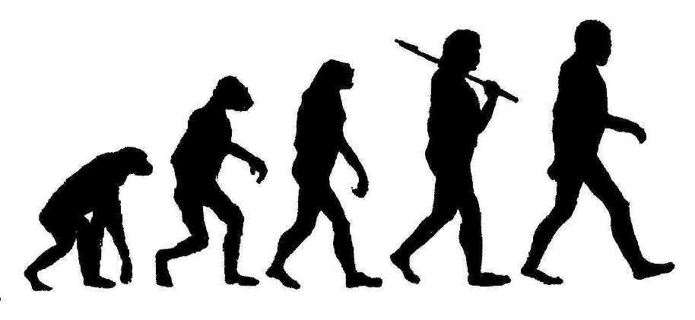

Good Progress  You consider the themes/ideas and features of the scenes to support you in creating an appropriate set for each location. | Outstanding Progress  You label your designs clearly, with detail about design, understanding staging (how are the audience set up? In the round/end on/proscenium arch) with subject specific terminology.

TASK 5 - CHARACTER DEVELOPMENT

Create a character information sheet for each character.
Watch the following to support - https://revisionworld.com/gcse-revision/english-literature/dna-dennis-kelly/characters

Name of character: | Phil
Key fact about character:
Key moment for this character in the play (minimum of one)
Key quote for this character (minimum of one)
Personality Traits (support with quotes if possible)

Beginning of play vs. End of play - character changes (support with quotes if possible)

Name of character: | Lea
Key fact about character:
Key moment for this character in the play (minimum of one)
Key quote for this character (minimum of one)
Personality Traits (support with quotes if possible)

Beginning of play vs. End of play - character changes (support with quotes if possible)

Name of character: | Jan
Key fact about character:
Key moment for this character in the play (minimum of one)
Key quote for this character (minimum of one)
Personality Traits (support with quotes if possible)

Beginning of play vs. End of play - character changes (support with quotes if possible)

Name of character: | Mark
Key fact about character:
Key moment for this character in the play (minimum of one)
Key quote for this character (minimum of one)
Personality Traits (support with quotes if possible)

Beginning of play vs. End of play - character changes (support with quotes if possible)

Name of character: | Danny
Key fact about character:
Key moment for this character in the play (minimum of one)
Key quote for this character (minimum of one)
Personality Traits (support with quotes if possible)

Beginning of play vs. End of play - character changes (support with quotes if possible)

Name of character: | Cathy
Key fact about character:
Key moment for this character in the play (minimum of one)
Key quote for this character (minimum of one)
Personality Traits (support with quotes if possible)

Beginning of play vs. End of play - character changes (support with quotes if possible)

Name of character: | Brian
Key fact about character:
Key moment for this character in the play (minimum of one)
Key quote for this character (minimum of one)
Personality Traits (support with quotes if possible)

Beginning of play vs. End of play - character changes (support with quotes if possible)

Name of character: | Danny
Key fact about character:
Key moment for this character in the play (minimum of one)
Key quote for this character (minimum of one)
Personality Traits (support with quotes if possible)

Beginning of play vs. End of play - character changes (support with quotes if possible)

Name of character: | Richard
Key fact about character:
Key moment for this character in the play (minimum of one)
Key quote for this character (minimum of one)
Personality Traits (support with quotes if possible)

Beginning of play vs. End of play - character changes (support with quotes if possible)

Name of character: | John Tate
Key fact about character:
Key moment for this character in the play (minimum of one)
Key quote for this character (minimum of one)
Personality Traits (support with quotes if possible)

Beginning of play vs. End of play - character changes (support with quotes if possible)

Name of character: | Adam
Key fact about character:
Key moment for this character in the play (minimum of one)
Key quote for this character (minimum of one)
Personality Traits (support with quotes if possible)

Beginning of play vs. End of play - character changes (support with quotes if possible)

TASK 6 - COSTUME DESIGN

Design a costume for each character:
Jan
Mark
Danny
Cathy
Phil
Lea
Lou
Richard
Brian
John Tate
Adam

Consider how you can use the information from ‘Task 5’ to support you in adding detail to each character’s costume that supports you in communicating their personality and key features to an audience.

Good Progress  You can create an appropriate costume for each of the characters. | Outstanding Progress  You label your designs clearly, with detail about design, information on colour, material and specific descriptions to support your presentation of knowledge of the characters.

TASK 7 - EXAM PREP – Relevant for Qa(i), Qb(ii)

List as many things you could do as an actor on stage - things you could do vocally or physically which could communicate an idea, emotion or character trait to an audience.
Verbal (Vocal) changes | Non-Verbal (Physical) changes

TASK 8 - PRACTICE QUESTION

WRITE FROM THE PERSPECTIVE OF THE ACTOR

Look at pages 256-257

(a) There are specific choices in this extract for performers.
(i) You are going to play Lou. Explain two ways you would use non-verbal communication to play this character in this extract.
(4)
(ii) You are going to play Danny. He is breaking the news to Lea.

As a performer, give three suggestions of how you would use performance skills to show this.
(6)
You must provide a reason for each suggestion.

Question (a)(i)
1)
2)

TASK 9 - PRACTICE QUESTION

WRITE FROM THE PERSPESCTIVE OF THE DIRECTOR

Look at pages 256-257

(b) There are specific choices in this extract for performers.

(ii) Lea is trying to calm the situation down.

As a director, discuss how the performer playing this role might demonstrate the different attitudes of the characters to the audience in this extract.

You must consider:

    - voice
    - physicality
    - stage directions and stage space

(12)
Question (b)(i)

