3.1 – Product Lifecycle

Do It now Task
Complete the lifecycle of the different stages you will go through in your life.

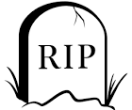
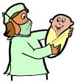

Write a definition for product lifecycle.
______________________________________________________________________________________________________________________________________________________________________________________________________________________________________________________________________________________________________________________
Using the diagram provided, can you work out the different phases of the product lifecycle using the terms below.
Development | Growth | Introduction | Decline | Maturity

Activity 2
What is happening to the sales and profit at each stage of the product life cycle?
Stage | Number of Sales | Amount of Profit | Product

