Calculating Missing Side using the Sine Rule
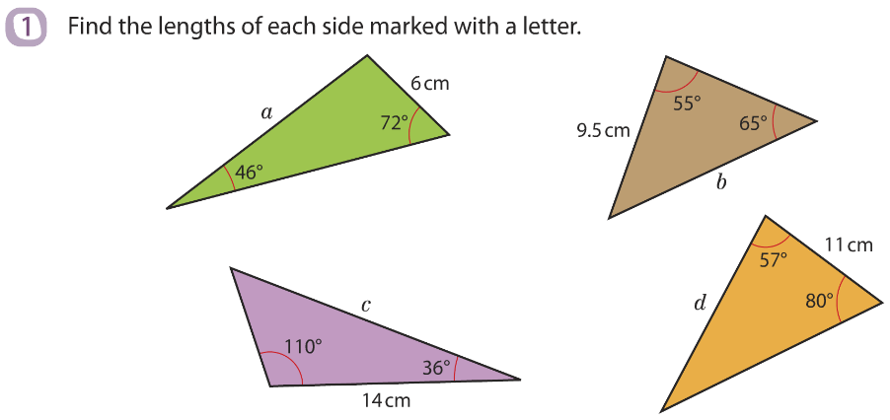
Give you answers to 3 significant figures

Calculating Missing Side using the Sine Rule
Give you answers to 3 significant figures

