HOME LEARNING: Muscle Movement
Agonist / Antagonist Muscles
Origin and insertion

- Label what movement is taking place
- Tell me what the agonist/antagonist muscles are in the following pictures.
- Label the Origin and Insertion
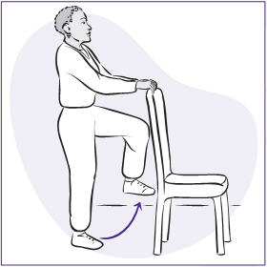
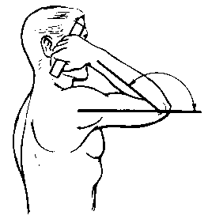

Elbow 1)_________. Hip 1) __________.
Agonist Muscle _______________ Agonist Muscle ______________
Antagonist Muscle _______________ Antagonist Muscle ______________
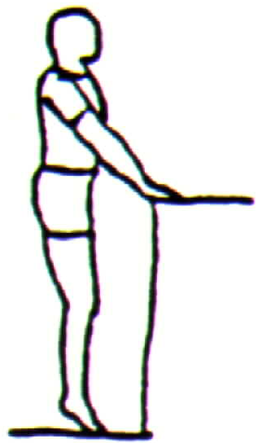
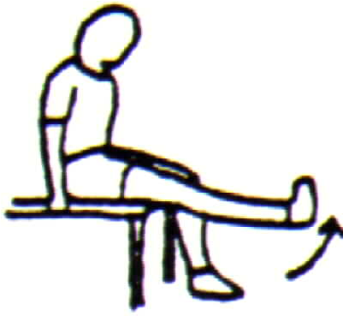

Knee 1)_________. Plantar 1)__________.
Agonist Muscle _______________ Agonist Muscle ______________
Antagonist Muscle _______________ Antagonist Muscle ______________

Written Task:
Explain what happens to someone’s arm when they go for a shot in basketball

……………………………………………………………………………………………………………………………………………...............
……………………………………………………………………………………………………………………………………………...............
……………………………………………………………………………………………………………………………………………...............
……………………………………………………………………………………………………………………………………………...............
……………………………………………………………………………………………………………………………………………...............
……………………………………………………………………………………………………………………………………………...............
……………………………………………………………………………………………………………………………………………...............
……………………………………………………………………………………………………………………………………………...............
……………………………………………………………………………………………………………………………………………...............
……………………………………………………………………………………………………………………………………………...............
……………………………………………………………………………………………………………………………………………...............
……………………………………………………………………………………………………………………………………………...............
……………………………………………………………………………………………………………………………………………...............
……………………………………………………………………………………………………………………………………………...............
……………………………………………………………………………………………………………………………………………...............
……………………………………………………………………………………………………………………………………………...............
Monday 4th November 2019

Skeletal Muscels
Target | Good Progress | Outstanding Progress
3-4 | Identify the location of some key muscles and know what antagonistic pairs are | The location of key muscles and explain with examples how antagonistic pairs help us
5 > | The location of key muscles and explain with examples how antagonistic pairs help us | Identify the location of most muscles and some of their jobs and describe with examples how antagonistic pairs help

QUESTION: How do muscles help us move?
Green for Growth: (end of lesson)
Antagonistic Pairs
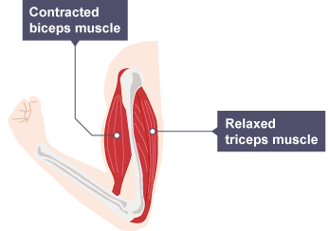
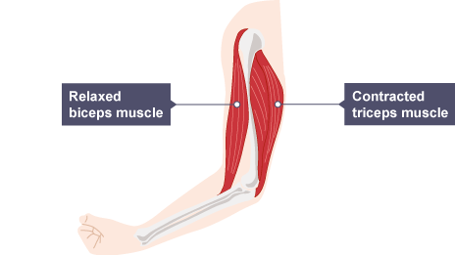

Biceps
Hamstrings
Gluteus maximus
Gastrocnemius
Pectoralis major

