Use the glossary to define the following words:

Variation
Interdependence
Adaptation
Extinct
Biodiversity
Endangered

Name some different ways animal adapt to the winter.
B2.3 Adaptation and inheritance (M)
Describe the difference between continuous and discontinuous variation giving an example of each.

What type of graph do we use for each?
What resources do animals and plants compete for?
How do we know other species existed in the past that are now extinct?

What are some of the causes of extinction?

How could we prevent extinction?
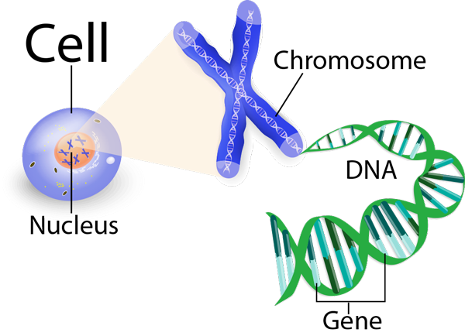
What is DNA?

What is a chromosome?

What is a gene?

How many chromosomes do humans have?
How many chromosomes are in the sperm and egg cells?

Describe how scientists worked together to discover DNA

What is evolution and how do we know it happens?
Describe adaptations the oryx has to survive in the desert.

What adaptations do plants have to survive in the desert?
Describe the difference between inherited and environmental variation. Give some examples for each.
Describe in 4 simple steps the process of natural selection using the peppered moth as an example.

