GCSE DANCE
Revision Booklet
Year 10
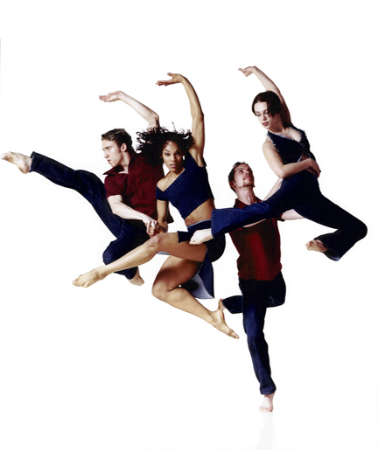

GCSE DANCE Command Words
Analyse
Separate information into components and identify characteristics (examine in detail in order to explain and interpret).
Comment
Present an informed opinion.
Compare
Identify similarities and/or differences.
Consider
Review and respond to given information.
Define
Specify meaning.
Describe
Set out characteristics.
Discuss
Present key points (detailed writing taking into account different ideas, characteristics and/or features).
Evaluate
Judge from available evidence (make an informed judgement on the effectiveness).

Explain
Set out purposes or reasons.
Give
Produce an answer from recall.
How
State in what ways.
Identify
Name or otherwise characterise.
Interpret
Translate information into recognisable form (demonstrate an understanding of meaning or significance of characters and/or features).
Name
Identify correctly.
Outline
Set out main characteristics.
State
Express in clear terms.
Suggest
Present a possible case (present a possible answer).
Tick
Put a mark to indicate something is correct.
What
Specify something.
Which
Specify from a range of possibilities.
Why- Give a reason or purpose.

Action, Space, Dynamics,
Relationship
What is the difference?
Title | Explanation | Example
ACTION | The movement that you are performing.
SPACE | Where you move to in the performance area.  Spatial awareness.
DYNAMICS | The quality of the movement.  How it looks.  Describes how it looks.
RELATIONSHIP | How you work and interact with another dancer in the space/audience/music
CHOREOGRAPHIC DEVICE | How you develop/change movement to make it more interesting
Sort the words below into the correct columns
ROLL LOW SMOOTH QUESTION & ANSWER REPETITION RETROGRADE
ACTION & REACTION SHARP ISOLATED JUMP KICK DIAGONAL QUICK
LEAD & FOLLOW FRAGMENTATION INVERSION MIRRORING FAST PATHWAY
TRAVEL LEVELS SUDDEN ACCUMULATION CONTRAST HIGHLIGHTS
COMPLEMENT ACCELERATION DIRECTIONS TURN ELEVATION COUNTERPOINT CLIMAX
STRONG PATTERNS ELEVATION GESTURE LIGHT CONTACT UNISON
ACTION | SPACE |  | DYNAMICS |  | RELATIONSHIP |  | CHOREOGRAPHIC DEVICE

KEY VOCABULARY DEFINITIONS – find out what they mean!
TERM | DEFINITION
CANON
UNISON
COMPLIMENTARY
CONTRASTING
QUESTION and ANSWER
RELATIONSHIP
STIMULUS
PATHWAY
COUNTER-BALANCE
PROJECTION
CLIMAX
CONTRACTION
DEVELOPMENT
MOTIF
DYNAMICS
CONTACT
FOCUS
FORMATION
GESTURE
PHRASE
BINARY
POSTURE
ALIGNMENT
REPETITION
IN THE ROUND
PROSCENIUM ARCH
TERNARY
EXTENSION
TRANSITION
RETROGRADE
RONDO
IMPROVISATION
NARRATIVE
MANIPULATION OF NUMBER
PEDESTRIAN
STRUCTURE
CHOREOGRAPHIC INTENT
Knowledge and Understanding of Skills for Performance
Expressive Skills
‘Something a dancer can only demonstrate during a performance and can be identified immediately on sight’

Physical Skills
‘Something a dancer spends time in class exploring, to help develop and improve their overall technique’

Technical Skills

‘Specific technical skills which relate to the composition of the choreography’

Try to put these different skills into the correct column:

Projection Facial Expressions Dynamic Content Focus

Alignment Flexibility Balance Musicality

Stamina Spatial Awareness Control Strength

Co-ordination Action Content Posture Extension

Sensitivity to Dancers Isolation Timing Content

Dynamic Content Phrasing

Expressive Skills | Physical  Skills | Technical Skills

Give an example in your own work of where you have demonstrated 3 of these skills – choose wither your set phrases or your performance pieces.
1.

2.

3.

Hypothetical choreography questions (part A of the exam paper).
Here are some suggestions which are similar to what you may see on your exam paper.

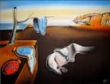
- ‘It is not the strongest of species that survive, not the most intelligent, but the one most responsive to change’. Charles Darwin

- ‘It is said that something as small as the flutter of a butterfly’s wing can ultimately cause a typhoon halfway around the world’. Chaos Theory
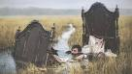

Choose two and identify a choreographic intention for each and describe a motif which you could create for both.

Developing your motif
There are a huge variety of ways that you can develop a motif, but the most important reason to develop it in the first place is to add interest to your dance. Listed below are the different choreographic devices you could use;

Motif and Development (this links to your ASDR)
Repetition
Contrast
Highlights
Climax
Manipulation of number
Unison and canon

If you get a question in your exam about how you would develop your motif/phrase, you MUST show the comparison to the original e.g. ‘I would use motif and development but changing the roll which originally was in unison to the left to a roll in canon all going different directions’. If you just put ‘I would use motif and development and change the space’ this wouldn’t get the marks.

Answer the following question;
Using one of your choices from above, identify 4 ways in which you would develop the motif you have described.

Other questions could relate to safe practice and understanding the definitions of key terminology. Have a go at the questions below…

- List 3 reasons why we warm up

- What exercises could you do to help prepare for elevation?

- Why is a cool down important?

- Why is it important for a dancer to stay hydrated?

- What does the dance relationship unison mean?

- Define the word ‘focus’.

- Give 2 different ways a dancer could rehearse for effective use of focus

- Name 2 technical/physical skills demonstrated by the dancer in the picture below
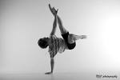

- Describe an exercise you could do to improve one of the skills you named in the question above.

- What does alignment mean?

- What does posture mean?

- Why is rehearsal so important for a dancer? What does it help with?

Anthology Questions
Below are some sample questions based on the works you have studied. There are some pointers for some of the questions as to what to include in your answers – have a go at them!

- Name a style of dance that is used in A Linha Curva (1 mark)

- Describe a movement/some movements that help show this (4marks)
(Use action, space, dynamics and relationships for this question!)

- Explain how costume adds to the sense of a party atmosphere (4marks)
(Colours, fit, disc collars, black tops)

- Explain how the lighting helps structure in A Linha Curva (3marks)
(Spacing of the dancers, different sections, pre programmed etc)

- Who choreographed Artificial Things?

- Describe the costumes in Artificial Things.

- Using your knowledge of the similarities and differences in the costumes used in Artificial Things and Emancipation of Expressionism, discuss how costume is used to enhance our appreciation of these two works

(You must show a comparison between the two and evaluate how effective they are in helping the audience understand what the dance is about – start by describing what the costumes actually are!!!)

- Describe a motif from one of the set anthology works you have studied in terms of action, space, dynamics and relationships.

- How is this motif developed throughout the piece? (Think about your choreographic devices!)

