GCSE BIOLOGY Name:
Cell biology – Trilogy
Complete the questions by typing in the answer boxes, which will expand as necessary.
Then fill in the self-assessment form as fully as you can to help you reflect on your work.
1.0 Figure 1 shows cells containing and surrounded by oxygen molecules.
Oxygen can move into cells or out of cells.
Figure 1
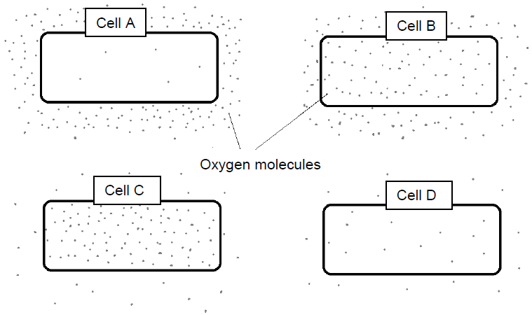
1.1 Into which cell, A, B, C or D, will oxygen move the fastest?
[1 mark]
Put an X in one box only.

A

B

C

D
1.2 Use words from the box to complete the sentences.
[2 marks]

active transport | diffusion | membranes
mitochondria | nuclei | osmosis

Oxygen is taken into cells by the process of .

The parts of cells that use the most oxygen are .

1.3 Which process produces oxygen in some cells?
[1 mark]
Put an X in one box only.
Diffusion

Photosynthesis

Protein synthesis

Respiration

2.0 Figure 2 shows part of the surface of a plant root.
Figure 2
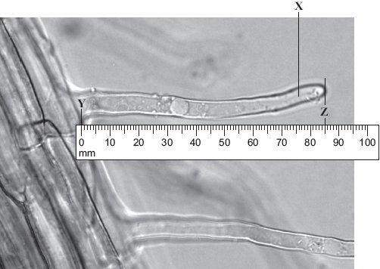
2.1 There are hundreds of structure X on each root.
What is the name of structure X?
[1 mark]

2.2 The photograph shows the root magnified 100 times. The distance between Y and Z in the photograph is the length of structure X.
Calculate the actual length of Y–Z.
[1 mark]

Actual length Y–Z = mm

2.3 Structure X is very small. There are hundreds of structures like X on a plant root.
Explain how this helps the plant.
[2 marks]

3.0 Figure 3 shows muscle cells from the wall of the stomach, as seen through a light microscope.
Figure 3
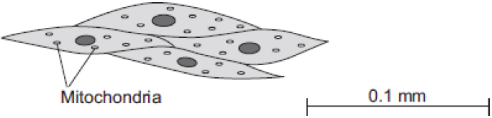

3.1 Describe the function of muscle cells in the wall of the stomach.
[2 marks]

3.2 The muscle cells in Figure 3 contain many mitochondria.
What is the function of mitochondria?
[1 mark]

3.3 The muscle cells also contain many ribosomes. The ribosomes cannot be seen in Figure 3.
What is the function of a ribosome?
[1 mark]

3.4 Suggest why the ribosomes cannot be seen through a light microscope.
[1 mark]

4.0 Some students set up an experiment to find the concentration of sucrose solution in potato cells.
The students used discs of potato cut to the same size and weighing approximately
10 grams.
The discs were put into each of five beakers.
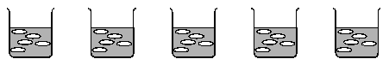
Beaker 1 | Beaker 2 | Beaker 3 | Beaker 4 | Beaker 5
Distilled water | 10% sucrose solution | 20% sucrose solution | 30% sucrose solution | 40% sucrose solution

4.1 After two hours the students carefully dried the potato disks with paper towel before reweighing the discs.
Why did the students dry the potato before weighing it?
[1 mark]

4.2 The students calculated the percentage gain or loss in mass of potato.
The students’ results are shown in the Table 1.
Table 1
 | Beaker 1 | Beaker 2 | Beaker 3 | Beaker 4 | Beaker 5
Final mass in g | 13.0 | 12.2 | 9.0 | 7.9 | 7.3
Initial mass in g | 10.0 | 10.6 | 10.0 | 10.1 | 10.4
Percentage gain or loss in mass | Gain 30% | Gain 15.1% | Loss 10% | Loss 21.8%
Calculate the percentage loss of mass in beaker 5.
[3 marks]

Percentage loss of mass: %

4.3 Predict the concentration of sucrose solution in the potato cells.
Use the results in Table 1.
[1 mark]

Concentration of sucrose solution: %

5.0 Some scientists investigated the rates of absorption of different sugars by the small intestine.
In one experiment they used a piece of normal intestine.
In a second experiment they used a piece of intestine poisoned by cyanide.
Cyanide is poisonous because it prevents respiration.
Table 2 shows their results.
Table 2
 | Relative rates of absorption
Sugar | Normal intestine | Intestine poisoned  by cyanide
Glucose | 1.00 | 0.33
Galactose | 1.10 | 0.53
Xylose | 0.30 | 0.31
Arabinose | 0.29 | 0.29

5.1 Name two sugars from Table 2 which can be absorbed by active transport.
[2 marks]

5.2 Use evidence from Table 2 to explain why you chose these sugars.
[4 marks]

5.3 All of the sugars named Table 2 can be absorbed by diffusion.
Explain how information from Table 2 provides evidence for this.
[2 marks]

6.0 Bone marrow contains stem cells.
6.1 Explain why bone marrow can be called a tissue.
[2 marks]

6.2 Read the information about stem cells.

Stem cells are used to treat some human diseases.
Stem cells can be collected from early embryos. These stem cells have not begun to differentiate, so they could be used to produce any kind of cell, tissue or organ. The use of embryonic stem cells to treat human diseases is new and, for some diseases, trials on patients are happening now.
Stem cells can also be collected from adult bone marrow. The operation is simple but may be painful. Stem cells in bone marrow mainly differentiate to form blood cells. These stem cells have been used successfully for many years to treat some kinds of blood disease. Recently there have been trials of other types of stem cell from bone marrow. These stem cells are used to treat diseases such as heart disease.
Evaluate the use of stem cells from embryos or from adult bone marrow for treating human diseases.
You should give a conclusion to your evaluation.
[5 marks]

Feedback Form Instructions
When you have answered as many questions as you can, complete the form on the last page to help you reflect on your work.
How to fill in the form
1 Put your confidence score in Column C. This is not about the number of marks you achieved but how sure you felt while you were answering the question.

Confidence | Definition
0 | I didn’t answer this one
1 | I guessed the answer
2 | I needed help with the answer
3 | I understood the question but wasn’t sure about my answer
4 | I was fairly confident I would get most of the marks
5 | I was sure my answer was correct and I would get full marks
2 Use the mark scheme to check your answers.
Put the mark you think you achieved in Column Mark.
3 Write an overall comment about how you felt each question went.
- If you got help, make a note in the comment box specifying the source: internet,
friend, book, parent or tutor.
4 Complete ‘I can…’ and ‘I need to…’ sentences.
- ‘I can…’ sentences might include the questions you found easiest to answer, got the most marks for or felt the most confident about.
- ‘I need to…’ sentences might include areas you need to revise, questions you want to ask your teacher or the next topic or skill you want to work on.
5 Return the form to your teacher.

Cell biology – Trilogy
Feedback form Name

Qu | Total marks | Self-assessment
 |  | C | Mark | Comment
1 | 4
2 | 4
3 | 5
4 | 5
5 | 8
6 | 7
Overall
I can ……

I need to …….

Qu | Total marks | Teacher review
 |  | Mark | Comment
1 | 4
2 | 4
3 | 5
4 | 5
5 | 8
6 | 7
Overall
You can ……

You need to …….

