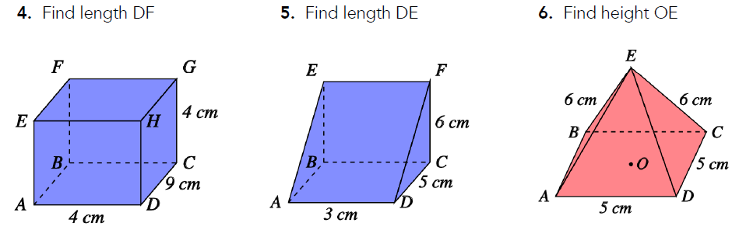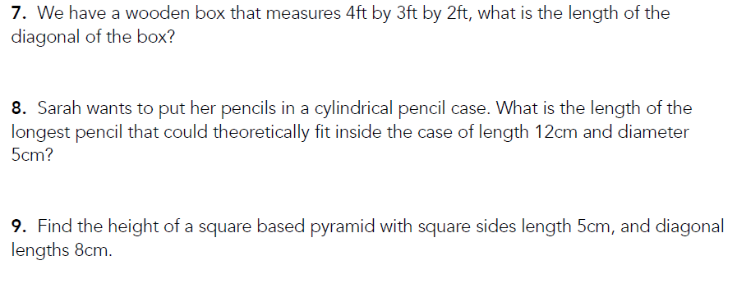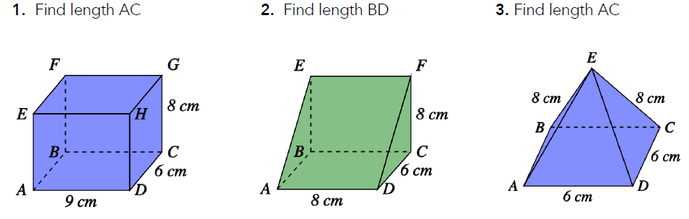

Your task: Apply Pythagoras' theorem to find the missing length of each 3-D shape. Give your answers to one decimal place where necessary.