Faces, Edges and Vertices

Complete the table below. Include a sketch of each shape in the relevant box!
Shape | Sketch | Faces | Edges | Vertices
Cube
Cuboid
Tetrahedron (Triangular-based Pyramid)
Square-based Pyramid
Pentagonal-based Pyramid
Triangular Prism
Hexagonal Prism
Cylinder
Cone
Sphere
Frustum (square-based pyramid with the top cut off!)

There is a sum linking the number of Faces, Edges and Vertices a Polyhedron has (not a Cylinder, Cone or Sphere) – can you work it out?

Faces, Edges and Vertices

Shape | Sketch | Faces | Edges | Vertices
Cube
Cuboid
Tetrahedron (Triangular-based Pyramid) | 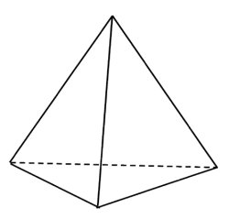
Square-based Pyramid | 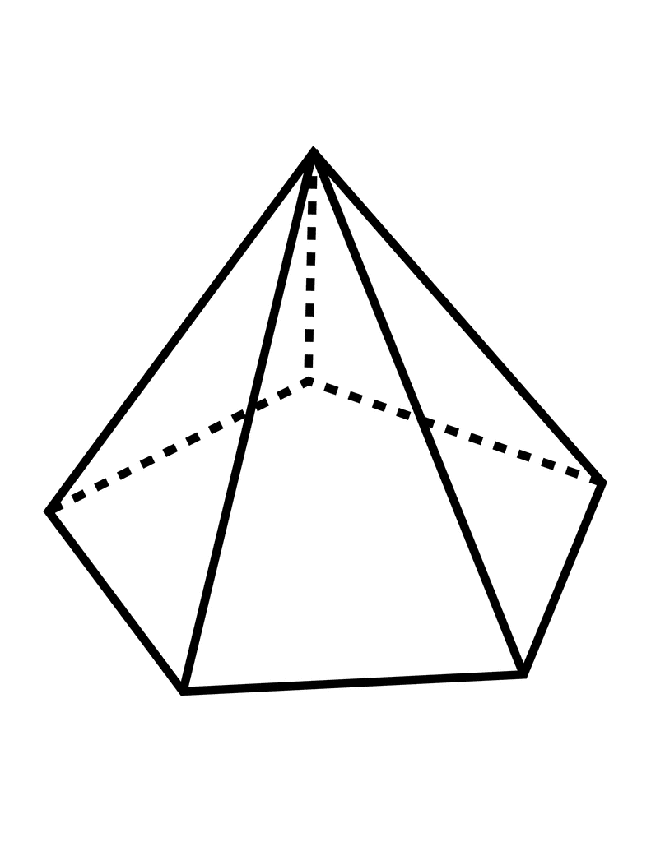  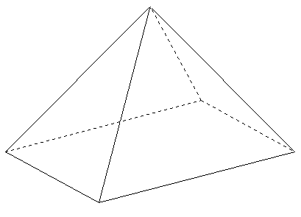
Pentagonal-based Pyramid
Triangular Prism | 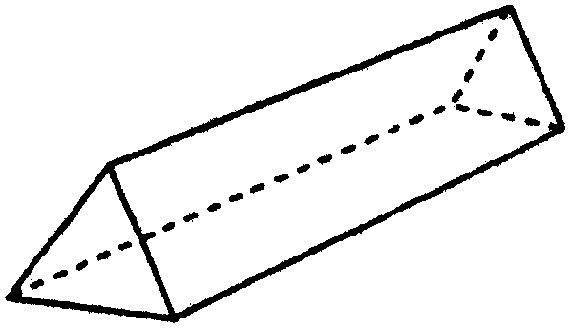
Hexagonal Prism | 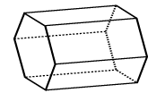  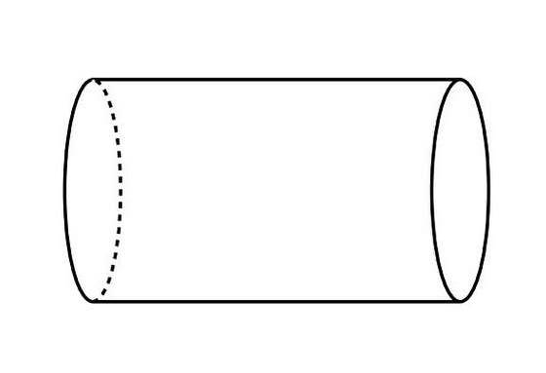
Cylinder
Cone | 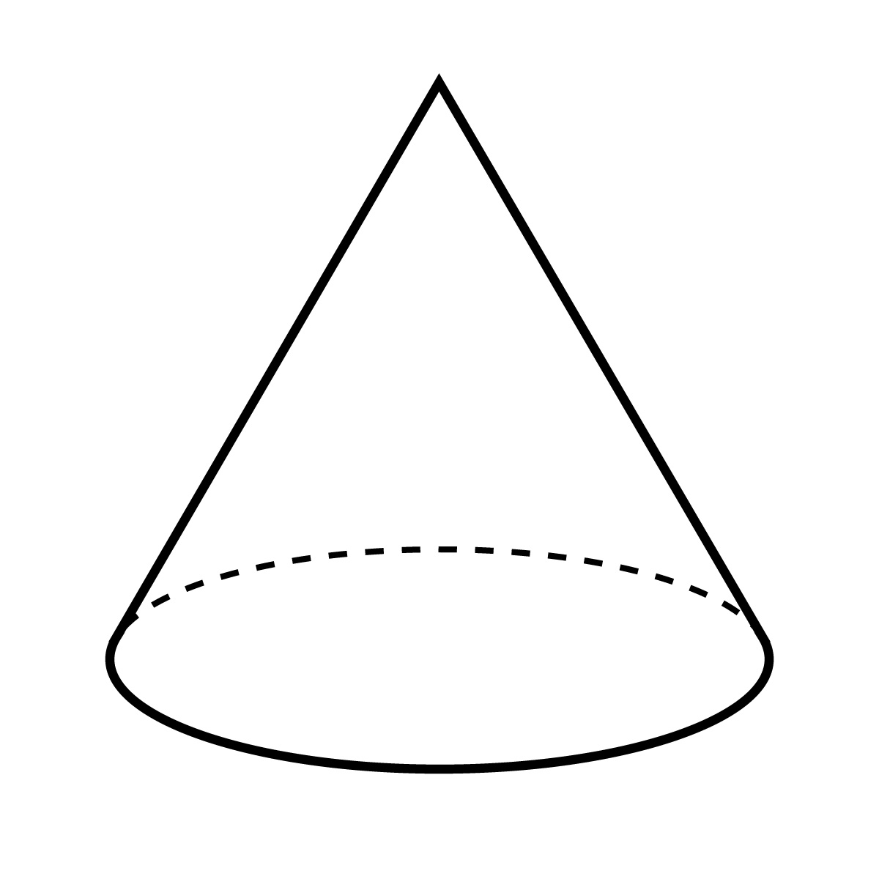
Sphere
Frustum (square-based pyramid with the top cut off!) | 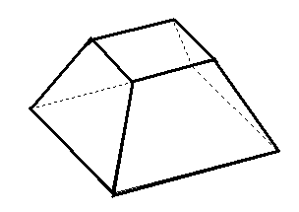

There is a sum linking the number of Faces, Edges and Vertices a Polyhedron has (not a Cylinder, Cone or Sphere) – can you work it out?

