4.1 – Factors when Pricing a Product

Do It now

When pricing a product what do you need to consider? Explain why.

|  |
| --- |
|  |
|  |
|  |

4.2 – Pricing Strategies

Do it Now

Identify the four pricing strategies and identify whether they are a short or a long-term strategy.

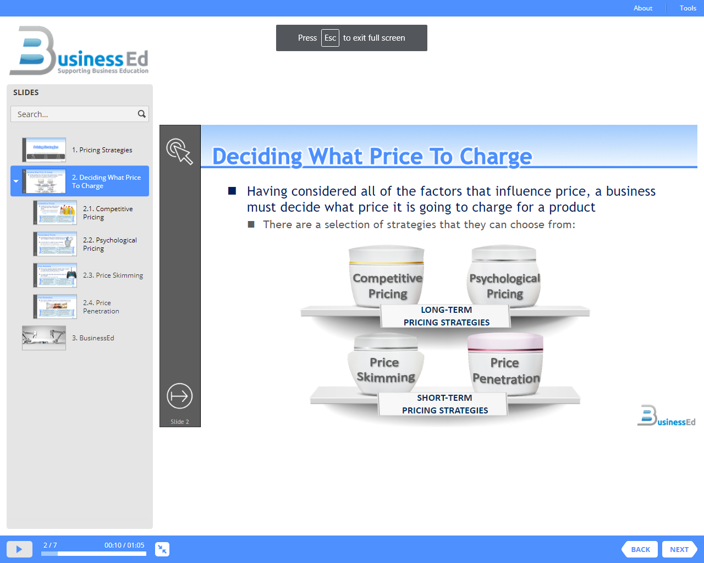

Investigate, in detail, the four pricing strategies?

|  |  |  |  |  |
| --- | --- | --- | --- | --- |
| Strategy | How does it works | When is it used? | Advantages | Disadvantages |
|  |  |  |  |  |
|  |  |  |  |  |
|  |  |  |  |  |
|  |  |  |  |  |

4.3 – Advertising Methods

Do it Now

Identify the four pricing strategies and identify whether they are a short or a long-term strategy.

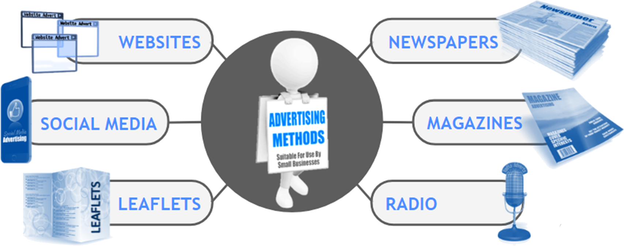

Advertising

Write a definition for advertising.

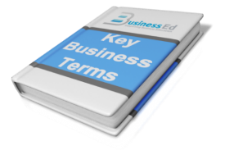

It is important that advertising is planned carefully to ensure that:

|  |
| --- |
|  |
|  |
|  |

Advertising Media

|  |  |  |  |
| --- | --- | --- | --- |
| Media | How does it works | Advantages | Disadvantages |
|  |  |  |  |
|  |  |  |  |
|  |  |  |  |

|  |  |  |  |
| --- | --- | --- | --- |
| Media | How does it works | Advantages | Disadvantages |
|  |  |  |  |
|  |  |  |  |
|  |  |  |  |

4.4 – Sales Promotion

Do it Now





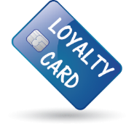

Write a definition for sales promotions.



Sales Promotion Techniques

|  |  |  |  |
| --- | --- | --- | --- |
| Technique | What is involved? | Advantage | Disadvantage |
|  |  |  |  |
|  |  |  |  |
|  |  |  |  |
|  |  |  |  |
|  |  |  |  |
|  |  |  |  |

4.5 – Customer Service

Do it Now!

What makes good customer service?



Why Provide Good Customer Service

|  |  |
| --- | --- |
|  | Good customer service can be used as a Unique Selling Point (USP), to gain an advantage over competitors |
|  | Finding new customers is time-consuming and can be expensive. It is far easier to look after existing customers so that they remain loyal |
|  | Good word-of-mouth comments will help to create a positive image of a business that cares |

Factors of Customer Service

|  |  |
| --- | --- |
|  | Customers will expect staff to know the products they are selling, and able to explain any features, or answer any questions without using jargon |
|  | Staff need to be dressed appropriately, polite, helpful, and have good communication skills in order to engage with customers |
|  | Complaints, returns, exchanges and repairs all need to be dealt with in an efficient and customer-focused way |

Impact of Good Customer Service



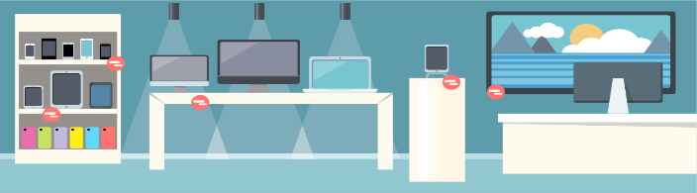

Poor Customer Service

What is the impact of poor customer feedback?

|  |  |
| --- | --- |
|  |  |
|  |  |

What is the negative impact poor customer service has on a business?

|  |
| --- |
|  |