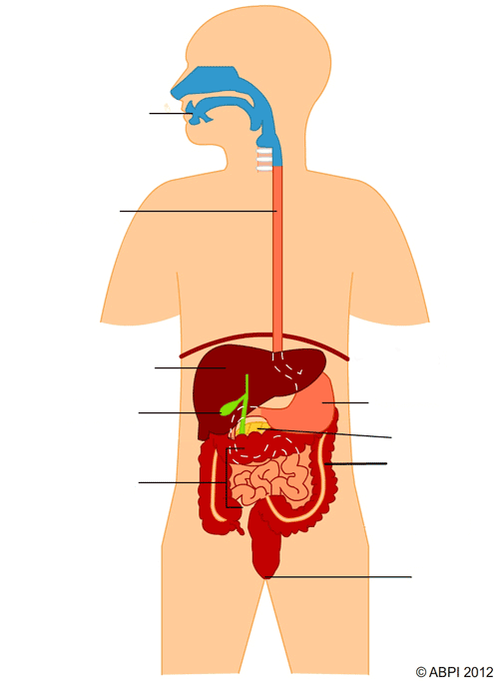

How can **alcohol** and **drugs** impact your body? *Give examples:*

Give an example of what could happen if you had **too much** of a certain **nutrient** in your diet:

Give an example of what could happen if you had **not enough** of a certain **nutrient** in your diet:

Describe the **food tests** you would carry out to test for the following **nutrients:**

|  |  |
| --- | --- |
| **Nutrient** | **Food Test** |
| Starch |  |
| Glucose |  |
| Protein |  |
| fat |  |

Diet and Health

What do we need **fibre** in our diet for?

Name the different **enzymes**, the **nutrients** they break down, and **what** they are broken down into

What is the job of the **villi**?

**Where** can they be found?

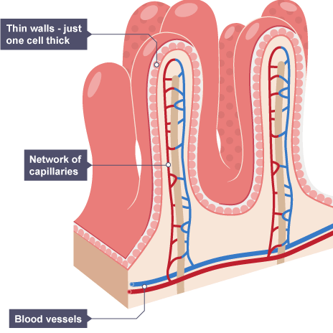

What is **peristalsis**?

What is **mechanical** digestion?

What is **chemical** digestion?

What is the role of **bacteria** in the digestive system?

Label the **name** and **function** of the different parts of the digestive system

|  |  |
| --- | --- |
| **Nutrient:** | **What the we use it for:** |
|  |  |
|  |  |
|  |  |
|  |  |
|  |  |

Fill in the wheel with the food groups and nutrients that can be found in each group:

