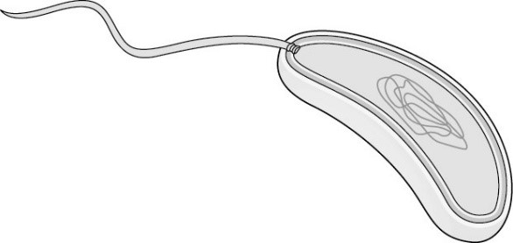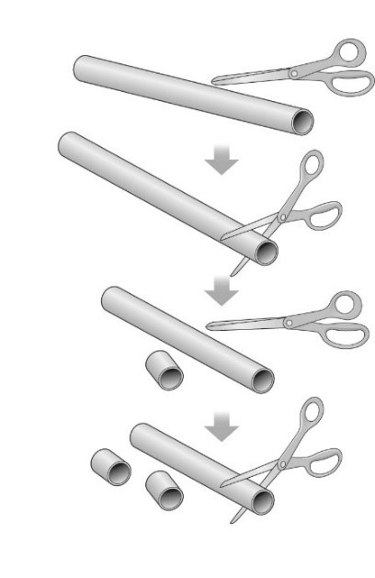

What is an enzyme? How does it work? Where does it work? Examples?

What is the equation for respiration and photosynthesis?

How does a greenhouse help plants grow?

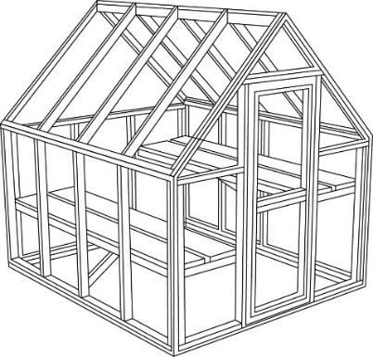

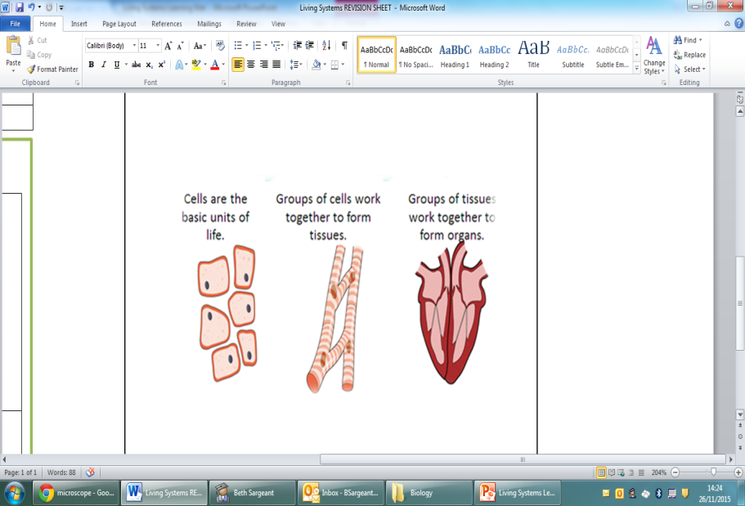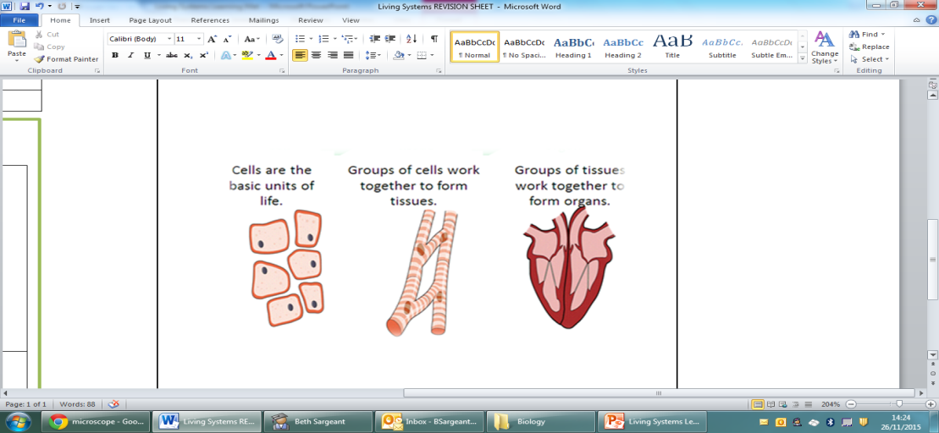

Link the **definition**, **diagram** and **key words** together:

The basic unit of life

Groups of tissue working together

Groups of cells working together

**Cells**

**Tissue**

**Organ**

**Label** the different parts of the **microscope**:

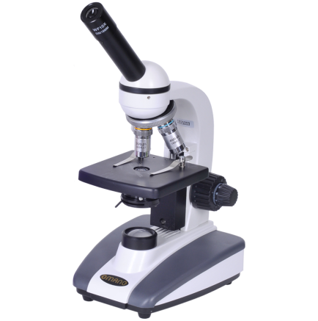

**Diffusion**

|  |
| --- |
| **membrane diffuse oxygen high**  **glucose water concentration** |

**Use the words above to fill in the gaps:**

Cells need …………………. , …………………….. and …………………….. to function. These substances ………………. through the cell ………………….. .

Particles move from a ………… concentration to a low …………………. .

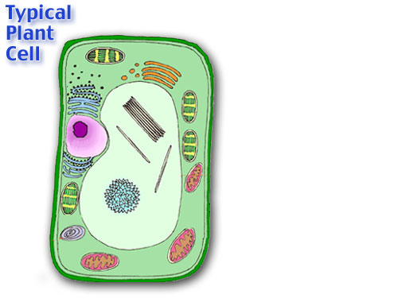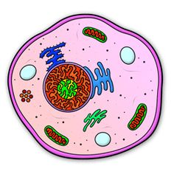

Draw 2 examples of **specialised cells** and list their **special features**:

|  |  |  |
| --- | --- | --- |
| Diagram |  |  |
| Features |  |  |

Label the following “typical” **plant** and **animal cells**

Give three **similarities** and three **differences** between plant and animal cells:

|  |  |
| --- | --- |
| **Similarities** | **Differences** |
|  |  |
|  |  |
|  |  |

**Living Systems**