Name: Set:

Film Music Assessment

- What is the pattern of semi-tones for a Major chord? (1 mark)

- What is the pattern of semi-tones for a minor chord? (1 mark)

- What type of chord sounds happy? (1 mark)

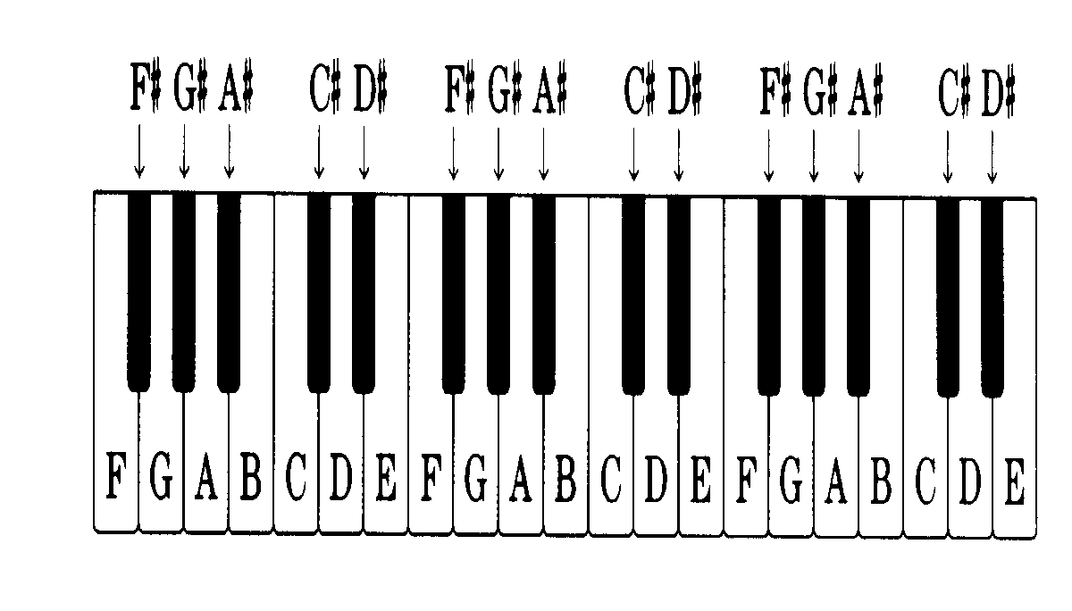
- Circle the notes you would play for the triad of C Major (1 mark)
- Circle the notes you would play for the triad of F minor (1 mark)
- Circle the notes you would play the triad of G Major (1 mark)

- What is a leitmotif? (2 marks)

- Describe how the following elements of music would change in a leitmotif when a character is about to die: (4 marks)
- Dynamics______________________________________________
- Tempo________________________________________________
- Melody/Pitch___________________________________________
- Instrumentation_________________________________________

- The extract of music you are about to listen to is from the film ‘Independence Day’ when the President is about to speak to a group of Pilots who are about to risk their lives to battle against an alien spacecraft that threatens Earth. Writing in full sentences, complete the following table describing each element of music in the extract: (8 marks)
Element of Music | Description
Dynamics
Melody/Pitch
Tempo
Harmony (chords)
Instruments
Tonality (Mood)

