English Language Paper 1

On December the third, the wind changed overnight, and it was winter. Until then the autumn had been mellow, soft. The leaves had lingered on the trees, golden-red, and the hedgerows were still green. The earth was rich where the plow had turned it.
Nat Hocken, because of a wartime disability, had a pension and did not work full time at the farm. He worked three days a week, and they gave him the lighter jobs: hedging, thatching, repairs to the farm buildings.
Although he was married, with children, his was a solitary disposition; he liked best to work alone. It pleased him when he was given a bank to build up or a gate to mend at the far end of the peninsula, where the sea surrounded the farmland on either side. Then, at midday, he would pause and eat the pasty that his wife had baked for him and, sitting on the cliff’s edge, would watch the birds. Autumn was best for this, better than spring. In spring the birds flew inland, purposeful, intent; they knew where they were bound; the rhythm and ritual of their life brooked no delay. In autumn those that had not migrated overseas but remained to pass the winter were caught up in the same driving urge, but because migration was denied them, followed a pattern of their own. Great flocks of them came to the peninsula, restless, uneasy, spending themselves in motion; now wheeling, circling in the sky, now settling to feed on the rich, new-turned soil; but even when they fed, it was as though they did so without hunger, without desire. Restlessness drove them to the skies again.
Black and white, jackdaw and gull, mingled in strange partnership, seeking some sort of liberation, never satisfied, never still. Flocks of starlings, rustling like silk, flew to fresh pasture, driven by the same necessity of movement, and the smaller birds, the finches and the larks, scattered from tree to hedge as if compelled.
Nat watched them, and he watched the sea birds too. Down in the bay they waited for the tide. They had more patience. Oystercatchers, redshank, sanderling, and curlew watched by the water’s edge; as the slow sea sucked at the shore and then withdrew, leaving the strip of seaweed bare and the shingle churned, the sea birds raced and ran upon the beaches. Then that same impulse to flight seized upon them too. Crying, whistling, calling, they skimmed the placid sea and left the shore. Make haste, make speed, hurry and begone; yet where, and to what purpose? The restless urge of autumn, unsatisfying, sad, had put a spell upon them, and they must flock, and wheel, and cry; they must spill themselves of motion before winter came.
“Perhaps,” thought Nat, munching his pasty by the cliff’s edge, “a message comes to the birds in autumn, like a warning. Winter is coming. Many of them perish. And like people who, apprehensive of death before their time, drive themselves to work or folly, the birds do likewise.”
The birds had been more restless than ever this fall of the year, the agitation more marked because the days were still. As the tractor traced its path up and down the western hills, the figure of the farmer silhouetted on the driving seat, the whole machine and the man upon it, would be lost momentarily in the great cloud of wheeling, crying birds. There were many more than usual; Nat was sure of this. Always, in autumn, they followed the plow, but not in great flocks like these, nor with such clamour.
Nat remarked upon it when hedging was finished for the day. “Yes,” said the farmer, “there are more birds about than usual; I’ve noticed it too. And daring, some of them, taking no notice of the tractor. One or two gulls came so close to my head this afternoon I thought they’d knock my cap off! As it was, I could scarcely see what I was doing when they were overhead and I had the sun in my eyes. I have a notion the weather will change. It will be a hard winter. That’s why the birds are restless.”
Nat, tramping home across the fields and down the lane to his cottage, saw the birds still flocking over the western hills, in the last glow of the sun. No wind, and the grey sea calm and full. Campion in bloom yet in the hedges, and the air mild. The farmer was right, though, and it was that night the weather turned. Nat’s bedroom faced east. He woke just after two and heard the wind in the chimney. Not the storm and bluster of a sou’westerly gale, bringing the rain, but east wind, cold and dry. It sounded hollow in the chimney, and a loose slate rattled on the roof. Nat listened, and he could hear the sea roaring in the bay. Even the air in the small bedroom had turned chill: A draft came under the skirting of the door, blowing upon the bed. Nat drew the blanket round him, leaned closer to the back of his sleeping wife, and stayed wakeful, watchful, aware of misgiving without cause.
Then he heard the tapping on the window. There was no creeper on the cottage walls to break loose and scratch upon the pane. He listened, and the tapping continued until, irritated by the sound, Nat got out of bed and went to the window. He opened it, and as he did so something brushed his hand, jabbing at his knuckles, grazing the skin. Then he saw the flutter of the wings and it was gone, over the roof, behind the cottage.
It was a bird; what kind of bird he could not tell. The wind must have driven it to shelter on the sill.
Great flocks of them came to the peninsula, restless, uneasy, spending themselves in motion; now wheeling, circling in the sky, now settling to feed on the rich, new-turned soil; but even when they fed, it was as though they did so without hunger, without desire. Restlessness drove them to the skies again.
Black and white, jackdaw and gull, mingled in strange partnership, seeking some sort of liberation, never satisfied, never still. Flocks of starlings, rustling like silk, flew to fresh pasture, driven by the same necessity of movement, and the smaller birds, the finches and the larks, scattered from tree to hedge as if compelled.

Q1: Read again the beginning of the source from lines 4 to 7.
List four things you learn about the character, Nat Hocken. (4 marks)
1)
2)
3)
4)

Q2: Look in detail at this extract from lines 14 to 21 of the source:

How does the writer use language to describe the birds? (8 marks)
You could include the writer’s use of:
- words and phrases
- language features and techniques
- sentence forms
Q3: You need to think about the whole of the source.

The text is from the beginning of a short story.

How has the writer structured the text to interest you as a reader?

You could write about:

- what the writer focuses your attention on at the beginning
- how and why the writer changes this focus as the extract develops
- any other structural features that interest you. (8 marks)

Q4:

Focus this part of your answer on the lines 22 to the end.

A student, having read this section of the text said: “The writer contrasts the normal actions of Nat with the strange actions of the birds to create tension and a sense of foreboding.’

To what extent do you agree?

In your response, you could:

- write about your own impressions of Nat and the birds.
- evaluate how the writer has created these impressions.
- support your opinions with quotations from the text. (20 marks)

SECTION B: Writing

You are advised to spend about 45 minutes on this section.
Write in full sentences.
You are reminded of the need to plan your answer.
You should leave enough time to check your work at the end.

Question 5

You have been asked to write a creative piece of writing for a new school magazine.

Either:

Write a description suggested by this picture:

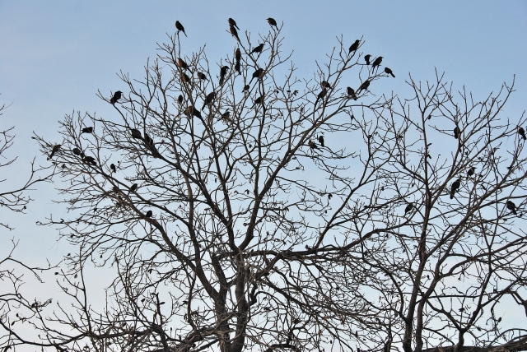
Or:

Write the beginning of a story that includes a character who is in a frightening situation.

(24 marks for content and organisation
16 marks for technical accuracy)
[40 marks]

