1. Pressure =
A force ÷ area B area ÷ force
C area + force D area - force
[1]
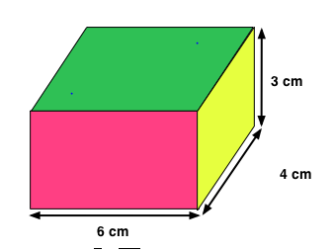
2. The lengths of a block of wood are 6cm, 4 cm and 3 cm.
On which side must the block be placed in order to exert the least pressure?
A 4 cm x 3 cm
B Any of the surfaces
C 6 cm x 4 cm
D 6 cm x 3 cm

[1]
3. What is the pressure exerted on a surface by a brick of weight 10 N with an area in contact with the surface of 20 cm².
A 0.5 N/cm² B 2 N/m² C 200 N/m² D 30 N/m²
[1]

4. The pressure in liquids and gases is caused by:
A the particles pressing down. B the particles pushing up.
C the particles moving sideways. D the particles moving in all directions and colliding with things.
[1]

5. The diagram shows a spurting cylinder with water spurting out at A, B and C.
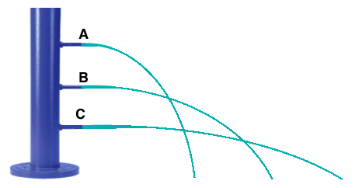
Which one of the following statements is correct?
A The spout with the greatest pressure pushes the water furthest
B The pressure at spout A is greater than at spout B.
C The spout with the least pressure pushes the water furthest.
D Water at spout C travels the furthest because there is more water at the bottom of the cylinder.
[1]

6. A bicycle tyre contains gas. The tyre cannot expand (get bigger).
Complete the following sentences by circling the correct word in each pair.
If you increase the temperature of the gas in the tyre, then the pressure will decrease/increase.
This is because the particles in the gas are moving faster/slower and colliding less/more often.
If air leaks out of the tyre, the gas pressure will decrease/increase.
This is because there are fewer/more molecules to collide with the walls.
[1]

7. The atmospheric pressure at the top of Mount Everest is less than at sea level because
A There is more snow at the top of Mount Everest
B There is less gravity at the top of Mount Everest
C It is colder at the top of Mount Everest
D There is less air at the top of Mount Everest
[1]
8. The moment of a force is:
A its turning effect.
B how long it takes to work.
C how far it moves.
D the distance of a force from a pivot.
[1]

9. You are opening a can of paint with a screwdriver. You apply a force of 10 N, 20 cm from the pivot. What is the moment of the force?
A 2 Nm B 20 Nm
C 200 Nm D 2000 Nm
[1]

10. What is the distance from the pivot of the girl on the seesaw?
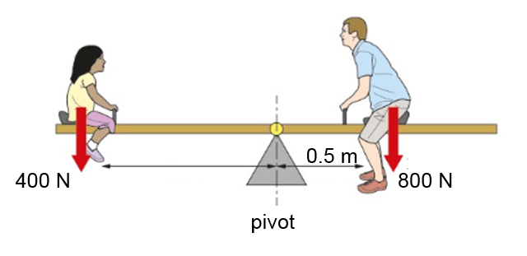
A 0.5 m B 2 m
C 1 m D 5 m

Total: _____ /10

