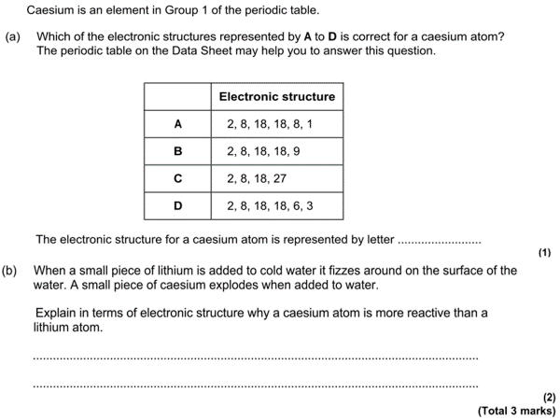
(c) Figure 2 shows sodium being put into water.
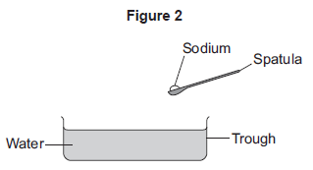
Describe three observations that can be seen when sodium is put into water.
1. _________________________________________________________________
2. _________________________________________________________________
3. _________________________________________________________________
(3)

(c) Figure 2 shows sodium being put into water.
Describe three observations that can be seen when sodium is put into water.
1. _________________________________________________________________
2. _________________________________________________________________
3. _________________________________________________________________
(3)

