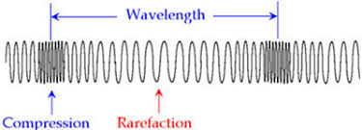

What type of wave does this represent:

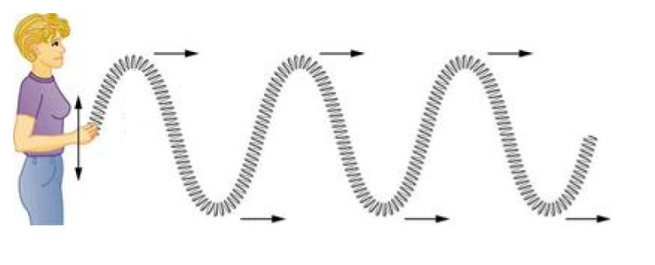

What type of wave does this represent:

How do they differ in terms of their direction of oscillation and direction of propagation?

Which type of wave needs a medium to travel?

What do the compressions and rarefactions represent in a longitudinal wave? Label this on the correct diagram.