Q1. The image below shows a lorry.
(a) The brakes of the lorry are in a poor condition.
What effect will the condition of the brakes have on thinking distance and the braking distance of the lorry?
Thinking distance ____________________________________________________
___________________________________________________________________
Braking distance _____________________________________________________
___________________________________________________________________
(2)
(b) Using a hand-held mobile phone while driving is illegal in the United Kingdom.
The table below shows the effect of using a mobile phone on thinking distance.

 | Thinking distance
Not using a mobile phone | 19 m
Using a mobile phone with hands-free kit | 23 m
Using a hand-held mobile phone | 27 m
Explain why driving while using a hand-held mobile phone is more dangerous than using a mobile phone with a hands-free kit.
Use data from the table above.
___________________________________________________________________
___________________________________________________________________
___________________________________________________________________
___________________________________________________________________
___________________________________________________________________
___________________________________________________________________
___________________________________________________________________
(4)
Q2.
(a) Figure 1 shows the distance-time graph for a car travelling at 15 m/s
Figure 1
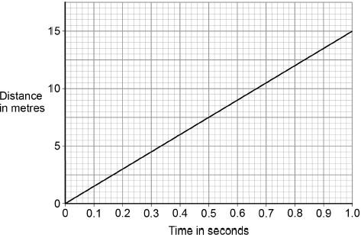
When the driver is tired, his reaction time increases from 0.50 seconds to 0.82 seconds.
Determine the extra distance the car would travel before the driver starts braking.
___________________________________________________________________
___________________________________________________________________
___________________________________________________________________
Distance = _______________________ m
(2)
(b) When the brakes are used, the temperature of the brakes increases.
Explain why. Use ideas about energy in your explanation.
___________________________________________________________________
___________________________________________________________________
___________________________________________________________________
___________________________________________________________________
(2)

(d) Figure 2 shows how the thinking distance, braking distance and stopping distance for a car vary with the speed of the car.
Figure 2
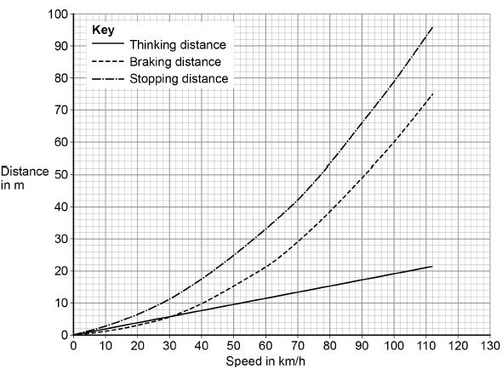
Describe the relationships shown in Figure 2
You should include factors that would affect the gradient of the lines.
___________________________________________________________________
___________________________________________________________________
___________________________________________________________________
___________________________________________________________________
___________________________________________________________________
___________________________________________________________________
___________________________________________________________________
___________________________________________________________________
___________________________________________________________________
___________________________________________________________________
___________________________________________________________________
(6)

Mark schemes
Q1.
(a) thinking distance stays the same
1
braking distance increases
1
(b) reaction time is increased by using a mobile phone
1
hand-held mobile phones increase the thinking distance more than hands-free phone
allow thinking distance is increased by using a mobile phone
1
by 4 m more than the hands-free phone
1
allow 2 marks for a hand-held mobile phone doubles the increase of the thinking distance
so overall stopping distance increases
1
[6]
Q2.
(a) either:
7.5 (m) and 12.3 (m) from the graph
or
15 (m/s) × 0.32 (s) using speed
allow 7.5 (m) and between 12.2 (m) and 12.4 (m)
1
extra distance = 4.8 (m)
1
an answer between 4.7 (m) and 4.9 (m) scores 2 marks
(b) there is a decrease in kinetic energy of the car
allow work is done by friction (on the brakes)
1
so this (causes) the internal / thermal energy store of the brakes to increase
1
(c) 19² − u² = 2 × 2 × 84
1
u² = 19² − (2 × 2 × 84)
1
u = 5 (m/s)
1
an answer of 5 (m/s) scores 3 marks
(d) Level 3: Scientifically relevant facts, events or processes are identified and given in detail to form an accurate account.
5−6
Level 2: Scientifically relevant facts, events or processes are identified and their relevance is clear. The account is not fully accurate.
3−4
Level 1: Facts, events or processes are identified and simply stated but their relevance is not clear.
1−2
No relevant content
0
Indicative content
• use of drugs, alcohol, tiredness and distractions would increase the thinking distance
• thinking distance increases with speed
• thinking distance is directly proportional to speed
• use of drugs, alcohol, tiredness and distractions would increase the gradient of thinking distance
• poor brakes, poor tyres, wet / icy roads and mass would increase the braking distance
• braking distance increases with speed
• braking distance increases at an increasing (accept greater) rate (with speed)
• poor brakes, poor tyres, wet / icy roads and mass would increase the gradient of braking distance
• braking distance is directly proportional to speed squared
• stopping distance = thinking distance + braking distance
• factors that increase thinking and / or braking distance would increase the gradient of stopping distance
• stopping distance increases at an increasing (accept greater) rate (with speed)
[13]

