Cosine Rule – Trigonometry
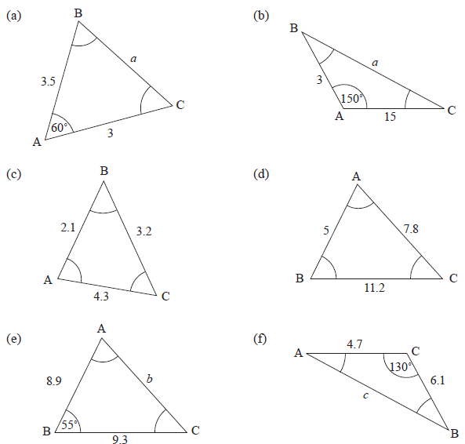

Cosine Rule – Trigonometry

