Name________________________________
Unit R066: Market and Pitch a Business Proposal
Task 2: Develop a pitch for your proposal
You have been asked to prepare a pitch for delivery to a decision-making panel who will decide whether or not to stock your product over rival products. In your pitch you need to include the following, with justification, where appropriate:
- Details of your product design
- Your brand identity
- Your pricing recommendation
- Your proposed promotional plan
- Any other relevant information
As this pitch is important to secure the future success of your product, you are to plan and carry out a practice pitch to support the development of the professional pitch to the panel.
Part 1 – An explanation of the factors you must consider when planning for a pitch
You must:
- Explain the factors that you need to take into account when planning to deliver a pitch i.e.
  - Venue
  - Audience
  - Objectives
  - Use of appropriate media
  - Personal appearance
- Considering the need to convince your audience that your product design will be successful, produce resources/supporting materials which include:
  - Structure of pitch
  - Script for pitch
  - At least ONE supporting visual aid
  - Consideration of possible questions from the audience
  - Any other relevant information
- In addition you should produce any other support material that you may use (e.g. presentation, handouts, props, prompts)

CAU Checklist – Task 2 Part A
Developing my Business Pitch
Factors of a Pitch
Investigate the factors that you will need to consider for your business pitch.
Good – Explain a range of factors that you need to consider. | Outstanding – Justify all factors that you need to consider.
Prepare for your Pitch
Create a plan for the structure of your pitch.
Produce a visual aid for your pitch accompanied with a script
Produce additional supporting material(s)

Good – Materials produced are mostly relevant to the audience and business proposal. | Outstanding – Materials produced are wholly relevant for the audience and business proposal.
Anticipate questions by the panel.
Good – Responses to a few (3-4) possible questions are planned for. | Outstanding – Responses to a range (5+) of possible questions are comprehensive, considered and well planned for.

DNA - Buisness Pitch Key Terms
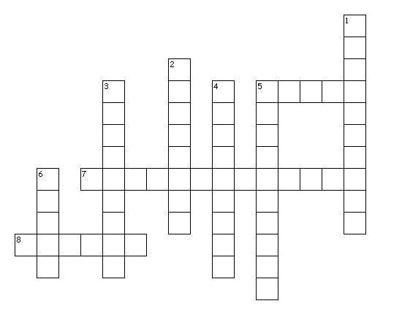
Across
5. Where the pitch takes place
7. To show how a product works
8. Communication using words
Down
1. How you look
2. Who you are presenting too
3. Communication without using words
4. Audience may ask you these
5. Used to help during the pitch
6. Used to help deliver the pitch

Factors of A Pitch
Watch the episode of Dragons Den. Write down your observations.
Venue | Consider: equipment, room layout, size
Objectives | What is the purpose of the pitch?
Audience | Who is the pitch aimed at?  Who is the product aimed at?
Personal appearance | How are they dressed?
Structure of pitch | What are the different phases of the pitch? (Beginning, Middle, End)
Visual Aids | Consider: Presentation Software, video, demonstrations
Verbal Skills | Consider: Clarity, tone, projection, formal/informal language
Non-Verbal Skills | Consider: Body language, posture, eye contact, confidence, gestures
Questioning | What questions were asked.
Any other observations?

Structure of the Pitch
Presentation Plan
Your brand identity
Your pricing recommendation
Any other relevant information
Your brand identity
Your proposed promotional plan

Details of your product design
Preparing your Pitch
What materials are you going to produce to prepare for your pitch?
- ______________________________________________________________________________
- ______________________________________________________________________________
- ______________________________________________________________________________
- ______________________________________________________________________________
- ______________________________________________________________________________
Possible Questions
Research 5 questions that you may be asked at the pitch with a response.
- ______________________________________________________________________________
______________________________________________________________________________
- ______________________________________________________________________________
_____________________________________________________________________________
- ______________________________________________________________________________
______________________________________________________________________________
- ______________________________________________________________________________
______________________________________________________________________________
- ______________________________________________________________________________
______________________________________________________________________________

