YEAR 8 Distance Learning
September-October 2020
‘I am Malala’

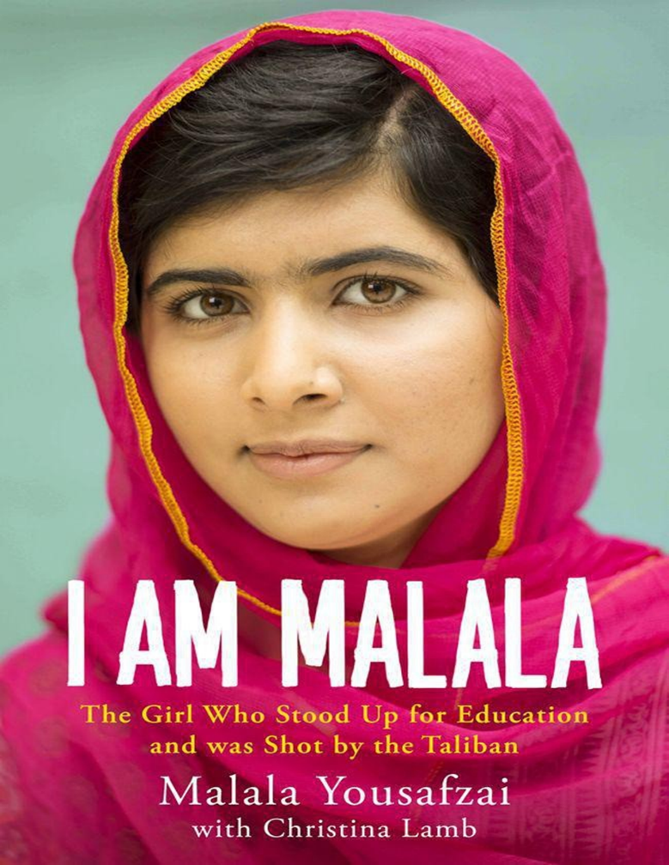

Pre-reading homework
TASK: Read ‘The Prologue’. Answer the text-dependent questions from this chapter.
The Prologue
- At which point in the day was Malala attacked? ​
__________________________________________________________________________________________________________
- What is the time span between the attack and the creation of Malala’s novel? ​
__________________________________________________________________________________________________________
- What is the time difference between her current location and her homeland, Pakistan? ​
__________________________________________________________________________________________________________
- What do the ovens get fuelled with in Pakistan? ​
__________________________________________________________________________________________________________
- What is happening in paragraph three? ​
__________________________________________________________________________________________________________
- What was the date of the attack? ​
__________________________________________________________________________________________________________

- What is the name of the main city in the Swat Valley?
__________________________________________________________________________________________________________
- Which tomb was on the left when the bus stopped? ​
__________________________________________________________________________________________________________
- What question does the attacker as when he leans into the bus?
__________________________________________________________________________________________________________
Lesson 1 Chapter 8
TASK: Read Chapter 8 ‘The Autumn of the Earthquake’.
Reread the following extract: “The whole nation was in shock for a long time after the earthquake. Already so unlucky with our politicians and military dictators, now, on top of everything else, we had to deal with a natural disaster. Mullahs from the TNSM preached that the earthquake was a warning from God. They said it was caused by women’s freedom and obscenity. If we did not mend our ways an introduce sharia or Islamic law, they shouted in their thundering voices, more severe punishment would come.”
Answer the text-dependent questions on this extract (level one: understanding meaning of the text)
1. Why were the people in shock?
__________________________________________________________________________________________________________________
2. What did the Mullahs from TNSM say about the earthquake?
__________________________________________________________________________________________________________________

3. What did the Mullahs state had caused the earthquake?
__________________________________________________________________________________________________________________

4. What would have to be introduced if women did not improve their supposedly ‘bad’ behaviour?

__________________________________________________________________________________________________________________

5. In what type of tone did the Mullahs deliver this statement?
__________________________________________________________________________________________________________________

6. What did the Mullahs declare would happen if women did not improve their behaviour?

___________________________________________________________________________________________________________________________________________________________________________
Answer the text-dependent questions on this extract (level two/three: vocabulary and structure choices, writers’ intent)
- What does the adjective ‘unlucky’ to describe the politicians demonstrate about them?
___________________________________________________________________________________________________________________________________________________________________________

2. Does the collective pronoun ‘we’ refer to everyone, or just the regular people of Pakistan? Why might this be significant?
__________________________________________________________________________________________________________________
_________________________________________________________

3. What is the significance of the verb ‘preached’ here? Does it present the behaviour of the Mullahs as positive or negative? How?
__________________________________________________________________________________________________________________
_________________________________________________________

4. Why do you think the Mullahs specifically focused on women here? What were they trying to achieve through their propaganda?
____________________________________________________________________________________________________________________________________________________________________________________________________________________________________
5. The phrase ‘severe punishment’ seems to be ambiguous here – what type of punishment could it be referring to and why?

______________________________________________________________________________________________________________________________
_______________________________________________________________

Lesson 2 Chapter 8
How is the earthquake used as a piece of propaganda in this section? Answer the questions below to form a response.
1. In the concluding paragraph of chapter eight, the earthquake is being used as a piece of propaganda through……….

2. Those with extremist views are attempting to use the fear people have about the earthquake to……

3. By manipulating the fear of some of the people affected by the earthquake, the Mullahs are attempting to control………

TASK: Write the text for a newspaper report on the earthquake that happened in chapter 8
Success Criteria:
 Punchy headline
 5 Ws
 Re-tell of main events
 Quotes from witnesses
 Conclusion (what is happening now?)
 Written consistently in the past tense
 Extra information added using commas/brackets
 Powerful vocabulary
 Written in the style a non-fiction text
_________________________________________________________________________________________________________________________________________________________________________________________________________________________________________________________________________________________________________________________________________________________________________________________________________________________________________________________________________________________________________________________________________________________________________________________________________________________________________________________________________________________________________________________________________________________________________________________________________________________________________________________________________________________________________________________________________________________________________________________________________________________________________________________________________________________________________________________________________________________________________________________________________________________________________________________________________________________________________________________________________________________________________________________________________________________________________________________________________________________________________

Lesson 3 Chapter 10
TASK: Read Chapter Ten ‘Toffees, Tennis Balls and the Buddhas of Swat’.
Answer the text-dependent questions from this chapter.
- To what does Malala compare her village of Swat? ​
__________________________________________________________________________________________________________

- What happened when the Fazlullah appeared? ​
__________________________________________________________________________________________________________

- What did the Taliban destroy? ​
__________________________________________________________________________________________________________

- What mountains did the Taliban take over and why?​
__________________________________________________________________________________________________________

- What did policemen do because they were afraid? ​
__________________________________________________________________________________________________________

- Why did many men decide to join Fazlullah? ​
__________________________________________________________________________________________________________
Lesson 4 Chapter 10
TASK: Transactional Writing
Though we still had our television they had switched off the cable channels. Moniba and I could no longer watch our favourite Bollywood shows like Shararat or Making Mischief. It seemed like the Taliban didn’t want us to do anything. They even banned one of our favourite board games called Carrom in which we flick counters across a wooden board. We heard stories that the Taliban would hear children laughing and burst into the room and smash the boards. We felt like the Taliban saw us as little dolls to control, telling us what to do and how to dress. I thought if God wanted us to be like that He wouldn’t have made us all different.
Extract from Chapter Ten of I am Malala ‘Toffees, Tennis Balls and the Buddhas of Swat’.

Imagine if, like Malala and her friends, you were suddenly banned from watching your favourite television programmes, playing board games with your friends and even dressing in the way you chose.

Write a letter to your Head teacher arguing your point of view and giving reasons why young adults should be allowed to choose the activities they want to do during their free time and dress the way they like.

You are advised to plan your answer before you start to write.

Reasons why activities should
not be banned.

__________________________________________________________________________________________________________
__________________________________________________________________________________________________________
__________________________________________________________________________________________________________
__________________________________________________________________________________________________________
__________________________________________________________________________________________________________
__________________________________________________________________________________________________________
__________________________________________________________________________________________________________
__________________________________________________________________________________________________________
__________________________________________________________________________________________________________
__________________________________________________________________________________________________________
__________________________________________________________________________________________________________
__________________________________________________________________________________________________________
__________________________________________________________________________________________________________
__________________________________________________________________________________________________________
__________________________________________________________________________________________________________
__________________________________________________________________________________________________________
__________________________________________________________________________________________________________
__________________________________________________________________________________________________________
__________________________________________________________________________________________________________
__________________________________________________________________________________________________________

Week 2 homework
TASK: As Malala, you are going to write the chapter in your autobiography, which will tell everyone about a day in her life.
Success Criteria:
- Only include relevant ideas and content.
- Try to develop your writing with detail.
- Ensure you stay in the role of Malala.
- Try to use good vocabulary and use a range of sentence lengths and structures to achieve your purpose.
Have you started in the past tense?

Have you used time connectives?

Have you included quotations and relevant ideas from ‘I am Malala’?

Have you concluded in a clear/cohesive way?

Lesson 5 Chapter 11
TASK: Read Chapter 11: ‘The Clever Class’. Complete the task below based on this chapter.
- What is Malala afraid of in the first paragraph of this chapter?
__________________________________________________________________________________________________________

- What Shakespearean play did Malala and her friends perform at school?
__________________________________________________________________________________________________________

- What happened in Mingora on the last day of February 2008?
__________________________________________________________________________________________________________

- How does Malala’s father describe the people who looted the bombed schools?
__________________________________________________________________________________________________________

- How many schools had been destroyed by the end of 2008?
__________________________________________________________________________________________________________

- Find two reasons why the month of Ramadam was difficult for Malala and her family in 2008.
__________________________________________________________________________________________________________

Each of these key plot points have been put into chronological order. You are now going to rate the tension at each point of the chapter.
1 – the least tense.
8 – the most tense.

Key Plot Point | Tension
Malala fears that every man she passes is part of the Taliban.

Malala and her friends put on a performance of Romeo and Juliet.

Bombs starting going off around Mingora.

Malala begins giving interviews about her right for education.

The electrics and gas pipes were bombed by the Taliban.

People were unable to access clean water and were dying of Cholera.

The Taliban finally declare that all girls must stop going to school but Malala’s family refuse to give in.

The Taliban disappear into the mountains, but Malala knows they will return.

How is the tension developed throughout this chapter? Does it increase or decrease?
________________________________________________________________________________________________________________________________________________________________________________________________

Why do you think Malala has structured her chapter this way - what effect does it have on the audience?
________________________________________________________________________________________________________________________________________________________________________________________________

How does it reflect her own feelings at the time?
________________________________________________________________________________________________________________________________________________________________________________________________
Malala ends this chapter with:
“The Taliban could take our pens and books, but they couldn’t stop our minds from thinking.”
What does this reveal about Malala’s personality?
________________________________________________________________________________________________________________________________________________________________________________________________

Lesson 6 Chapter 13
TASK: Read ‘Chapter 13’, ‘The Diary of Gul Makai’. Answer the text-dependent questions from this chapter.
Focus on this section:
‘When I overheard my father talking about this, I said, “why not me?” I wanted people to know what is happening. Education is our right, I said. Just as it is our right to sing and play. Islam has given us this right and says that every girl and boy should go to school. The Quran says we should seek knowledge, study hard and learnt the mysteries of our world’.
1. What does ‘this’ refer to in the opening sentence?
____________________________________________________________________________________________________________________

2. What is Malala referring to when she says ‘what is happening’?
____________________________________________________________________________________________________________________
3. What is the impact of the collective pronoun ‘our’?

____________________________________________________________________________________________________________________

4. Malala is using imperatives (statements) here, how does this make her sound confident?
______________________________________________________________________________________________________________________________________________________________________________
5. How are the teachings of the Quran being undermined by Fazlullah’s earlier orders to destroy historical statues?
______________________________________________________________________________________________________________________________________________________________________________
Lesson 7 – Chapter 13
TASK: In this chapter, Malala writes about a diary entry she wrote for a BBC correspondent based on her experiences living under the Taliban. You are going to write your own version of Malala’s diary entry. Follow the instructions below.
1. Go through the chapter and note down at least 3 topics Malala mentions writing about in her diary.
2. Google the topics and make notes that will help you imagine you are Malala and have experienced a day in her life.
3. You should now use the topics to write your diary entry following the success criteria below
Success Criteria:
• Begin with Dear Diary,
• Use emotive language to describe a day in your life living under the control of the Taliban.
• Write at least three main paragraphs with an introduction and a conclusion.
- Challenge yourself to include further examples of DAFOREST in your work.

Look at the example below from ‘The Diary of Anne Frank’ to help you.

Dear Diary,
Today, Mother, Father, Margot and I were sitting quite pleasantly together when Peter suddenly came in and whispered in Father's ear. I caught the words "a barrel falling over in the warehouse" and "someone fiddling with the door."
Margot heard it too, but was trying to calm me down, since I'd turned white as chalk and was extremely nervous. The three of us waited. In the meantime Father and Peter went downstairs, and a minute or two later Mrs. van Daan came up from where she'd been listening to the radio. She told us that Pim had asked her to switch it off and tiptoe upstairs. But you know what happens when you're trying to be quiet--the old stairs creaked twice as loud. Five minutes later Peter and Pim, the color drained from their faces, appeared again to relate their experiences.
They had positioned themselves under the staircase and waited. Nothing happened. Then all of a sudden they heard a couple of bangs, as if two doors had been slammed shut inside the house. Pim bounded up the stairs, while Peter went to warn Dussel, who finally presented himself upstairs, though not without kicking up a fuss and making a lot of noise. Then we all tiptoed in our stockinged feet to the van Daan family on the next floor. Mr. van D. had a bad cold and had already gone to bed, so we gathered around his bedside and discussed our suspicions in a whisper…
______________________________________________________________________________________________________________________________________________________________________________________________________________________________________________________________________________________________________________________________________________________________________________________________________________________________________________________________________________________________________________________________________________________________________________________________________________________________________________________________

Lesson 8 Chapter 15
TASK: Read ‘Chapter 15. Answer the text-dependent questions from this chapter.
Focus on this section:
“Leaving our home felt like having my heart ripped out. I stood on our roof looking at the mountains the snow-topped Mount Elum where Alexander the Great had reached up and touched Jupiter. I looked at the trees all coming into leaf. The fruit of our apricot tree might be eaten by someone else this year. Everything was silent, pin-drop silent. There was no sound from the river or the wind; even the birds were not chirping.”

- What is the impact of the simile in the opening sentence?
​
__________________________________________________________________________________________________________

- Why is the phrase ‘heart ripped out’ so emotive?
__________________________________________________________________________________________________________
- The leaves are symbolic here, what do you think they might represent about the situation?
__________________________________________________________________________________________________________

- The final sentences stress the silence of the moment, what is the impact of this silence?

- What is the effect of the repetition of the word “silent”?

__________________________________________________________________________________________________________
- What is happening in this scene?
_____________________________________________________
_____________________________________________________
- Where does Malala stand to look at the mountains? __________________________________________________________________________________________________________
- Which type of fruit tree is in their garden? __________________________________________________________________________________________________________
- What were the birds not doing? __________________________________________________________________________________________________________

- How does Malala describe her emotions in this scene? __________________________________________________________________________________________________________

TASK: Tension is created in this scene as Malala and her family have been forced to leave their home. Identify three ways in which atmosphere is created in this extract and complete the table.

What is the atmosphere like? | How is this reflected in the text (evidence)? | Why has the writer/editor chosen to present the atmosphere in this way?

TASK: Using the table above, answer the questions below in full sentences using quotes to support your ideas where possible.

- What is the atmosphere in this chapter? Does it change throughout?
- How is the atmosphere shown to the reader?
- Why has the atmosphere being presented in this way? Consider the events and what the reader is meant to feel.

Lesson 9 Chapter 16
TASK: Read chapter 16, entitled ‘The Valley of Sorrows’. Complete the inference DNA, then the TDQs.
The Valley of Sorrows
DNA-
- What is personification?
_______________________________________________________
- What impression can you infer from the chapter title? What does the language choice of “sorrows” suggest? __________________________________________________________________________________________________________
TDQs-
Re-read the highlighted section of the text below:
People had desperately tried to protect what little they owned, moving their animals to higher ground, but the floods saturated the corn they had harvested, destroyed the orchards and drowned many of the buffaloes. The villagers were helpless. They had no power, as all their makeshift hydroelectric projects had been smashed to pieces. They had no clean water as the river was brown with wreckage and debris. So strong was the force of the water that even concrete buildings had been reduced to rubble. The school, hospital and electricity station along the main road were all razed to the ground.

- What is the impact of the emotive adverb ‘desperately’ on the reader’s response?

- How does the phrase ‘what little they owned’ reflect that the Swat region has little money?

- How does the triple emphasis (underlined section) reflect the extent of the destruction?

- The simple sentence ‘the villagers were helpless’ creates tension, how does it achieve this?

- How does the final sentence of the paragraph convey the extreme nature of their situation?

Independent enquiry-
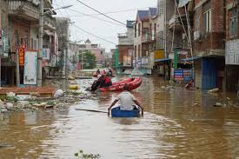

Summarise, in either bullet points or a thought map, how someone may describe a natural disaster such as a flood.
Consider-
- The 5 senses what would be seen, heard, felt, tasted, smelled?
- Emotions that may be experienced
- The order of reactions- from the initial rush of water through to the image seen in the image.

Lesson 10 – Chapter 16
TASK- Imagine witnessing a natural disaster such as a flood to write a first person description.

Last lesson you read about a flood in Malala’s experience. To be able to EMPATHISE, we will imagine what it may be like to be witness to a flood.

Word Consciousness-
Empathise- understand and share the feelings of another.

Using your thought map/ bullet points from last lesson, write a three paragraph description of experiencing a flood.

Areas very close to where we live have suffered floods in recent years, and footage of those floods may help you imagine for yourself. Please watch the clip:
https://youtu.be/QmqVz5LVicQ

Planning-
What has created the flood in your description? Heavy rain and storms? A nearby river breaking its banks?

How does the flood water arrive? Through drains overflowing, or a rush through the streets from a river or sea?

What is the damage, how wide scale are the effects? Do people have to run from their homes, use boats? Do they have to evacuate the area?

Paragraph structure:
Opening- describe the moment the flood ‘hits’. Use dramatic description and short sentences to create a fast pace.

Development- describe the initial aftermath as the flood damages and destroys. Focus on some small details to zoom in; an elderly resident being trapped, the objects that have been caught in the flow of the water…

Conclude- describe the lasting effects of the flood on the people affected. Perhaps use a time connective to indicate passage of time (For example, “One month passes”). Focus on the changes to people’s lives and the lingering effects such as businesses closed down, sandbags used as precautions.

Lesson 11 – Chapter 17
TASK: Read chapter 17, entitled ‘Praying to be tall’. Complete the DNA, then the TDQs.

DNA:
What makes an effective descriptive piece of writing?

Re-read the highlighted section of the text below:
“Meanwhile our courts were busy with another issue. In Pakistan we have something called the Blasphemy Law, which protects the Holy Quran from desecration. Under General Zia’s Islamic radicalisation campaign, the law was made much stricter so that anyone who “defiles the sacred name of the Holy Prophet, PBUH,” can be punished by death or life imprisonment”
- What is the effect of the phrase ‘another issue’?
_______________________________________________________________________________________________________________________________________________________________
- How does the noun ‘radicalisation’ demonstrate that Malala is aware that the situation is extreme and dangerous?
_______________________________________________________________________________________________________________________________________________________________
- Is it concerning that there has been no discussion about this law before it ‘was made much stricter’?
_______________________________________________________________________________________________________________________________________________________________
- Does the punishment of ‘death or life imprisonment’ seem extreme? Why?
_______________________________________________________________________________________________________________________________________________________________
- This type of leadership is the opposite to a democracy – what differences can you see in the extract compared to countries such as ours?
_______________________________________________________________________________________________________________________________________________________________

Lesson 12 – Chapter 20
TASK: Read Chapter 20, entitled ‘Who is Malala?’
Complete the grid below.
Four Levels of Reflection: Who is Malala?
Word/Phrase Level | ‘The first paper, n Monday 8th October’/’When I got home…..’/’In the morning……’  What is the impact of each sentence opener being in a chronological order? How does this build tension?
Sentence Level | ‘I had no worries that day’  Although this sentence is positive, it builds tension due to later negative events – how does this sentence create suspense?
Section Level | Re-read the section from ‘Moniba and I…’ to ‘a chicken’ – How does this description keep the reader engaged/interested? Explain your response.
Passage Level | Throughout these three pages (200-203) there are several methods, alongside the language choices, that the writer uses to engage the reader and develop the tension.  What are these techniques? Identify them and then given examples from the text.
Assessment Question
Re-read chapter 20. How has the writer structured the following extract to interest the reader?

Remember, this is about how this section has been put together and why the writer may have chosen to describe events in this way.

________________________________________________________________________________________________________________________________________________________________________________________________________________________________________________________________________________________________________________________________________________________________________________________________________________________________________________________________________
________________________________________________________________________________________________________________________________________________________________________________________________________________________________________________________________________________________________________________________________________________________________________________________________________________________________________________________________________
________________________________________________________________________________________________________________________________________________________________________________________________________________________________________________________________________________________________________________________________________________________________________________________________________________________________________________________________________
__________________________________________________________________________________________________________________________________________________________________________________________________________________________________________________________________________________________________________________________________________________________________________________________________________________________________________________________________________________________________________________________________________________________________________________________
WWW:
EBI:
Lesson 13 – Rights of the Child
Read the UN convention: Rights of the Child
https://www.unicef.org/child-rights-convention/what-is-the-convention
Answer the following TDQs:
- When was this UN convention created?
- What have the main achievements been of this convention?
- Name two barriers that still exist for children today?
- At what age is a child considered an adult?
- What does “ratify” mean?

_____________________________________________________________________________________________________________________________________________________________________________________________________________________________________________________________________________________________
______________________________________________________________________________________________________________________________________________________________________________________________________________________________________________________________________________________________________________________________________________________
Lesson 14 – Write a letter to the Prime Minister informing him of the rights you think children should be entitled to.
Success Criteria:
- Clear communication of rights (e.g. shelter, safety etc)
- Conventions of a letter (Dear/Yours sincerely/address/date)
- Range of punctuation
- High level vocabulary choices
- Formal tone
- Paragraphing
CHALLENGE: can you link in what you have learned about Malala and Pakistan?
_____________________________________________________________________________________________________________________________________________________________________________________________________________________________________________________________________________________________
______________________________________________________________________________________________________________________________________________________________________________________________________________________________________________________________________________________________________________________________________________________
_____________________________________________________________________________________________________________________________________________________________________________________________________________________________________________________________________________________________
______________________________________________________________________________________________________________________________________________________________________________________________________________________________________________________________________________________________________________________________________________________
_____________________________________________________________________________________________________________________________________________________________________________________________________________________________________________________________________________________________
___________________________________________________________________________________________________________________________________________________________________________
Lesson 15 – Research another inspirational young figure who is fighting for change like Malala is
(Stuck? Look up Marcus Rashford or Greta Thunberg as a starting point)
Name: __________________________________________
Age: __________________________________________
What are they fighting for?
_________________________________________________________
__________________________________________________________________________________________________________________
How are they fighting for this?
_________________________________________________________
__________________________________________________________________________________________________________________
Facts about their personal life
_________________________________________________________
__________________________________________________________________________________________________________________
Why have they inspired you?
_________________________________________________________
__________________________________________________________________________________________________________________
Lesson 16 – Write a book review of I am Malala

