GCSE CHEMISTRY Name:
Atomic structure and the periodic table
Separate and Trilogy
Complete the questions by typing in the answer boxes, which will expand as necessary.
Then fill in the self-assessment form as fully as you can to help you reflect on your work.
1.0 A student separated a mixture of two alcohols, ethanol (boiling point 78 °C) and butanol (boiling point 118 °C).
The apparatus is shown in Figure 1.
Figure 1
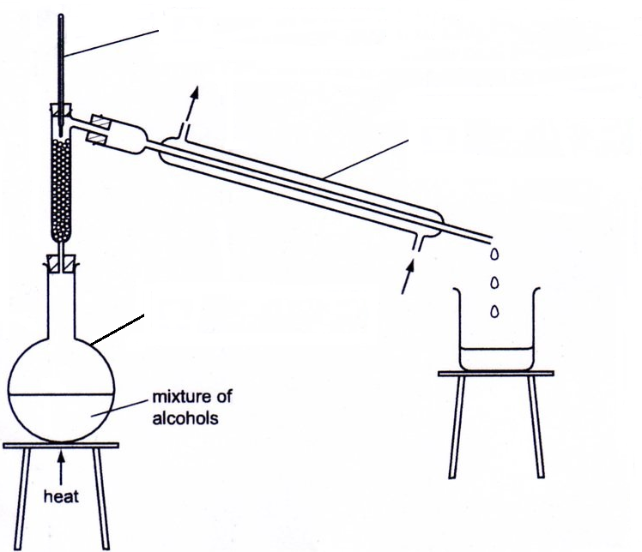
A

B
C

1.1 Complete the boxes in Figure 1 to identify the pieces of apparatus labelled A, B and C.
[3 marks]

1.2 What is the name of this separation process?
[1 mark]

1.3 Suggest why the first liquid to collect in the beaker is ethanol.
[1 mark]

1.4 Alcohols are flammable.
Suggest how the mixture of alcohols should be safely heated so that ethanol can be collected.
[1 mark]

2.0 The picture shows a pair of gold rings.
Gold rings are made from alloys of gold.
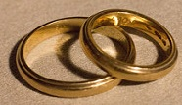
Robert Chealb Creative commons license

The bar chart shows the composition of the alloy of gold used in the rings.
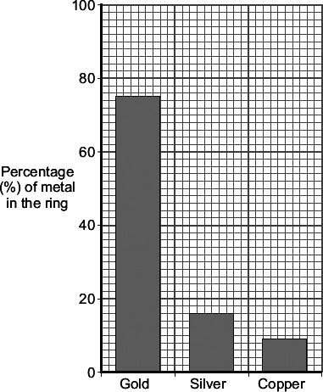

2.1 State the composition of the alloy used to make the rings.
[3 marks]

2.2 An atom of gold can be represented as .
This shows that a gold atom has an atomic number of 79 and a mass number of 197.
Complete the table to show the numbers of each sub-atomic particle in this gold atom.
[3 marks]

Name | Number
Proton
Electron
Neutron

3 A student is given a mixture of salt and sand.
Describe a method the student could use to separate the mixture.
The student should obtain:
• salt crystals
• dry sand
In your method you should name all of the apparatus you will use.
[6 marks]

4.0 The graph shows the melting points of Group 1 metals plotted against their atomic numbers.
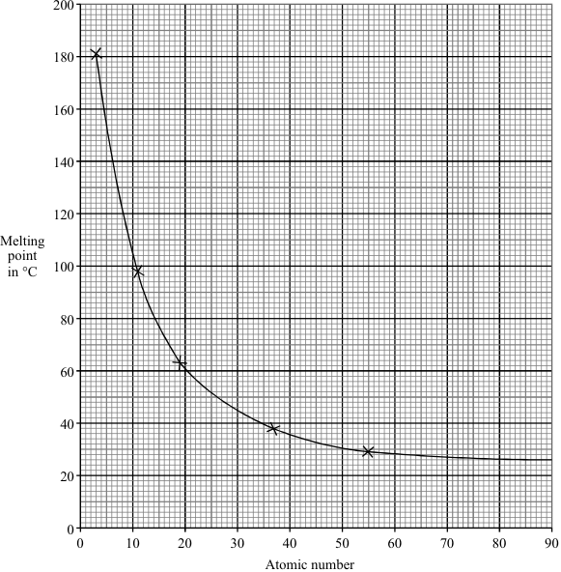

4.1 Give two conclusions that can be drawn from the graph.
[2 marks]

4.2 The alkali metal francium has an atomic number of 87.
Estimate the melting point of francium.
[1 mark]
Melting point of francium = °C

4.3 Lithium has 3 electrons. Draw a diagram to show the electronic structure of lithium.
[1 mark]

4.4 Describe what you would see when sodium is added to water.
[3 marks]

4.5 Complete the balanced equation for the reaction of sodium with water.
[2 marks]

 | + |  | → |  | NaOH + H₂

4.6 Describe the trend in reactivity of group 1 metals with water.
[1 mark]

4.7 Explain the trend in reactivity of group 1 metals with water.
[3 marks]

5.0 The table gives the melting points of some of the elements of Group 7.

Element | Atomic number | Melting point in °C
Fluorine | 9 | –220
Chlorine | 17
Bromine | 35 | –7
Iodine | 53 | 114
Astatine | 85 | 301

5.1 Plot a graph of the melting point against atomic number.
Draw a line of best fit.
[2 marks]
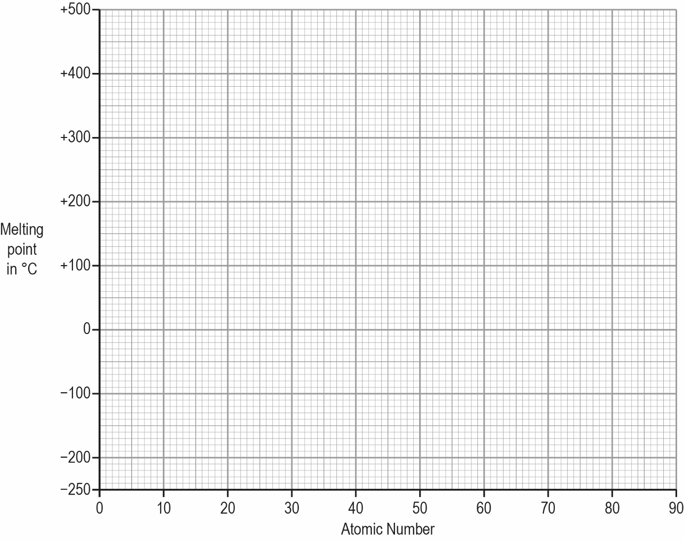
5.2 Estimate the melting point of chlorine.
[1 mark]
°C

5.3 What is the state of iodine at 25 °C?
[1 mark]

5.4 Chlorine has two isotopes .
Why do these two isotopes have a different mass number?
[2 marks]

5.5 The relative formula mass of chlorine is 35.5.
Explain why this is not a whole number.
[1 mark]

6.0 Dmitri Mendeleev was one of the first chemists to classify the elements.
Mendeleev arranged the elements in order of their atomic weight in a table.
Part of his table is shown below.
Use the periodic table and the information in the table below to help you to answer the questions.

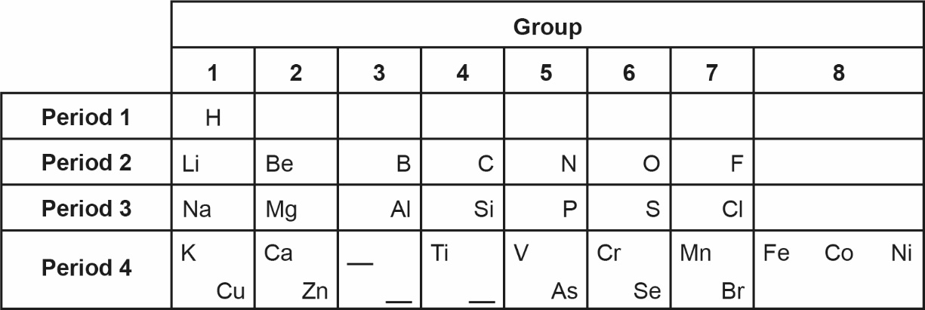

6.1 Which group of the modern periodic table is missing from Mendeleev’s table?
[1 mark]

6.2 Mendeleev placed hydrogen at the top of Group 1 in his version of the periodic table.
The modern periodic table does not show hydrogen in Group 1.
State one similarity between hydrogen and the elements in Group 1.
[1 mark]

6.3 Mendeleev changed the position of iodine in his version of the periodic table so it was in the same group as chlorine.
Give two reasons why he put iodine in the same group as chlorine.
[2 marks]

6.4 Protons and electrons were discovered after Mendeleev proposed his version of the periodic table.
Describe how the numbers of protons and electrons in atoms are used to place elements in the modern periodic table.
[2 marks]

Feedback Form Instructions
When you have answered as many questions as you can, complete the form on the last page to help you reflect on your work.
How to fill in the form
1 Put your confidence score in Column C. This is not about the number of marks you achieved but how sure you felt while you were answering the question.

Confidence | Definition
0 | I didn’t answer this one
1 | I guessed the answer
2 | I needed help with the answer
3 | I understood the question but wasn’t sure about my answer
4 | I was fairly confident I would get most of the marks
5 | I was sure my answer was correct and I would get full marks
2 Use the mark scheme to check your answers.
Put the mark you think you achieved in Column Mark.
3 Write an overall comment about how you felt each question went.
- If you got help, make a note in the comment box specifying the source: internet,
friend, book, parent or tutor.
4 Complete ‘I can…’ and ‘I need to…’ sentences.
- ‘I can…’ sentences might include the questions you found easiest to answer, got the most marks for or felt the most confident about.
- ‘I need to…’ sentences might include areas you need to revise, questions you want to ask your teacher or the next topic or skill you want to work on.
5 Return the form to your teacher.

Atomic structure and the periodic table
Separate and Trilogy
Feedback form Name

Qu | Total marks | Self-assessment
 |  | C | Mark | Comment
1 | 6
2 | 6
3 | 6
4 | 13
5 | 7
6 | 6
Overall
I can ……

I need to …….

Qu | Total marks | Teacher review
 |  | Mark | Comment
1 | 6
2 | 6
3 | 6
4 | 13
5 | 7
6 | 6
Overall
You can ……

You need to …….

