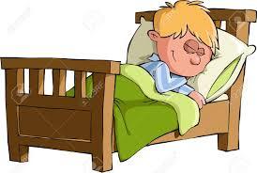



RICE



Fats & Carbs for aerobic & anaerobic energy



Long term effects of exercise on muscles, skeletal, CV, respiratory



Short term effects of exercise (muscle, CV, respiratory



Warm ups & cool downs



Methods of training



Principles of training



Fitness tests



Normative data



Levers



Physical fitness components

&

Skill related fitness components

Classification of bones



How to reduce the risk of injuries

Ligaments

& tendons



Muscle types



Structure of arteries, capillaries and veins

Location of bones



Injuries that can occur



PAR-Q



Performance Enhancing Drugs



Aerobic & anaerobic thresholds of training

Possible movements



Antagonistic pairs



% of inhaled & exhaled air



Planes & axis



Health

Fitness

Exrcises



Aerobic & anaerobic respirations



Alveoli &

gaseous exchange



Vital capacity, tidal volume, VO2 MAX



Vasodilation, vasoconstriction & vascular shunt



% of inhaled & exhaled air



Vital capacity, tidal volume, VO2 MAX

Functions of the skeleton



Structure (labeling) the heart



Functions of the CV system



Muscle fibres



Location of bones

Classification

of joints