Q1. Draw one line from each velocity−time graph to the statement describing the motion shown by the graph.
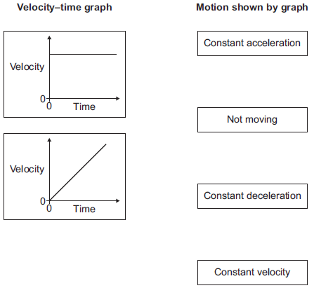
(2)
Q2. A train travels from town A to town B. Figure 1 shows the route taken by the train. Figure 1 has been drawn to scale.
Figure 1
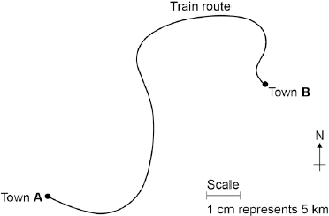
(a) The distance the train travels between A and B is not the same as the displacement of the train. What is the difference between distance and displacement?
___________________________________________________________________
___________________________________________________________________
(1)
(b) Use Figure 1 to determine the displacement of the train in travelling from A to B. Show how you obtain your answer.
___________________________________________________________________
___________________________________________________________________
Displacement = ___________________ km Direction = _________________________
(2)
(d) Figure 2 shows how the velocity of the train changes with time as the train travels along a straight section of the journey.
Figure 2
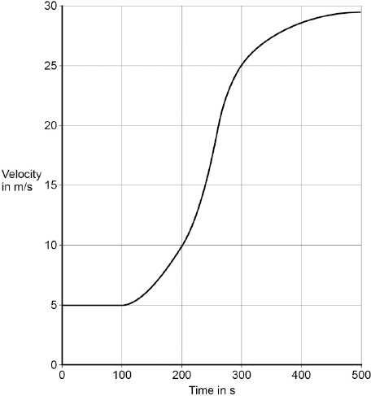
Estimate the distance travelled by the train along the section of the journey shown in Figure 2. To gain full marks you must show how you worked out your answer.
___________________________________________________________________
___________________________________________________________________
___________________________________________________________________
___________________________________________________________________
Distance = _________________________ m
(3)

Q3. A number of different forces act on a moving vehicle. A car moving at a steady speed has a driving force of 3000 N.
(i) What is the value of the resistive force acting on the car? Tick () one box.

Tick ()
2000 N
3000 N
4000 N
(1)
(ii) What causes most of the resistive force? Tick () one box.

Tick ()
Air resistance
Faulty brakes
Poor condition of tyres
(1)
(b) A car is moving along a road. The driver sees an obstacle in the road at time t = 0 and applies the brakes until the car stops. The graph shows how the velocity of the car changes with time.
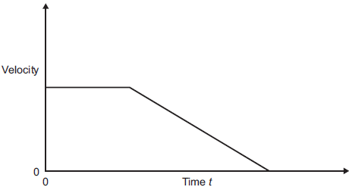
(i) Which feature of the graph represents the negative acceleration of the car? Tick () one box.

Tick ()
The area under the graph
The gradient of the sloping line
The intercept on the y-axis
(1)
(ii) Which feature of the graph represents the distance travelled by the car? Tick () one box.

Tick ()
The area under the graph
The gradient of the sloping line
The intercept on the y-axis
(1)
Q4. The diagram shows the velocity-time graph for an object over a 10 second period.
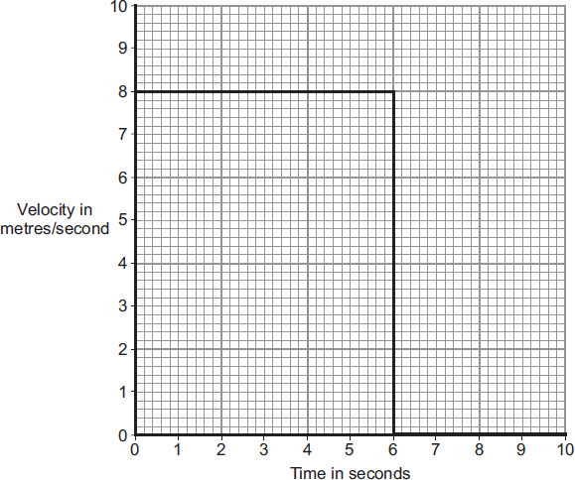
(a) Use the graph to calculate the distance travelled by the object in 10 seconds.
Show clearly how you work out your answer.
___________________________________________________________________
___________________________________________________________________
Distance = ______________________________ m
(2)

(b) Complete the distance-time graph for the object over the same 10 seconds.
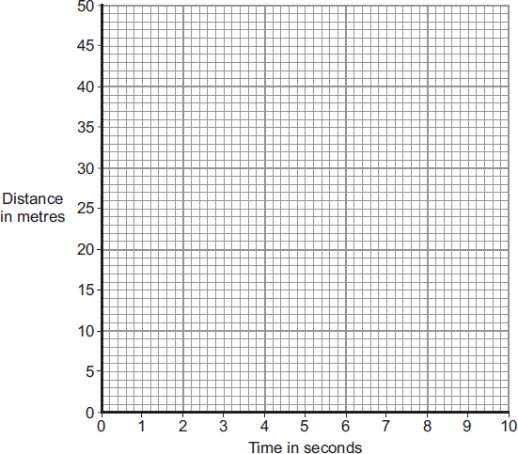
(2)
Q5. The athlete takes part in a race on a straight, horizontal running track. The graph below shows the velocity−time graph for the athlete. A, B, C, D and E represent points in the race.
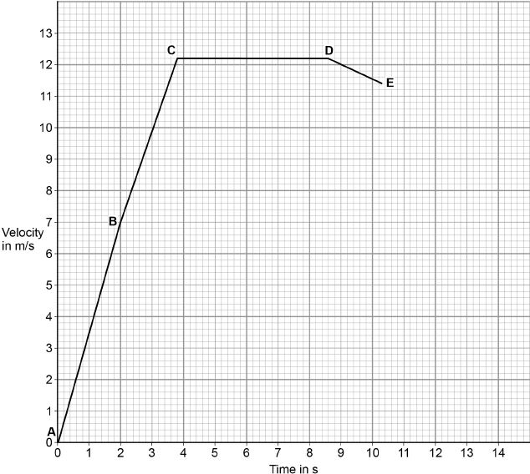
(c) Determine the time taken for the athlete to move between points C and D.
Time at C = _________________ s
Time at D = _________________ s
___________________________________________________________________
___________________________________________________________________
Time taken between points C and D = _________________ s
(2)
(d) Point E represents the end of the race. After point E, the athlete has a constant deceleration.
The athlete stops 14 seconds after the start of the race. Complete the graph above to show the motion of the athlete after point E.
(2)

(e) Which section of the graph above shows the athlete moving at constant velocity? Tick one box.

A−B
B−C
C−D
D−E
(1)
(f) What does the area under a velocity-time graph represent? Tick one box.

Acceleration
Distance travelled
Energy
Speed
(1)

