Unit 7

Ethical, legal, cultural and environmental concerns
Ethical adjective
relating to a set of moral principles that govern the behaviour of a group or individual.
Legal adjective
relating to the law.
Cultural adjective
relating to the ideas, customs, and social behaviour of a society.
Environmental adjective
relating to the natural world and the impact of human activity on its condition.

NAME ________________________________________

CLASS _____________

Growth of computer technology

Over the last few decades, computing has played an increasingly pivotal role in society as we know it. Computers, new technology and the internet all impact different people in different ways. Along with the many benefits this may bring, there are also some issues that have arisen.

Pick 4 of the categories below and explain how the growth of computers has made an impact.

Manufacturing / Crime / Business / Entertainment / Communication / Shopping / Health

____________ | ____________
____________ | ____________

We can organise issues into four main areas (although an issue may overlap more than one of these).

Ethical issues are about what is considered right or wrong by society.

Legal issues are about what is right or wrong according to law.

Cultural issues are about how groups of people with particular beliefs, practices or languages may be affected, e.g. ethnic groups, religions, ages

Environmental issues are about how we impact the natural world in which we live.

Stakeholders

A person who may be involved either directly, or indirectly with an issue is known as a stakeholder. Most issues will often have many stakeholders, some of which are obvious, and some are less so. For higher grades, you will have to identify a range of stakeholders for a given issue.

Task 1

“Computer Science has developed new software/robotics that means that Nuclear Power is now 100% safe to use! There are now plans to convert all of the UK’s energy supply to Nuclear Power.”
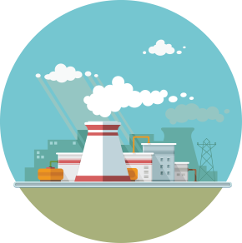
Use the mind map to identify as many potential stakeholders in this scenario as you can think of
Stakeholder
Stakeholder
Stakeholder
Effect
Effect
Effect
Effect
Stakeholder
Stakeholder
Effect
Nuclear Power

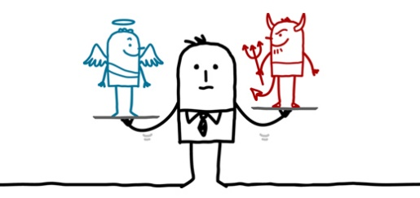
Ethical and cultural issues
There are several laws that govern the use of computer systems but ethics is about good practice and behaving in a morally correct way. Ethical actions are different from lawful actions. Sometimes actions can be legal; but are they also ethical?

The Computer Ethics Institute has written 10 commandments for computer scientists. Give an example of each below.

- Thou shalt not use a computer to harm other people.
- Thou shalt not interfere with other people's computer work.
- Thou shalt not snoop around in other people's computer files.
- Thou shalt not use a computer to steal.
- Thou shalt not use a computer to bear false witness.
- Thou shalt not copy or use proprietary software for which you have not paid (without permission).
- Thou shalt not use other people's computer resources without authorization or proper compensation.
- Thou shalt not appropriate other people's intellectual output.
- Thou shalt think about the social consequences of the program you are writing or the system you are designing.
- Thou shalt always use a computer in ways that ensure consideration and respect for your fellow humans.
These commandments stress that a computer scientist must always consider how their work can affect other people.
Task
Look at the examples of some ethical and cultural issues below. Using your knowledge of stakeholders and computer ethics, explain how these issues are often seen as controversial.

Surveillance

Censorship

Privacy on the internet

Employment

Use of Social Media

Artificial Intelligence

Digital Divide
A society which is dependent on technology can create inequality. The gap between those who have access to the latest technology and those who do not is called the “digital divide”. The digital divide is a global issue as well as a national issue.
Task
Using the space below, describe some of the main causes of a “digital divide”.

Environmental Issues
The technologies we use every day consume a lot of resources and power and can present environmental hazards. For instance, a smartphone – it’s made up of materials that have been mined from the earth. When it’s used it consumes a fair amount of energy and when its finished with it will often end up on a landfill site.
Energy Consumption
E-Waste
Positive impacts of technology on the Environment

Legal Issues
As computers became increasingly widespread, new laws were needed to protect individuals and organisations from harm. Relevant examples of legislation include:
- The Data Protection Act 1998
- The Computer Misuse Act 1990
- Freedom of Information Act 2000
- Copyright, Designs and Patents Act 1988
- Creative Commons Licensing

The Data Protection Act 1998
Many companies collect personal data which they use for their business. Some of this data is vital to the day to day running of these organisations. Give examples below of data that could be stored by business / organisations.

Personal Data

The Data Protection Act was introduced to protect this personal data. It tells organisations which collect and store this information exactly how they can and can’t use it. It also gives people, whose data is stored, certain rights when it comes to accessing and changing the information. Below are two terms you will need to understand.
Data Subject:
Data Controller:
Organisations are required to adhere to the eight principles of the DPA. These specify that personal data must be:
The 8 principles are:
Description
1
2
3
4
5
6
7
8

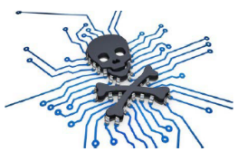
The Computer Misuse Act 1990
This law was brought in to counteract hacking and cyber-crime. There are three levels of offence to this law.

How do you think the following people broken the laws in the Computer Misuse Act?

A WPC used police national computer to access electoral rolls and car registration records in attempts to track down woman who had an affair with her boyfriend.
A disgruntled IT supplier hacked estate agency website and replaced pictures of houses with inappropriate images.
An employee who is about to made redundant finds the Managing Director’s password; logs into the
computer system using this and looks at some confidential files.

Freedom of Information Act
The Freedom of Information Act was set up to end a culture of secrecy in government. Before its introduction, the UK had no laws which gave people the right to know about the activities of public authorities.
Describe how the Freedom of Information Act works and give an example of when it was used

Copyright, Designs and Patents Act
This law gives the creators of some types of media rights to control how they're used and distributed. Music, books, video and software can all be covered by copyright law. Computer scientists, artists, authors, photographers and musicians earn their money by charging people to access/use their work. They own the copyright to their work – no one else can use it without paying for it or asking their permission first. Sometimes people try and copy this work by downloading music illegally for free or scanning books. This is both illegal and unethical. The increase in technology has made piracy far easier than before.
When you buy software, for example, copyright law forbids you from:
- Giving a copy to a friend
- Making a copy and then selling it
- Using the software on a network (unless the licence allows it)
- Renting the software without the permission of the copyright holder
Explain the different types of software licence below
Single User Licence
Multi-user Licence
Site Licence
Can you find any examples of copyright infringement on the internet?

Creative Commons Licensing
Creative Commons (CC) licences make it easier and legal to share data online.
CC licences help copyright owners share their work while keeping the copyright. They allow the copyright owner to say exactly what other people can do with it. For example, a CC licence might say that other people can copy and distribute the copyright owner's work if they give them credit.
There are several CC licences. The four licences below are most commonly used.
Licence | Description

Proprietary and Open Source Software
All software development takes time and expertise, but there are many models for funding software development, and different models of ownership. There are two categories of software that you must understand.
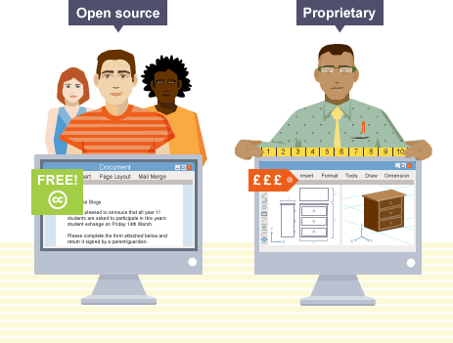
Proprietary Software
Advantages | Disadvantages

Open Source Software
Advantages | Disadvantages

