GCSE PHYSICS Name:
Particle model of matter – Trilogy
Complete the questions by typing in the answer boxes, which will expand as necessary.
Then fill in the self-assessment form as fully as you can to help you reflect on your work.
1.0 A teacher uses a tray filled with table tennis balls to model how particles are arranged in materials, as shown in Figure 1.
Figure 1
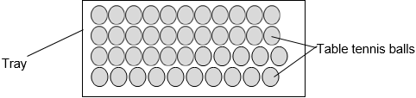
1.1 Initially the balls are arranged in a regular pattern as shown in Figure 1.
Which state of matter is best represented by the balls in Figure 1?
[1 mark]
Put an X in one box only.
solid

liquid

gas

1.2 The teacher then moves the tray from side to side so that the table tennis balls are no longer in a regular pattern.
Which state of matter is now best represented by the balls?
[1 mark]
Put an X in one box only.
solid

liquid

gas

1.3 The teacher next performs another demonstration by moving the tray more vigorously so that some of the balls jump out of the tray.
The teacher tells the students that the balls that have left the tray represent gas particles.
Which two processes could this demonstration represent?
[2 marks]
Put an X in two boxes.
boiling

condensing

evaporation

freezing

melting

1.4 Gases can be at different temperatures.
[1 mark]
Put an X in one box only.

The temperature of a gas is related to…
the average size of the particles

the average mass of the particles

the average kinetic energy of the particles

1.5 Figure 2 shows some of the gas particles in a balloon.
Figure 2
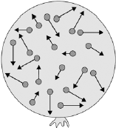
Describe the movement of the gas particles inside the balloon.
[2 marks]

1.6 The gas in the balloon has a mass of 0.032 kg.
The balloon has a volume of 0.025 m³.
Calculate the density of the gas in the balloon.
[2 marks]

Density of gas = kg/m³

2.0 Figure 3 shows a fridge with a freezer compartment.
Figure 3
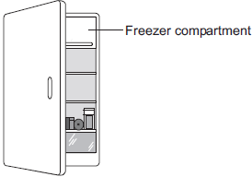
2.1 Energy is transferred to cool food when it is placed in the fridge.
Complete the sentence to describe how energy is transferred to cool the food.
[2 marks]

food fridge surroundings

Energy is transferred from the

to the

This energy is then transferred to the .

2.2 The fridge and freezer compartment contain water in three different states.
Use your knowledge of the particle model to explain the differences in how the particles are arranged in solids, liquids and gases
Include in your answer any differences in how the particles move in each state of matter.
[6 marks]

2.3 The temperature of the air inside the freezer compartment is –5 °C.
The temperature of the air inside the fridge is 5 °C
Explain why the particles in the freezer compartment move at a different speed than those in the main part of the fridge.
[2 marks]

3.0 A student used the apparatus in Figure 4 to compare the specific heat capacities of different metals.
Figure 4
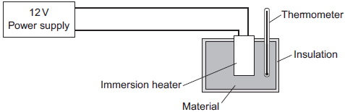
The student measured the time taken to increase the temperature of each material by 10 °C.
Figure 5 shows the student’s results.
Figure 5
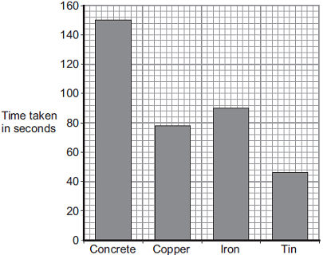
Material

3.1 The student makes the following conclusion;
‘The specific heat capacity of concrete is five times greater than tin.’
Use data from the bar chart to decide if the student’s conclusion is correct.
[2 marks]

3.2 The iron block had a mass of 1.023 kg.
The specific heat capacity of iron is 450 J / kg °C.
Calculate the energy transferred by the heater to increase the temperature of the iron block by 10 °C.
Use the correct equation from the physics equation sheet.
Give your answer to two significant figures.
[3 marks]

Energy transferred = J

The student used the same apparatus to heat a 1 kg block of aluminium.
He recorded the temperature of the block as it was heated from room temperature.
The results are shown in Figure 6.
Figure 6
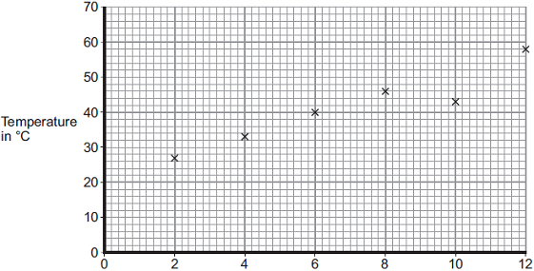
Time the immersion heater is switched on for in minutes

3.3 After how many minutes did the student record the incorrect temperature?
[1 mark]

Time = minutes

3.4 Draw the line of best fit for the points plotted in Figure 6.
[1 mark]

3.5 What was the temperature of the room?
[1 mark]

Temperature °C

3.6 Another student suggested repeating the experiment using a heater with a greater power.
Explain what effect this would have on the gradient of the graph the student drew.
[3 marks]

Feedback Form Instructions
When you have answered as many questions as you can, complete the form on the last page to help you reflect on your work.
How to fill in the form
1 Put your confidence score in Column C. This is not about the number of marks you achieved but how sure you felt while you were answering the question.

Confidence | Definition
0 | I didn’t answer this one
1 | I guessed the answer
2 | I needed help with the answer
3 | I understood the question but wasn’t sure about my answer
4 | I was fairly confident I would get most of the marks
5 | I was sure my answer was correct and I would get full marks
2 Use the mark scheme to check your answers.
Put the mark you think you achieved in Column Mark.
3 Write an overall comment about how you felt each question went.
- If you got help, make a note in the comment box specifying the source: internet,
friend, book, parent or tutor.
4 Complete ‘I can…’ and ‘I need to…’ sentences.
- ‘I can…’ sentences might include the questions you found easiest to answer, got the most marks for or felt the most confident about.
- ‘I need to…’ sentences might include areas you need to revise, questions you want to ask your teacher or the next topic or skill you want to work on.
5 Return the form to your teacher.

Particle model of matter – Trilogy
Feedback form Name

Qu | Total marks | Self-assessment
 |  | C | Mark | Comment
1 | 9
2 | 10
3 | 11
Overall
I can ……

I need to …….

Qu | Total marks | Teacher review
 |  | Mark | Comment
1 | 9
2 | 10
3 | 11
Overall
You can ……

You need to …….

