Name: |  | Target Stage:
LO2 – Financial Viability
DNA – Pick a business from the list. What costs the business money?

2.1 – Costs
Write a definition of costs.
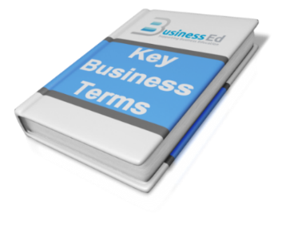

Types of Costs
Fixed |  | Examples:
Variable |  | Examples:
Total |  | Formula:

Sir Ramics
Working Out:
Fixed Costs: | Variable Costs: | Total Costs:
Chochoholics
Working Out:
Fixed Costs: | Variable Costs: | Total Costs:
Fix Me Car
Working Out:
Fixed Costs: | Variable Costs: | Total Costs:

2.2 Revenue
What is revenue?

What is the formula to calculate revenue?

Calculate the revenue for the following items.
Calculation | Revenue
Sir Ramics:

2.4 – Profit
What is profit?

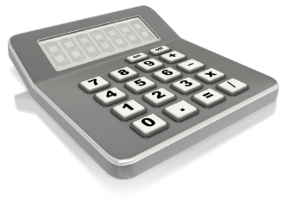
Profit Formula

Calculations | Profit
Sir Ramics:

