Q1. (a) The diagram shows the forces acting on a parachutist in free fall.
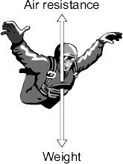
The parachutist has a mass of 75 kg. Calculate the weight of the parachutist. Gravitational field strength= 10N/Kg. Show clearly how you work out your answer and give the unit.
___________________________________________________________________
___________________________________________________________________
Weight = __________________________
(3)
(c) A student wrote the following hypothesis.
‘The larger the area of a parachute, the slower a parachutist falls.’
To test this hypothesis the student made three model parachutes, A, B and C, from one large plastic bag. The student dropped each parachute from the same height and timed how long each parachute took to fall to the ground.
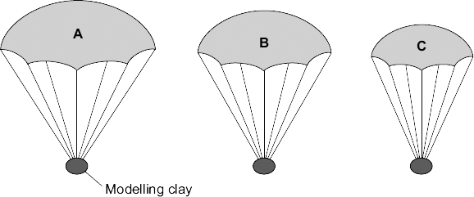
(i) The height that the student dropped the parachute from was a control variable. Name one other control variable in this experiment.
______________________________________________________________
(1)
(ii) Use the student’s hypothesis to predict which parachute, A, B or C, will hit the ground first.
Write your answer in the box. Give a reason for your answer.
______________________________________________________________
______________________________________________________________
______________________________________________________________(2)
Q2. (a) The diagram shows a steel ball-bearing falling through a tube of oil. The forces, L and M, act on the ball-bearing.
What causes force L?
___________________________________________________________________
(1)
(b) The distance – time graph represents the motion of the ball-bearing as it falls through the oil.
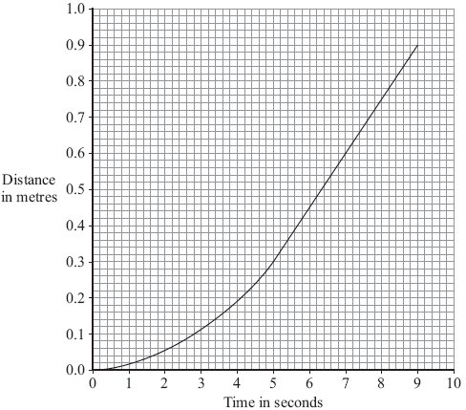
(i) Explain, in terms of the forces, L and M, why the ball-bearing accelerates at first but then falls at constant speed.
______________________________________________________________
______________________________________________________________
______________________________________________________________
______________________________________________________________
______________________________________________________________
______________________________________________________________
(3)
(ii) What name is given to the constant speed reached by the falling ball-bearing?
______________________________________________________________
(1)
(iii) Calculate the constant speed reached by the ball-bearing.
Show clearly how you use the graph to work out your answer.
______________________________________________________________
______________________________________________________________
______________________________________________________________
Speed = ______________________________ m/s
(2)
(Total 7 marks)

Mark schemes
Q1.
(a) 750
allow 1 mark for correct substitution, ie 75 × 10 provided no subsequent step shown
2
newton(s) / N
do not accept n
1
(b) Marks awarded for this answer will be determined by the Quality of Written Communication (QWC) as well as the standard of the scientific response.
Examiners should also refer to the Marking Guidance, and apply a ‘best-fit’
approach to the marking.
0 marks
No relevant content.
Level 1 (1-2 marks)
There is a brief attempt to explain why the velocity /
speed of the parachutist changes.
or
the effect of opening the parachute on velocity/speed is given.
Level 2 (3-4 marks)
The change in velocity / speed is clearly explained in terms of force(s)
or
a reasoned argument for the open parachute producing a lower speed.
Level 3 (5-6 marks)
There is a clear and detailed explanation as to why the parachutist
reaches terminal velocity
and
a reasoned argument for the open parachute producing a lower speed
examples of the physics points made in the response to explain
first terminal velocity
• on leaving the plane the only force acting is weight (downwards)
accept gravity for weight throughout
• as parachutist falls air resistance acts (upwards)
accept drag / friction for air resistance
• weight greater than air resistance
or
resultant force downwards
• (resultant force downwards) so parachutist accelerates
• as velocity / speed increases so does air resistance
• terminal velocity reached when air resistance = weight
accept terminal velocity reached when forces are balanced
to explain second lower terminal velocity
• opening parachute increases surface area
• opening parachute increases air resistance
• air resistance is greater than weight
• resultant force acts upwards / opposite direction to motion
• parachutist decelerates / slows down
• the lower velocity means a reduced air resistance
air resistance and weight become equal but at a lower (terminal) velocity
6
(c) (i) any one from:
• mass of the (modelling) clay
accept size/shape of clay size/amount/volume/shape of clay
accept plasticine for (modelling)clay
• material parachute made from
accept same (plastic) bag
• number / length of strings
1
(ii) C
reason only scores if C is chosen
1
smallest (area) so falls fastest (so taking least time)
accept quickest/quicker for fastest
if A is chosen with the reason given as ‘the largest area so falls slowest’ this gains 1 mark
1
[12]
Q2.
(a) gravity
accept weight
do not accept mass
accept gravitational pull
1
(b) (i) Initially force L greater than force M
accept there is a resultant force downwards
1
(as speed increases) force M increases
accept the resultant force decreases
1
when M = L, (speed is constant)
accept resultant force is 0
accept gravity/weighty for L
accept drag/ upthrust/resistance/friction for M
do not accept air resistance for M but penalise only once
1
(ii) terminal velocity
1
(iii) 0.15
accept an answer between 0.14 – 0.16
an answer of 0.1 gains no credit
allow 1 mark for showing correct use of the graph
2
[7]

