Questions
Q1.
Evaluate the use of visual and verbal guidance to improve sports performance with a group of beginners in badminton.
.............................................................................................................................................
.............................................................................................................................................
.............................................................................................................................................
.............................................................................................................................................
.............................................................................................................................................
.............................................................................................................................................
.............................................................................................................................................
.............................................................................................................................................
.............................................................................................................................................
.............................................................................................................................................
.............................................................................................................................................
.............................................................................................................................................
.............................................................................................................................................
.............................................................................................................................................
.............................................................................................................................................
.............................................................................................................................................
.............................................................................................................................................
.............................................................................................................................................
.............................................................................................................................................
.............................................................................................................................................
.............................................................................................................................................
.............................................................................................................................................

(Total for question = 9 marks)

Q2.
Figure 7 shows Paula running in a marathon.
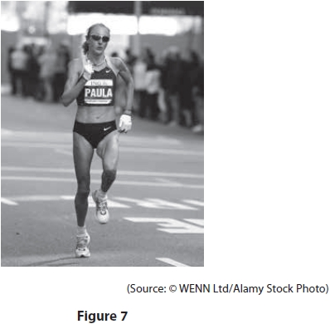
Explain how carbohydrate loading could improve an athlete's performance in this long distance event.
(4)
.............................................................................................................................................
.............................................................................................................................................
.............................................................................................................................................
.............................................................................................................................................
.............................................................................................................................................
.............................................................................................................................................
.............................................................................................................................................
.............................................................................................................................................
.............................................................................................................................................
.............................................................................................................................................
.............................................................................................................................................

(Total for question = 4 marks)

Q3.
One emotional health benefit of taking part in regular physical activity is that it can make you feel good.
(a) Identify one other emotional health benefit of regular participation in physical activity.
(1)
.............................................................................................................................................
.............................................................................................................................................
Regular participation in physical activity can also give physical health benefits.
(b) Give one example of a physical health benefit of regular participation in physical activity.
(1)
.............................................................................................................................................
.............................................................................................................................................

(Total for question = 2 marks)

Q4.
In 2013–14 it was reported that '58% of adults do not play sport'.
Two factors that can influence participation rates are socio-economic group and ethnicity.
(a) State two other personal factors that can influence participation rates.
(2)
1
.............................................................................................................................................
.............................................................................................................................................
2
.............................................................................................................................................
.............................................................................................................................................
(b) Explain two reasons why an individual's socio-economic group could influence their participation in sport.
(4)
1
.............................................................................................................................................
.............................................................................................................................................
.............................................................................................................................................
.............................................................................................................................................
2
.............................................................................................................................................
.............................................................................................................................................
.............................................................................................................................................
.............................................................................................................................................

(Total for question = 6 marks)

Q5.
During a football match, a footballer may display gamesmanship or sportsmanship.
(a) Describe the difference between gamesmanship and sportsmanship.
(2)
.............................................................................................................................................
.............................................................................................................................................
.............................................................................................................................................
.............................................................................................................................................
.............................................................................................................................................
.............................................................................................................................................
(b) Assess the importance of elite performers demonstrating sportsmanship in high-profile sports, such as football.
(3)
.............................................................................................................................................
.............................................................................................................................................
.............................................................................................................................................
.............................................................................................................................................
.............................................................................................................................................
.............................................................................................................................................

(Total for question = 5 marks)

Mark Scheme
Q1.
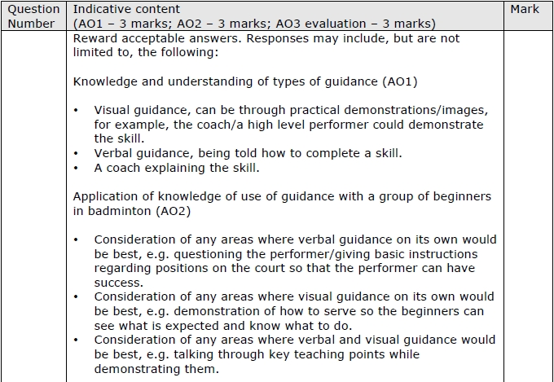
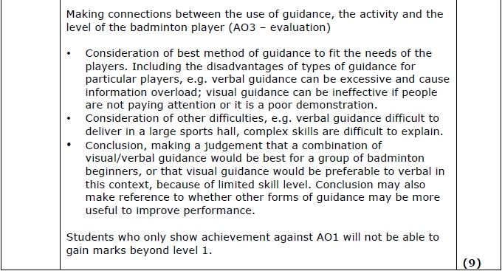
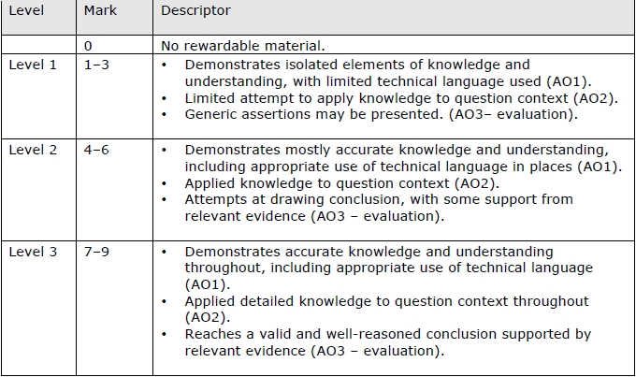

Q2.
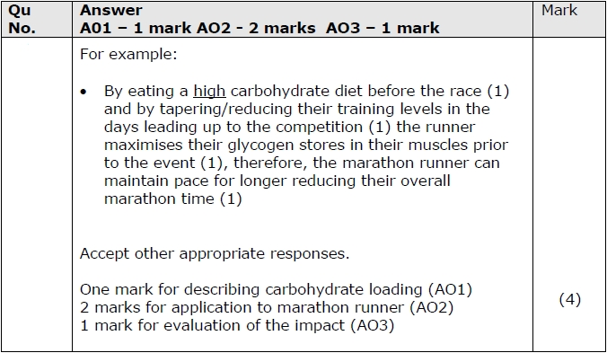

Q3.
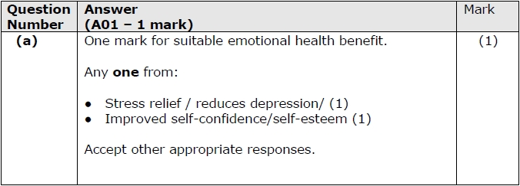
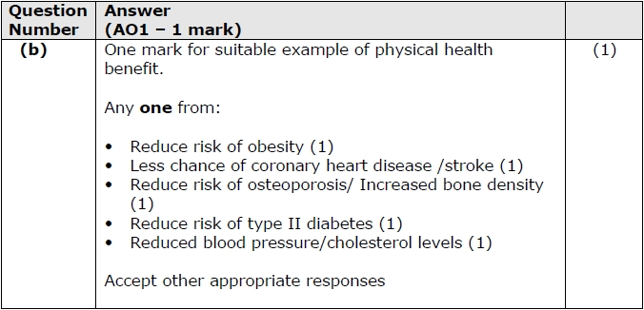

Q4.
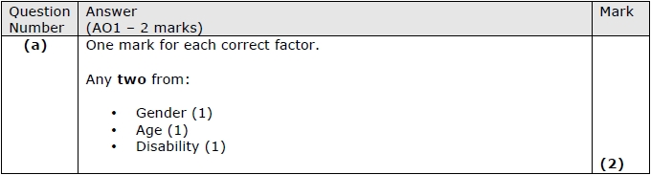
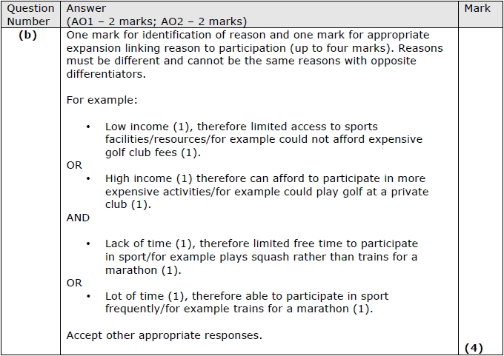

Q5.
