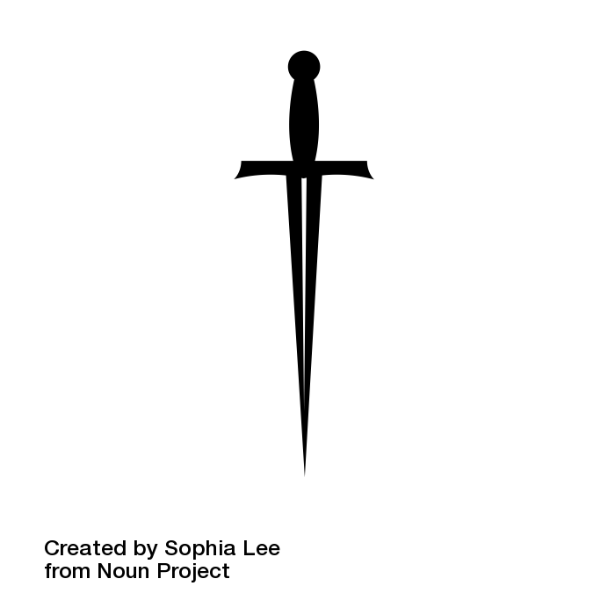

**Macbeth**

GCSE English Literature

Remote Learning Booklet

**Name:**

**Class:**

**Teacher:**

*In the event of school closure, work through the activities in this booklet for 60 minutes during each timetabled slot for English. If you are unsure how to complete an activity, email your teacher who will do their best to assist you. If you do not have access to email, move on to the next activity in the booklet.*

MACBETH

*The following activities are designed around retrieval practice. This means they focus on content already taught. Do your best to answer the questions without looking at your notes or the text. Answers for some of the activities can be found at the back of this booklet so you can mark your answers once you have finished. Be sure to revise anything you got wrong when reviewing your learning.*

|  |
| --- |
| **Activity 1: Retrieval Grid** |

*Consider the following questions in the retrieval grid and answer them in the blank grid below. Consider the amount of points each question is worth. The higher the amount of points, the longer ago we studied the content. Attempt to answer in as much detail as possible.*

|  |  |  |  |
| --- | --- | --- | --- |
| **What becomes of Lady Macbeth at the end of the play?** | **Who leads the attack against Macbeth’s castle near the end of the play?** | **Why do Macbeth and Lady Macbeth continually ask for darkness throughout the play?** | **How is Duncan’s blood and skin described by Macbeth upon ‘discovery’ of the king’s body?** |
| **What are the prophecies given to Macbeth and Banquo?** | **Who does the Porter imagine is knocking on the castle gates, or hell-gate’?** | **Why does Macbeth kill Macduff’s children and what is the correct term for this?** | **What becomes of Macbeth at the end of the play?** |
| **What are ‘hands’ symbolic of in the play?** | **What does Lady Macbeth have by her side as she sleepwalks and why is this significant?** | **How is Macbeth described by the Captain in his report and why is he described in this way?** | **What does the term ‘hamartia’ mean and what is Macbeth’s?** |

|  |  |  |  |
| --- | --- | --- | --- |
| **One Point** | **Two Points** | **Three Points** | **Four Points** |

|  |  |  |  |
| --- | --- | --- | --- |
|  |  |  |  |
|  |  |  |  |
|  |  |  |  |

*Turn to the answers section of the booklet at the back and mark your answers. If your answer differs to the ones printed in the booklet, it is not necessarily incorrect but what is printed in the booklet is what I would expect you to have considered. Add in any missing gaps in knowledge in a different colour pen so you know what the focus of your revision should be. Once you have marked your answers, move on to the next activity.*

|  |
| --- |
| **Activity 2: Picture Prompts** |

*Consider the following icons. Explain how each image is connected to Shakespeare’s ‘Macbeth’. Try and do this from memory. If you need to look at your notes or a copy of the play to add a note, write it in a different colour so you can see the missing gaps in your knowledge. Try not to just repeat the plot. Think about what Shakespeare is saying about each idea and why he is saying it.*

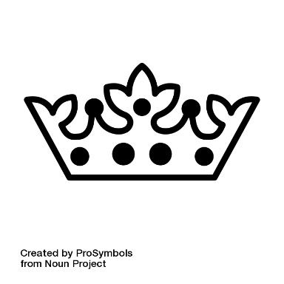







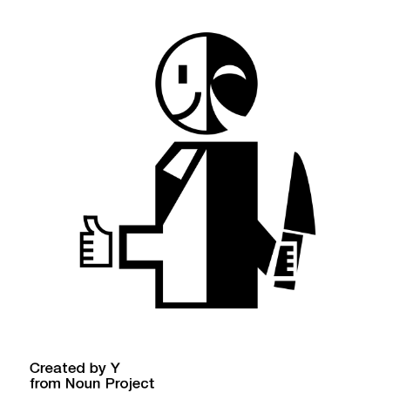

*Now look at the answers section in the back of the booklet. If what you have added does not appear, it does not mean that it is incorrect. The answers simply detail the basic knowledge I would expect you to add.*

|  |
| --- |
| **Activity 3: Word Challenge Grid** |

*Below are two grids containing a selection of random words. Connect each of the words to ‘Macbeth’, explaining how they link to the plot, characters or themes of Shakespeare’s play. The words have been selected at random so some may be a challenge but ensure you give it a go. There are multiple links that could be made so there are no answers in the back of the booklet for this activity. One has been done for you so you can see what I am expecting. There are no specific answers I am looking for here, so be creative with your links!*

|  |  |  |
| --- | --- | --- |
| **hope** | **challenge** | **history** |
| **walls** | **money** | **sound** |
| **fear** | **colour** | **silence** |

The Macbeths desire silence when they commit regicide. The slightest noise worries them. Not only is Shakespeare building tension here but the quiet only makes the knocking on the castle gates louder when it eventually occurs, a symbol that Macbeth’s fate is out to get him and will not be silenced.

|  |  |  |
| --- | --- | --- |
| **food** | **books** | **talk** |
| **divide** | **liberty** | **lost** |
| **unknown** | **illuminate** | **plans** |

|  |
| --- |
| **Activity 4: Quotation Retrieval** |

*The grid below contains a selection of quotations with words missing. Fill in the missing gaps in each quotation with the correct words and complete the rest of the grid with information on who says the quotation and what it tells us about each character. One has been completed for you. Check your work with the answers at the back of the booklet and correct any mistakes you have made in a different colour.*

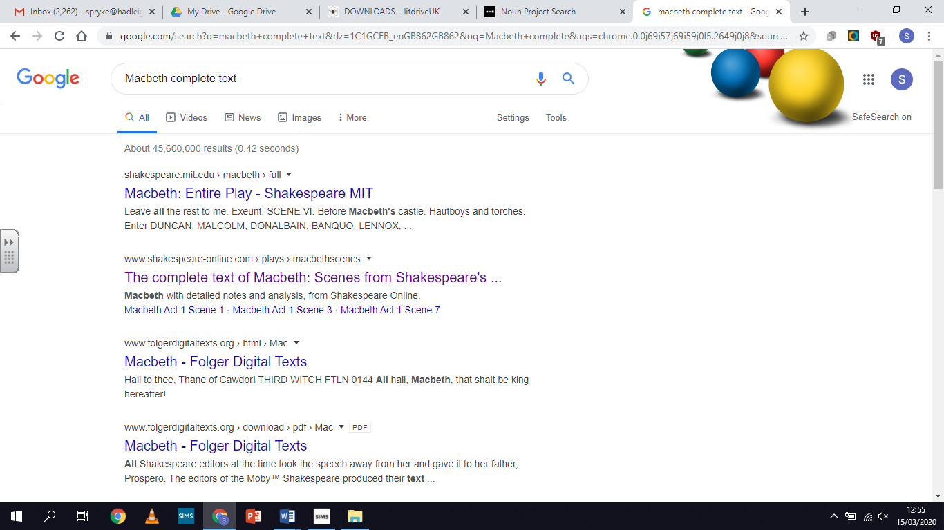*If you cannot remember a quotation, try and find it in your script before looking at the answers. Haven’t got a script? Find it on Google!*

|  |  |  |
| --- | --- | --- |
| **Quotation** | **Who says it?** | **What does this tell us about their character?** |
| foul  Fair  **‘___________ is __________ and foul is _____________.’**  fair | The Witches | The witches are used at the beginning of the play to show that things are not as they see. The dualism in this statement shows appearance is not always reality. |
| **‘Stars ___________ your ____________, let not _____________ see my black and ___________ desires.’** |  |  |
| **‘I do _______ thy nature, It is too full o’th’ ________________ of human ____________.’** |  |  |
| **‘The raven himself is _____________ that croaks the fatal _________________ of Duncan under my battlements.’** |  |  |
| **‘I have no _____________ to prick the sides of my __________, but only vaulting _______________.’** |  |  |
| **‘Is this a ______________ which I see before me.’** |  |  |

|  |  |  |
| --- | --- | --- |
| **‘I fear thou play’dst most ___________ for’t.’** |  |  |
| **‘We have ______________ the snake, not killed it.’** |  |  |
| **‘Thou canst not __________ I did it. Never __________ thy ___________ locks at me.’** |  |  |
| **‘__________ damned ___________.’** |  |  |
| **‘Tomorrow and _____________ and _____________, creeps in this petty pace from _____________ to ______________.’** |  |  |
| **‘This dead __________ and his ______________ queen.’** |  |  |

*Now mark your answers at the back of the booklet. Add in any missing gaps in your knowledge in a different colour pen and focus your revision on what you got incorrect.*

*The following activities are designed around academic reading. This means you will be given an article to read and answer questions on. These articles have been selected because they will aid your understanding of Shakespeare’s play and the big ideas he explores. There are no answers at the back of the booklet for this section so do your best. If you need any assistance, email your teacher and if you have no access to email, do what you can and then move on to the next activity.*

|  |
| --- |
| **Activity 5: Pre-Reading Activities** |



*This section of the booklet will focus on extracts from ‘Conjuring Darkness in Macbeth’, an article that can be found on the British Library website. Before you read the extracts, complete the following pre-reading activities to help you understand what the article. Answer in full sentences. If you would like to access the full article, you can find it here:* <https://www.bl.uk/shakespeare/articles/conjuring-darkness-in-macbeth>

**Pre-Reading questions**

1. **The British Library have filed this article under the following categories. Make notes around each category which explain how they link to ‘Macbeth’.**

**TRAGEDIES LANGUAGE**

1. **The summary for the article reads as:**

**Much of Macbeth is set at night, yet its first performances took place in the open air, during daylight hours. John Mullan explores how Shakespeare uses speech and action to conjure the play's sense of growing darkness.**

**What does the word ‘conjure’ mean? ____________________________________________________**

**What does the word ‘action’ mean in this context? _________________________________________**

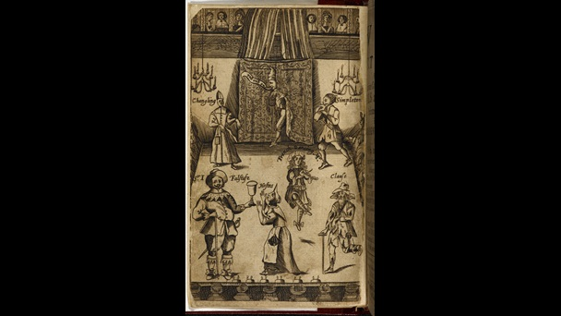**This picture shows a chandelier above the stage of a 17th century playhouse. Using the picture and the summary above, predict what ideas you think the article is going to explore:**

**I think this article** ________________________________________________ __________________________________________________________________ __________________________________________________________________ __________________________________________________________________

|  |
| --- |
| **Activity 6: Guided Reading** |

*Read the article. Highlight two sentences in each paragraph which you deem to be the most important. Down the left-hand side, add a title for each paragraph. On the right-hand side, summarise what each paragraph is saying in two or three bullet points. This follows the guided reading strategy we have used in class. One has been done for you so you can see what your work should look like.*

**Paragraph Titles**

**Bullet Point Paragraph Summary**

**Conjuring Darkness in Macbeth – Part 1**

It is strange to think that [Macbeth](https://www.bl.uk/works/macbeth) was almost certainly written for, and first performed at, the open-air Globe Theatre, where plays were staged in daylight. ‘Light thickens, and the crow / Makes wing to th’ rooky wood’ (3.2.50–51), says Macbeth – but the actor first speaking these words did so in the bright light of day. The palpable gathering of darkness that the speaker describes and welcomes had to be imagined by Shakespeare’s audience. We know for certain that Macbeth was performed in daylight at the Globe, for the astrologer Simon Forman records seeing it performed there in 1610. It had first been staged in 1606. Even if it were later performed at the indoor theatre at Blackfriars, where plays were illuminated by candlelight and where darkness was obtainable, this theatre was not available to Shakespeare’s company until 1608–09. It seems clear, then, that Shakespeare conceived it as a play where darkness had to be theatrically conjured rather than literally provided.

In modern times, productions of the play have given directors opportunities for many a special theatrical effect that has depended on alternations of darkness and concentrated light. Yet the original play, by having to create these alternations in the imagination, powerfully merges literal and metaphorical darkness. Shakespeare did have some special effects to hand: Macbeth begins with ‘thunder and lightning’ and, in the performances at the Globe, this lightning might have been represented by flashes from fireworks, as was done with other plays of the period. But, for the most part, in the bright daylight of a Thameside afternoon, the darkness that seems to envelop the play had to be created by words and gestures.

Key scenes of the play are set at night, and even in many of the daytime scenes characters are aware of the fading of the light. The Witches who open the play agree that they will meet Macbeth ‘ere the set of sun’ (1.1.5); Duncan arrives at Macbeth’s castle at evening (Act 1, Scene 6); the First Murderer, instructed by Macbeth to kill Banquo and Fleance, notes how ‘The west yet glimmers with some streaks of day’ (3.3.5). We often feel darkness coming, especially because both Macbeth and Lady Macbeth seem to invoke and invite it. They need darkness to do their worst.

On a stage crowded with Duncan and his thanes, Macbeth speaks in one of his asides that allow us to hear his unspoken thoughts. ‘Stars, hide your fires, / Let not light see my black and deep desires’ (1.4.50–51). This is the first reference to darkness in the play. He has just found out that he has become Thane of Cawdor, as prophesied by the Witches, and that Duncan is to visit his castle. The underside of the roof covering much of the stage of the Globe was decorated with painted stars, so Macbeth’s invocation is like a spell to darken the very space in which he stands. In the next scene, Lady Macbeth, excited by the tidings that the king is to come ‘tonight’ to her castle, brings on a kind of conjuration of darkness. ‘Come, thick night, / And pall thee in the dunnest smoke of hell’ (1.5.50–51). She has not heard her husband’s words as we have done, yet she seems to echo them with her wish that ‘heaven’ not ‘peep through the blanket of the dark / To cry, ‘Hold, hold!’’ (1.5.53–54)

Imagining darkness in daylight

-Performances were staged out in the open.

-Audiences had to imagine darkness on stage.

**Conjuring Darkness in Macbeth – Part 2**

Macbeth and Lady Macbeth separately call on darkness not just to assist their plans but to hide their deeds from ‘Heaven’ or their own consciences. ‘Let ... The eye wink at the hand’ (1.4.51–52), says Macbeth, as if the dark might hide his own action from himself. Later he echoes his wife’s when he talks to her of his planned murder of his friend Banquo, but in such way that she might remain ‘innocent of the knowledge’ of what he is about to do (3.2.45). ‘Come, seeling night, / Scarf up the tender eye of pitiful day,’ he continues. Seeling is a metaphor taken from hawking, where a hawk has its eyelids sewed shut in order to be trained. Macbeth looks forward to the darkness that will facilitate his murderous plans. But it is more than this. Day is ‘pitiful’, and in his ruthless actions Macbeth must escape pity. In his imagining, darkness is a psychological space, where scruple can be shed, compunction lost.

Audiences will be most aware of the gathering of darkness when Duncan comes to stay at Macbeth’s castle. What Lady Macbeth chillingly calls ‘This night’s great business’ (1.5.68) must happen in the dark. Servants carrying torches enter at Act 1, Scene 7 to signify that night has fallen. And it gets yet darker. At the opening of Act 2, Banquo’s son Fleance carries a torch when he enters with his father. It is after twelve and ‘The moon is down’ (2.1.2): it is pitch dark. With a brilliant touch, Shakespeare lets us hear how different characters make their own sense of the blackness. ‘There’s husbandry in heaven, / Their candles are all out’ (2.1.4–5), says Banquo, fancifully – and unconsciously reminds us of the obscuring of Heaven and starlight for which Macbeth and Lady Macbeth have wished.

Now, in this deep darkness, characters cannot see each other even by the light of torches. ‘Who’s there?’ asks Banquo as Macbeth enters with a torch-bearing servant (2.1.10). It is the same nervous exclamation as begins Shakespeare’s [Hamlet](http://www.bl.uk/works/hamlet), and as in the first scene of that play, which begins in darkness on the battlements of Elsinore, the audience at the Globe would have been able to see very clearly how the characters on stage were unable to see clearly. A little later, after Banquo has retired, Lady Macbeth enters and catches herself starting at the shriek of an owl, just before her husband comes to meet her. ‘Who’s there? What ho?’ (2.2.8) asks Macbeth, and at first she hardly seems to recognise him: ‘My husband!’ (2.2.13). Their dialogue creates a darkness in which sounds and apprehensions are amplified: ‘Didst thou not hear a noise?’ (2.2.14), ‘Did not you speak?’ (2.2.16). The terrible deed has been done and the darkness that made it possible concentrates their fears.

The discovery of Duncan’s murder is followed by an odd little scene, which must take place several days later, in which Ross and an Old Man discuss unnatural events that seem to have accompanied the killing. Shakespeare takes from his source story in Holinshed’s Chronicles the report that after Donwald murdered King Duff ‘For the space of six monenths together ... there appeered no sunne by day, nor moone by night in anie part of the realme’. In the wake of Duncan’s killing, darkness appears to have seeped from the night into the day. ‘By th’ clock ’tis day, / And yet dark night strangles the travelling lamp’ (2.4.6–7), observes Ross. Without any help from artificial lighting effects, we gain an impression of ‘night’s predominance’ (2.4.8), as he calls it.

**Paragraph Titles**

**Bullet Point Paragraph Summary**

**Bullet Point Paragraph Summary**

**Paragraph Titles**

**Conjuring Darkness in Macbeth – Part 3**

When we return to Macbeth he has been crowned king but fears Banquo and ‘his royalty of nature’ (3.1.49). He must again call darkness to his aid. Banquo tells him that he is riding out and will probably be ‘a borrower of the night / For a dark hour or twain’ (3.1.26–27) before he returns for Macbeth’s feast. Night will, of course, facilitate the arrangement of his murder, and when Macbeth instructs the two Murderers on their mission, he echoes Banquo’s own phrasing. Fleance, he tells the hired killers, must ‘embrace the fate / Of that dark hour’ (3.1.136–37). As so often in this play, darkness is simultaneously metaphorical and literal. The ‘dark hour’ is the time of killing – but also the lightless time when a trap can be sprung. When the Murderers attack Banquo, it is darkness that allows them to surprise him – but also that allows Fleance to escape. ‘Who did strike out the light?’ asks the Third Murderer (3.3.19). Darkness is not the friend to Macbeth that he believes. Fate is not his to command.

Darkness may seem to become Macbeth’s element, but his wife, once the prime mover of their plots, comes to dread it. Watching her sleepwalking, her Gentlewoman tells the Doctor that ‘she has light by her continually, ’tis her command’ (5.1.22). ‘Enter Lady with a Taper’ is the stage instruction in the First Folio, on which text all later editions are based. The taper, the smallest kind of candle, is Lady Macbeth’s safeguard against the powers of darkness. These were once the powers that she invoked, but now they crowd in on her. Once she called ‘Come, thick night, / And pall thee in the dunnest smoke of hell’ (1.5.50–51); now she feels and fears ‘Hell is murky’ (5.1.36). In her final scene before her death, Shakespeare shows how the horror of her deeds has possessed her, and does so by dramatising the most elemental and childlike of fears: fear of the dark.

**Summarise the article in one paragraph.**

|  |
| --- |
| **Activity 7: Post-Reading Questions** |

*Answer the following questions on the article above. Remember to answer in full sentences. If there is a question you are not sure about, email your teacher or miss it out and come back to it when you have finished the rest of the activities. If you need extra space, write on a difference piece of paper and attach it to this booklet once you have finished.*

1. **What were some of the special effects theatres employed to create thunder and lightning?**
2. **Why do Macbeth and Lady Macbeth ask for darkness at the beginning of the play?**
3. **Why do you think Macbeth describes day as ‘pitiful’ when he asks for darkness to come?**
4. **How does Shakespeare signify night has fallen before Duncan’s murder takes place?**
5. **The article states that ‘in the wake of Duncan’s killing, darkness appears to have seeped from the night into the day.’ What do you think this means and what is this symbolic of?**
6. **The article says, ‘The taper, the smallest kind of candle, is Lady Macbeth’s safeguard against the powers of darkness.’ Why do you think Lady Macbeth’s light is so small? What could this symbolise?**
7. **Characters come to ‘fear the dark’. What does this remind you of? What do you think Shakespeare is saying here?**

|  |
| --- |
| **Activity 8: Further Questions** |

*Answer the following questions on the article. These questions require shorter answers and can be answered as notes and brief annotations. If you need extra space, write on a different piece of paper and attach it to this booklet. If you need a copy of the script, you can find one online. Check your answers at the back of the booklet when you have finished.*

*Shakespeare did have some special effects to hand:*Macbeth*begins with ‘thunder and lightning’ and, in the performances at the Globe, this lightning might have been represented by flashes from fireworks, as was done with other plays of the period.*

1. **Why does Shakespeare open the play with thunder and lightning?**
2. **Why do the witches appear in thunder and lightning?**
3. **How does Shakespeare use speech in this scene to let the audience know what kind of weather the witches meet in?**

*We often feel darkness coming, especially because both Macbeth and Lady Macbeth seem to invoke and invite it. They need darkness to do their worst.*

1. **Retrieve a short quotation where Macbeth asks for darkness.**
2. **Retrieve a short quotation where Lady Macbeth asks for darkness.**
3. **What is darkness symbolic of?**

*Audiences will be most aware of the gathering of darkness when Duncan comes to stay at Macbeth’s castle. What Lady Macbeth chillingly calls ‘This night’s great business’ (1.5.68) must happen in the dark.*

1. **What does Duncan initially think of Macbeth’s castle when he first arrives. Retrieve a short quotation.**
2. **What does the Porter joke the castle has become in the scene after Duncan’s murder?**

*A little later, after Banquo has retired, Lady Macbeth enters and catches herself starting at the shriek of an owl, just before her husband comes to meet her. ‘Who’s there? What ho?’ (2.2.8) asks Macbeth, and at first she hardly seems to recognise him: ‘My husband!’ (2.2.13). Their dialogue creates a darkness in which sounds and apprehensions are amplified: ‘Didst thou not hear a noise?’ (2.2.14), ‘Did not you speak?’ (2.2.16). The terrible deed has been done and the darkness that made it possible concentrates their fears.*

1. **What kind of character is Banquo in the play?**
2. **Why are the Macbeths so afraid of noise?**
3. **Lady Macbeth only calls Macbeth by the name of ‘husband’ once in the play. Why do you think this is?**

*Darkness may seem to become Macbeth’s element, but his wife, once the prime mover of their plots, comes to dread it. Watching her sleepwalking, her Gentlewoman tells the Doctor that ‘she has light by her continually, ’tis her command’ (5.1.22). ‘*Enter Lady with a Taper*’ is the stage instruction in the First Folio, on which text all later editions are based. The taper, the smallest kind of candle, is Lady Macbeth’s safeguard against the powers of darkness.*

1. **Retrieve a short quotation which shows Lady Macbeth is scared of darkness.**
2. **What kind of character is Lady Macbeth at the end of the play?**

*The following activities are designed around exam questions. This means you will complete a series of small activities to help you answer an essay question like the one you will receive in your GCSE Literature paper. Use the notes from this booklet and a copy of the text to help you prepare.*

|  |
| --- |
| **Activity 9: Essay Preparation** |

*You will be answering the following question:*

Read the extract and answer the question that follows:

**DUNCAN**

My plenteous joys,  
Wanton in fulness, seek to hide themselves  
In drops of sorrow. Sons, kinsmen, thanes,  
And you whose places are the nearest, know  
We will establish our estate upon  
Our eldest, Malcolm, whom we name hereafter  
The Prince of Cumberland; which honour must  
Not unaccompanied invest him only,  
But signs of nobleness, like stars, shall shine  
On all deservers. From hence to Inverness,  
And bind us further to you.

**MACBETH**

The rest is labour, which is not used for you:  
I'll be myself the harbinger and make joyful  
The hearing of my wife with your approach;  
So humbly take my leave.

**DUNCAN**

My worthy Cawdor!

**MACBETH**

[Aside] The Prince of Cumberland! that is a step  
On which I must fall down, or else o'erleap,  
For in my way it lies. Stars, hide your fires;  
Let not light see my black and deep desires:  
The eye wink at the hand; yet let that be,  
Which the eye fears, when it is done, to see.

**Starting with this extract, explore how far Shakespeare presents Macbeth as an ambitious character.**

You could write about:

* how Shakespeare presents Macbeth as an ambitious character in the extract
* how Shakespeare presents Macbeth as an ambitious character in the play as a whole.

*Highlight and annotate the extract with initial ideas that jump out at you. What could you discuss from the extract in your answer?*

*Complete the following analytical verbs to help you explore Shakespeare’s authorial intent with Macbeth’s character. Authorial intent is when you explain* ***what*** *an author is doing and* ***why*** *they are doing it. The ‘why’ is extremely important and often missed out by students in their exams so that is what we are going to start with today. One has been done for you.*

**Shakespeare may be presenting Macbeth as an ambitious character:**

* **to warn audiences of the tragic consequences that could occur if one is blinded by their desires.**
* **to teach**
* **to reveal the importance of**
* **to criticise**
* **to advocate**

*Pick three of your sentences from above and rewrite them below. This time, extend your sentences with the connectives ‘because’, ‘but’ or ‘so’. Look at the example below to help you.*

**Shakespeare may be presenting Macbeth as an ambitious character to warn audiences of the tragic consequences that could occur if one is blinded by their desires so he traps his eponymous tragic hero in a cyclical nature of violence which eventually leads to his downfall.**

**1.**

**2.**

**3.**

*Pick one of the sentences above. Copy it out again. Extend it by using one analytical verb to lead in to a second analytical verb in order to explore more of Shakespeare’s authorial intent. Look at the example below to help you.*

**Shakespeare may be presenting Macbeth as an ambitious character to warn audiences of the tragic consequences that could occur if one is blinded by their desires, so he traps his eponymous tragic hero in a cyclical nature of violence which eventually leads to his downfall. By warning his audience about this, Shakespeare is also criticising ambitious people and the lengths they would go to in order to get what they want, a reference perhaps to the plotters who aimed to blow up Parliament in order to kill the king but failed.**

**1.**

*Write down five quotations you could use in your essay. They do not necessarily have to be spoken by Macbeth himself. One has been done for you to give you a sixth quotation.*

**‘We will proceed no further in this business.’**

1.

2.

3.

4.

5.

*Use your analytical verbs to quickly explain what Shakespeare is doing with each quotation. You do not need to write in full sentences as this is just a plan. Look at the example to help you.*

**Eg. ‘We will proceed no further in this business.’– revealing that even though Macbeth has had these thoughts, he is still wary of going ahead with the murder.**

1.

2.

3.

4.

5.

|  |
| --- |
| **Activity 10: I Do** |

*Identify the following in this example response which I have pre-prepared.*

* *Clear points at the beginning of each paragraph which relate to the question*
* *Embedded quotations*
* *Single word analysis*
* *Analytical verbs*
* *Authorial intent (what the writer is doing and why they are doing it.)*
* *Social/historical context*

*Pay close attention to how I am writing. You should aim to replicate this style of writing in your own answer.*

Macbeth’s ambitions are inextricably linked with violence; he needs to commit violent acts in order to achieve what he wants. Perhaps this is why he sees a dagger, which directs him to Duncan’s chambers. His ambition is making him see it. He even comments that ‘it is the bloody business’ which is causing him to hallucinate, suggesting Macbeth himself is aware that violence is the key to unlocking his ambition. Shakespeare may have used ‘bloody’ to warn audiences that if Macbeth does not change his ways, he will be stuck in a cyclical nature of violence which will never end, blindly leading him to his downfall. Through this warning, perhaps he wants his audiences to learn of the dangers of ambition and the trouble it can cause, cementing the play’s status as pro-royalist propaganda in the wake of the gunpowder plot, an attempt to end the persecution of Roman Catholics by the English government by killing the king. Macbeth’s ambitions are not too dissimilar to those of the failed plotters and the lesson is they learn is the same: actions have consequences and no-one can disrupt the Great Chain of Being.

|  |
| --- |
| **Activity 11: Exam Question** |

*Answer the following exam question. Use everything in this booklet to help you. If you need your copy of the text with you to help, you may use it but remember you will not have a copy in your real exam. Don’t forget to include the following:*

* *Clear points at the beginning of each paragraph which relate to the question*
* *Quotations*
* *Single word analysis (You could use your analytical verbs here too. Eg. ‘Shakespeare has Macbeth talk about ‘ambition’ to criticise…’)*
* *Authorial intent (what the writer is doing and why they are doing it.)*
* *Social/historical context*

*If you are unsure how to structure your essay, start with what Macbeth is like at the beginning of the play and explain how he develops. Remember, the question is asking ‘how far’ Shakespeare presents Macbeth as ambitious which means you need to make a decision and then use the essay to explain your thoughts. Is he very ambitious, partially ambitious or not ambitious at all? Why? Use the paragraph above to help you start if needed.*

**Starting with this extract, explore how far Shakespeare presents Macbeth as an ambitious character.**

_______________________________________________________________________________________________________________________________________________________________________________________________________________________________________________________________________________________________________________________________________________________________________________________________________________________________________________________________________________________________________________________________________________________________________________________________________________________________________________________________________________________________________________________________________________________________________________________________________________________________________________________________________________________________________________________________________________________________________________________________________________________________________________________________________________________________________________________________________________________________________________________________________________________________________________________________________________________________________________________________________________________________________________________________________________________________________________________________________________________________________________________________________________________________________________________________________________________________________________________________________________________________________________________________________________________________________________________________________________________________________________________________________________________________________________________________________________________________________________________________________________________________________________________________________________________________________________________________________________________________________________________________________________________________________________________________________________________________________________________________________________________________________________________________________________________________________________________________________________________________________________________________________________________________________________________________________________________________________________________________________________________________________________________________________________________________________________________________________________________________________________________________________________________________________________________________________________________________________________________________________________________________________________________________________________________________________________________________________________________________________________________________________________________________________________________________________________________________________________________________________________________________________________________________________________________________________________________________________________________________________________________________________________________________________________________________________________________________________________________________________________________________________________________

|  |
| --- |
| **‘Macbeth’ Answers** |

|  |
| --- |
| **Retrieval Grid** |

*Mark your answers to the following questions:*

|  |  |  |  |
| --- | --- | --- | --- |
| **What becomes of Lady Macbeth at the end of the play?** | **Who leads the attack against Macbeth’s castle near the end of the play?** | **Why do Macbeth and Lady Macbeth continually ask for darkness throughout the play?** | **How is Duncan’s blood and skin described by Macbeth upon ‘discovery’ of the king’s body?** |
| **What are the prophecies given to Macbeth and Banquo?** | **Who does the Porter imagine is knocking on the castle gates, or hell-gate’?** | **Why does Macbeth kill Macduff’s children and what is the correct term for this?** | **What becomes of Macbeth at the end of the play?** |
| **What are ‘hands’ symbolic of in the play?** | **What does Lady Macbeth have by her side as she sleepwalks and why is this significant?** | **How is Macbeth described by the Captain in his report and why is he described in this way?** | **What does the term ‘hamartia’ mean and what is Macbeth’s?** |

|  |  |  |  |
| --- | --- | --- | --- |
| **One Point** | **Two Points** | **Three Points** | **Four Points** |

|  |  |  |  |
| --- | --- | --- | --- |
| **Lady Macbeth ends her life after being driven mad by the guilt that consumes her.** | **Malcolm and Macduff lead the attack against Macbeth’s castle.** | **Macbeth and Lady Macbeth continually ask for darkness so that no one can see the evil acts they commit.** | **Duncan’s skin is described as ‘silver’ and his blood as ‘golden’, perhaps highlighting his royal, holy status.** |
| **Macbeth is told he will be Thane of Glamis (which he is already), Thane of Cawdor and King. Banquo is told he will not be king but that his children will be.** | **The Porter images a farmer who has hoarded his produce, an equivocator and a tailor are knocking on the gates of the castle.** | **Macbeth kills Macduff’s children after being told to beware Macduff. Macbeth slaughters Macbeth’s wife and children to ensure they are not a threat. The killing of children is called infanticide.** | **Macbeth is killed by Macduff.** |
| **Hands represent honourable and loyal actions at the beginning of the play yet as time progresses, they come to represent dishonesty and betrayal.** | **Lady Macbeth has a candle by her side. This is significant because she has spent the rest of the play asking for darkness to conceal her actions and now she is afraid of it.** | **Macbeth is described as ‘brave’. Shakespeare is setting up the audiences’ expectations so that it is all the more horrific when this loyal character betrays his king.** | **‘Hamartia’ is a fatal flaw in one’s character. Macbeth’s hamartia is his ambition.** |

|  |
| --- |
| **Activity 2: Picture Prompts** |

*Consider the basic knowledge I would have expected you to include and add any missing gaps in knowledge in a different colour pen.*

Macbeth is tempted with the idea of kingship. The crown offers him power and, in Macbeth’s view, invincible. Of course, this is incorrect. The crown could also link to the idea of the Divine Right of Kings, the idea that monarchs were chosen by God to be their spokesperson on earth. To commit regicide would have been the ultimate sin. An attack on the monarch was an attack on God.



Light and darkness is a common theme in the play. Macbeth and Lady Macbeth ask for darkness at the beginning of the play (‘stars hide your fires’/ ‘come thick night’) in order to hide their scheming actions. Darkness is symbolic of secrecy. By the end of the play, however, light is desired instead. Lady Macbeth holds a candle near here. She is afraid of darkness and its associations with guilt.



Violence becomes a cycle which is impossible to escape. The Captain confirms that Macbeth is capable of violent actions at the very beginning of the play. As soon as kills Duncan, however, Macbeth feels violence, which is celebrated at the beginning of the play, is the only way to consolidate and keep his power. Violence actions are committed through the play in a desperate attempt to hold on to power.



Macbeth’s fate is linked to the supernatural. The witches look to the future to see what will become of Macbeth and Banquo. Macbeth is very much taken which his prophecy and desires to see more. What could be seen as a positive thing, soon leads Macbeth to his downfall. Banquo’s ghost appears to hold Macbeth to account for his actions. Guilt takes on a supernatural form.





Duplicity (being two-faced) is a major theme in the play. Lady Macbeth often instructs Macbeth to look innocent whilst they plan the murder of Duncan. Shakespeare concerns himself with the idea of appearance vs reality. What things appear to be are not always reality.

|  |
| --- |
| **Quotation Retrieval** |

*Mark your answers for this exercise.*

|  |  |  |
| --- | --- | --- |
| **Quotation** | **Who says it?** | **What does this tell us about their character?** |
| foul  Fair  **‘___________ is __________ and foul is _____________.’**  fair | The Witches | The witches are used at the beginning of the play to show that things are not as they see. The dualism in this statement shows appearance is not always reality. |
| **‘Stars hide your fires, let not light see my black and deep desires.’** | Macbeth | Macbeth reveals his desires are ‘black’, implying he is already having murderous thoughts about killing his king. His ambition is beginning to stir within him and asks for darkness so he can make them a reality in secret. |
| **‘I do fear thy nature, It is too full o’th’ milk of human kindness.’** | Lady Macbeth | Lady Macbeth does not seem to have faith in her husband. She does not believe he will be able to go through any action that will make them king and queen quickly. Her doubts place her in a position of control. |
| **‘The raven himself is hoarse that croaks the fatal entrance of Duncan under my battlements.’** | Lady Macbeth | Lady Macbeth is certain Duncan will die in their castle. This quotation shows she is ambitious and will do anything to get what she wants. The use of ‘my’ shows she believes she is in control of the situation and Macbeth will follow her lead. |
| **‘I have no spur to prick the sides of my intent, but only vaulting ambition.’** | Macbeth | Macbeth realises there is no other reason for him to kill the king besides his ambition and decides to proceed no further. This shows he can still be redeemed at this point because of his reluctance to kill Duncan. |
| **‘Is this a dagger which I see before me.’** | Macbeth | Macbeth imagines the violence he will soon be committing. We begin to wonder if Macbeth is of sound mind but the fact the dagger disappears before he kills Duncan shows he is not mad and is in complete control of himself. |
| **‘I fear thou play’dst most foully for’t.’** | Banquo | Banquo, a loyal friend of Macbeth’s begins to have his doubts. He echoes the witches’ words ‘foul’. He has his suspicions and this makes him a threat to Macbeth. |
| **‘We have scorched the snake, not killed it.’** | Macbeth | Macbeth begins to fear for the security of his kingship. He is stumbling into a cycle of violence at this point in the play which he will find it difficult to escape from. |
| **‘Thou canst not say I did it. Never shake thy gory locks at me.’** | Macbeth | Macbeth’s guilt is beginning to consume him. Banquo’s ghost appears to him to hold him to account for his actions. His ghost terrifies Macbeth showing he is beginning to lose control of himself. Violence does not come without its consequences. |
| **‘Out damned spot.’** | Lady Macbeth | Lady Macbeth believes she has a spot of blood on her hand which she cannot scrub away, just like she cannot rid herself of her guilt. She has a light near her as she is afraid of the darkness which is also associated with guilt. Lady Macbeth’s fate has caught up with her and she becomes a weak and vulnerable character. |
| **‘Tomorrow and tomorrow and tomorrow, creeps in this petty pace from day to day.’** | Macbeth | Macbeth, although determined to fight on, seemingly questions the point of life upon hearing news of his wife’s death. He had lost all sense of right and wrong, all sense of purpose and has nothing left but to fight for what little he has. |
| **‘This dead butcher and his fiend-like queen.’** | Malcolm | Malcolm, Duncan’s son, describes Macbeth in this way. He believes Macbeth killed for no reason but for himself. Macbeth has left a legacy of blood and death and will be remembered for the tyrannical rule he imposed over Scotland. |

|  |
| --- |
| **Further Questions** |

*Mark your answers:*

1. **Why does Shakespeare open the play with thunder and lightning? To create an atmosphere of fear and terror. The weather could foreshadow the turbulent times Scotland will face throughout the play.**
2. **Why do the witches appear in thunder and lightning? Shakespeare has the witches appear in this weather to show they are characters to be feared; they are associated with supernatural imagery.**
3. **How does Shakespeare use speech in this scene to let the audience know what kind of weather the witches meet in? The witches ask when they will meet again, ‘in thunder, lightning or in rain.’**
4. **Retrieve a short quotation where Macbeth asks for darkness. ‘Stars hide your fires. Let not light see my black and deep desires.’**
5. **Retrieve a short quotation where Lady Macbeth asks for darkness. ‘Come thick night and pall thee in the dunnest smokes of hell.’**
6. **What is darkness symbolic of? Guilt, scheming, murderous thoughts, plots and machinations**
7. **What does Duncan initially think of Macbeth’s castle when he first arrives. Retrieve a short quotation. He likes the location of the castle. He says it ‘hath a pleasant seat.’**
8. **What does the Porter joke the castle has become in the scene after Duncan’s murder? He jokes that he is the porter of hell-gate, meaning the castle has become a metaphorical hell.**
9. **What kind of character is Banquo in the play? Noble, loyal, a trusted friend.**
10. **Why are the Macbeths so afraid of noise? The Macbeths worry that noise will lead to discovery of their secrets and plans.**
11. **Lady Macbeth only calls Macbeth by the name of ‘husband’ once in the play. Why do you think this is? Perhaps because she believes herself to be superior or to play on the fact that he has somewhat disappointed her with his reaction to Duncan’s murder.**
12. **Retrieve a short quotation which shows Lady Macbeth is scared of darkness. ‘She has light by her continually, ‘tis her command.’**
13. **What kind of character is Lady Macbeth at the end of the play? Weak, vulnerable, scared, like a child.**