Unit 6

Software
Software noun
a set of instructions or programs instructing a computer to do specific tasks. Software is a generic term used to describe computer programs. Scripts, applications, programs and a set of instructions are all terms often used to describe software.

NAME ________________________________________

CLASS _____________

Types of software

Without software to make them work, computer systems are just electronic circuits without instructions telling them what to do. Software is the reason we use a computer system. These are the programs that allow us to do something useful with our computer. Software is often divided into two categories:

System Software – designed to run and maintain a computer system. This includes device drivers, Operating Systems, and utility software (used to help the computer operate more efficiently).

Application Software – intended to perform a specific task. Examples of application software include office suites, games, database systems and educational software. Application software can be a single program or a collection of small programs.

Task - Complete the table by placing the examples in the correct categories below. (Higher – can you describe what they do too?)
System Software | Application Software

Windows 10 Anti-virus Microsoft Office Spotify

Google Chrome Firewall Clean up tools

Candy Crush Linux Adobe Photoshop HP Printer Driver

Android Notepad Skype

System Software
The purpose of systems software is to make the hardware (the physical components such as the CPU and Memory) as useful as possible. It is the layer between the hardware and applications software.
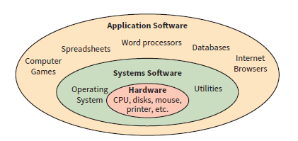
Task – Give a definition of the different types of system software below

Operating System
Device Drivers
Utility Software
Basic Input Output System (BIOS)

Operating Systems
The purpose of an operating system is to manage computer hardware and software resources and provide common services for computer programs.

Examples of OS

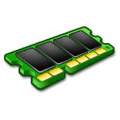
The Operating System (OS) allows the programs that run on the computer to interact with the different hardware in a consistent way. When you save a document to a disc, you don’t need to worry about whether it is a hard disc from one manufacturer or a solid-state drive from another. The way the data is written to these discs is different, but the OS hides these differences from the user and the programmer who wrote your application. There are many different operating systems in use today, but they all perform several key functions.
Memory Management
Processor Management / Multitasking
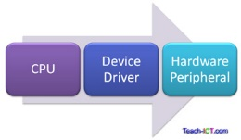

Peripheral Management / Drivers

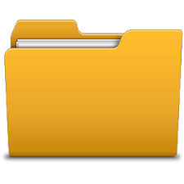
User Management / Account

File Management

User Interfaces
Users interact with the operating system through a user interface. This is the environment which allows the user to enter and receive information and gives the overall feel of the computer system. There are different types of user interface available to computers.
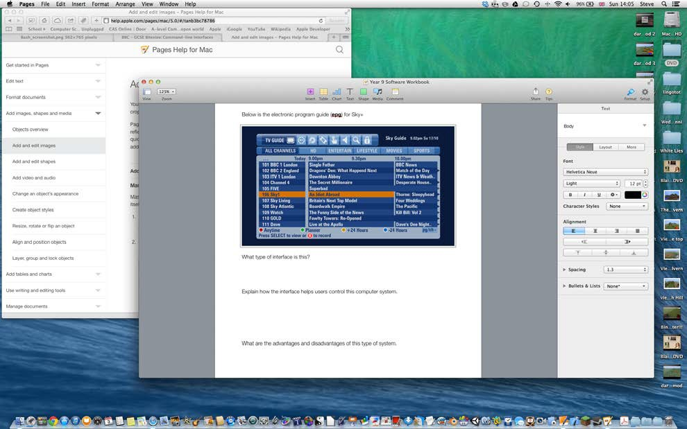

What type of interface is this?
Explain how the interface is used to control this computer system.
What are the advantages and disadvantages of this type of system.
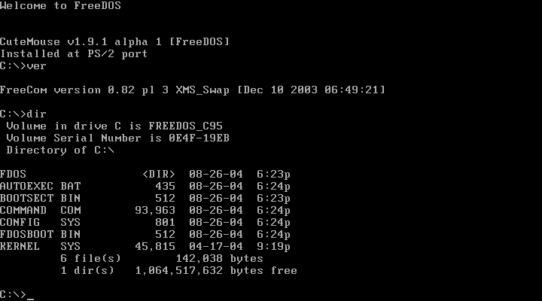

What type of interface is this?
Explain how the interface is used to control this computer system.
What are the advantages and disadvantages of this type of system.

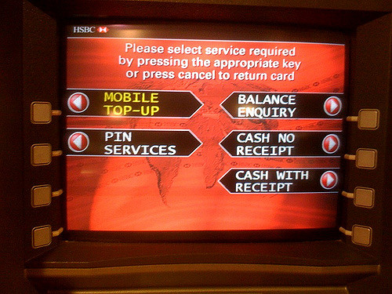

What type of interface is this?
Explain how the interface is used to control this computer system.
What are the advantages and disadvantages of this type of system.

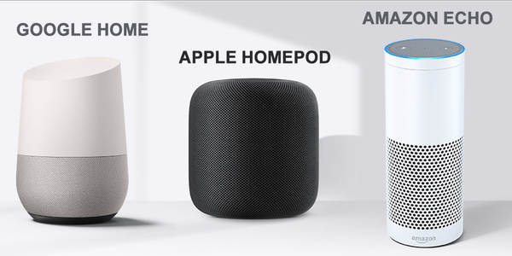

What type of interface do these computer systems use?
Explain how the interface is used to control this computer system.
What are the advantages and disadvantages of this type of system.

Utility Software
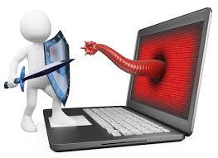
An OS will usually contain utility software which helps to maintain a computer. They can be used to configure the system, analyse how it is working and optimise it to improve its efficiency. Some examples are security programs such as:
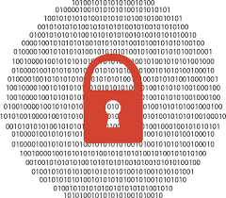
Anti-Virus Software
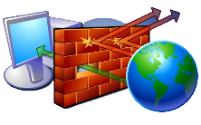
Encryption
Firewalls
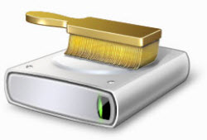
Other utility software maybe used for system optimisation such as:
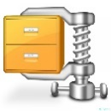
System clean-up tools
File Compression

Defragmentation
When you add files and programs to a new computer it can often slow down. This is often due to the way some Operating Systems save files. Each sector on the hard disc can hold files of a certain size. If a file is bigger than one sector it may take up more than one. Sometimes when the OS saves a file, space in a sector runs out before the file is completely saved. It then breaks up the file and saves the rest in a different part of the hard drive. This means that the file is in fragments.
Draw what the files in a hard disc may look like in a fragmented drive.

Draw what the disc would look like after it has been defragmented.

Explain how Defragmentation works and its benefits to the user’s experience.

Backing Up
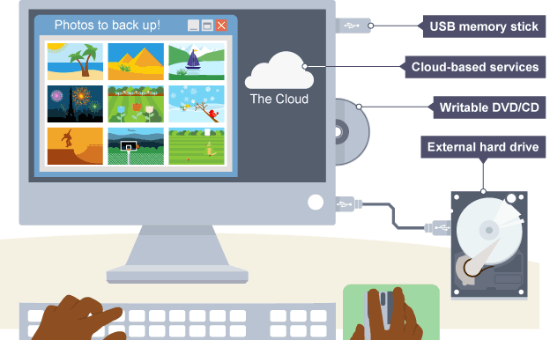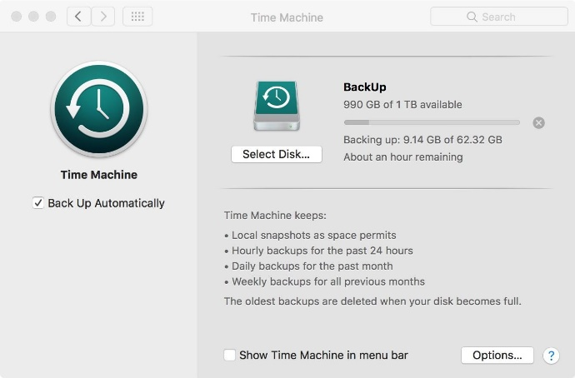
Another way to help maintain a system is by backing up data. This can be carried out automatically by a utility program (Such as Apple Time Machine). A backup is a copy of data or files. Backing up is important for everyone using computers as files and data can become corrupted, be accidentally overwritten or deleted. Backups are often made on separate storage drives or on a different server.
There are two main types of backup:
Full backup
Incremental backup

