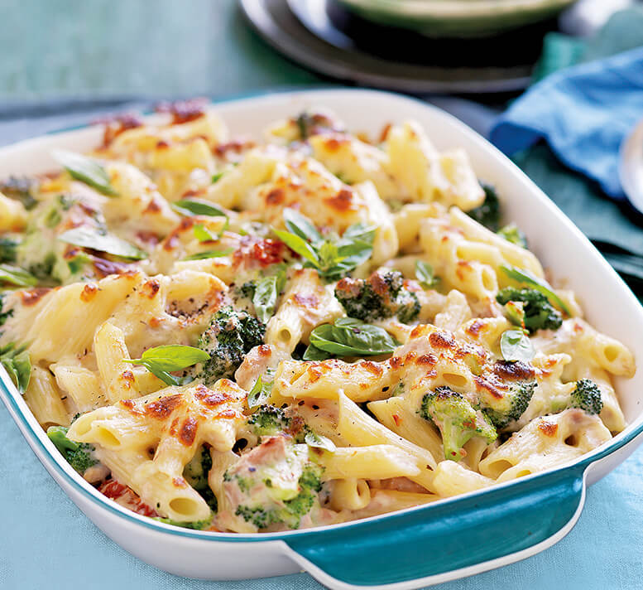
Tuna and broccoli pasta

Ingredients
100g rigatoni pasta
40g cheese
100g broccoli
100g canned tuna (in water) drained
25g soft margarine
25g plain flour
250ml semi-skimmed milk
1x5ml spoon dried oregano
50g sweetcorn (canned or frozen)
Black pepper

Equipment
Two saucepans, weighing scales, grater, chopping board, knife, colander, measuring jug, wooden spoon, measuring spoons, whisk, ovenproof dish or foil tray.

Method
- Bring a saucepan of water to the boil, and then add the pasta. Simmer for about 10-12 minutes, until al dente.
- Grate the cheese and cut the broccoli into small pieces.
- While the pasta is cooking, make the sauce:
- Place the butter or margarine and melt
- Reduce the heat and add the plain flour to the saucepan and stir till it creates a paste
- Add the milk a little bit at time till the mixture becomes a thick sauce;
- Remove from the heat, stir in the oregano or other herbs.
- During the last 2 minutes of the pasta boiling, add the sweetcorn and broccoli to the saucepan.
- Preheat the grill.
- Drain the boiling hot water away from the pasta and vegetables into a colander in the sink.
- Pour the drained pasta and vegetables into the sauce.
- Stir in the canned tuna.
- Pour the mixture into an ovenproof dish or foil tray.
- Sprinkle the cheese over the top, and add a few twists of black pepper.
- Place under a hot grill until the cheese is bubbling and golden brown.

Top tips
- Try different varieties of pasta shapes, such as macaroni or shells.
- Use different types of vegetables, like leeks, peppers and mushrooms.
- Add a spoon of pesto, mustard or tomato puree to the sauce for extra flavour.

Skills
Grating | Using a hob | Using a grill | Making a roux sauce | Draining
Combining | Claw grip

