5.3 – Business Planning

Do Now!

Write a definition for a business plan



Identify the different parts of the business plan.



Business Plan

Business Idea

Excellent - Why is answering these questions vital for a business?

What question should a business be able to answer about its business idea?



**BUSINESS**

**PLAN**



Aims & Objectives

What are aims and objectives?

Excellent – How do Aims and Objective help a business?



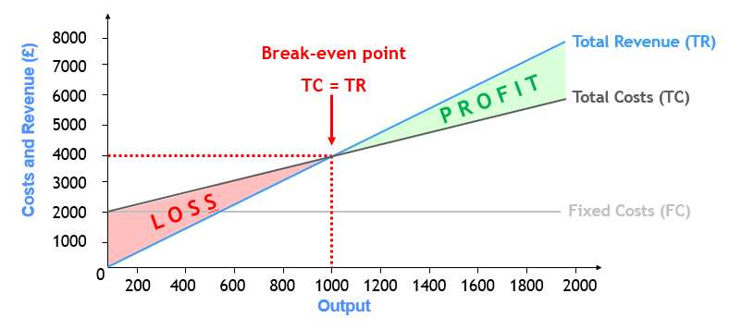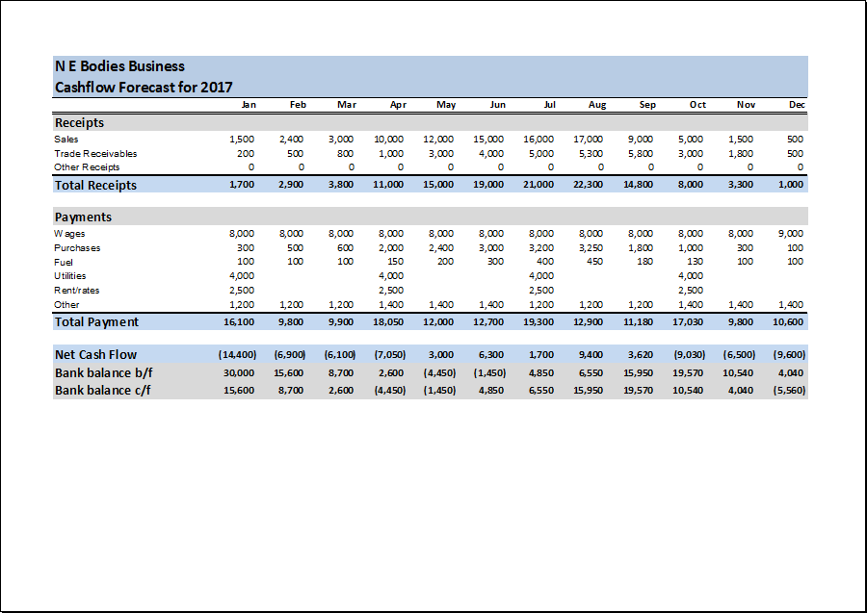

What information is included in a financial forecast?

Excellent – Why is predicting how financially successful your business is important.

Financial Forecasts

Excellent – Why is Market research vital for a business?



Market Research

Sources of Finance



Excellent – Why does a business need to show how they are financing the business?

What different sources of are available to small businesses?

Excellent – Why is a sales plan important?

What does a sales plan show?

Sales Plan



What does a marketing plan include?

Excellent – Why is Market research vital for a business?

Marketing Plan



Purpose of a Business Plan

Why do businesses do a business plan?

|  |  |
| --- | --- |
| Reason | Explanation |
|  |  |
|  |  |
|  |  |
|  |  |
|  |  |