YEAR 8 Distance Learning
November - December 2020
‘Conflict Poetry’

Lesson 1 ‘How to read a poem’
DNA: Watch the clip:https://www.youtube.com/watch?v=T63MCogI4sM&safe=active
Write down answers to the following:
- Who are they?

- When is it happening?

- What is happening?

- Why is it happening?

- Where is it happening?

MAIN TASK: Look at the poem ‘I am very bothered……’ By Simon Armitage – ask the five key questions.
I am very bothered when I think
of the bad things I have done in my life.
Not least that time in the chemistry lab
when I held a pair of scissors by the blades
and played the handles
in the naked lilac flame of the Bunsen burner;
then called your name, and handed them over.
O the unrivalled stench of branded skin
as you slipped your thumb and middle finger in,
then couldn't shake off the two burning rings. Marked,
the doctor said, for eternity.
Don't believe me, please, if I say
that was just my butterfingered way, at thirteen,
of asking you if you would marry me.
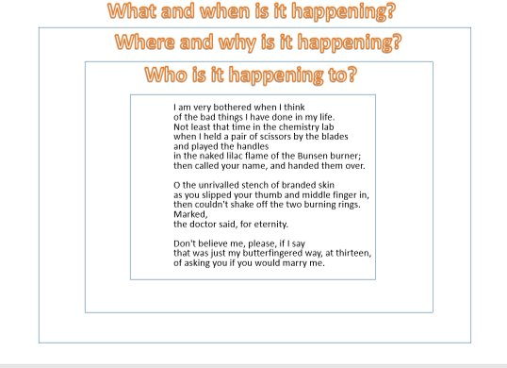
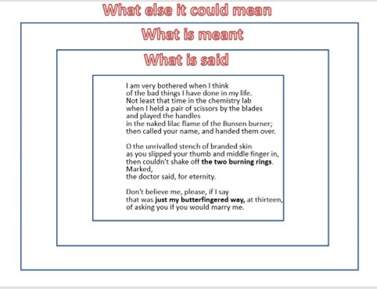

Answer the text-dependent questions:
Who does Armitage’s poem appear to be about… (explicit)​?

What line gives the impression of conflict and why (inference)​

Why is this line important to the meaning of the poem? (connotation)​

How could this have different connotations? (ambiguity)​

​
Overall, the reader feels…(opinion)​

PLENARY: What are the five key questions when analysing poetry?

Lesson 2 ‘I can’t breathe’
DNA: What connotations can you relate to the phrase in the image? CHALLENGE: Can you think of any situations recently where you have seen this phrase?
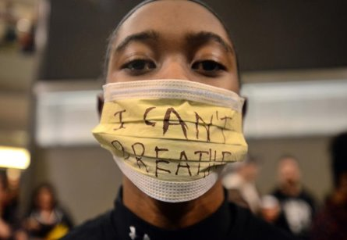

MAIN: The poem was written by a transgender black woman during the 2015 BlackLivesMatter movement. ​
Watch the clip to learn about how it began:​ https://www.youtube.com/watch?v=mI7eHX9u4Q0
Read through the poem ‘I can’t breathe’.​
What is the tone of the poem? What semantic field is shown here? Identify words to support this. ​
I can't breathe for your hate stifles me...​
marred by your anger, scarred by your bigotry. ​
For generations the stench of injustice that I've been forced to inhale, ​
How long oh Lord, must I endure this constant hell? ​
​
From the scorched lands of my ancestors to the bountiful shores of this place, ​
Racial intolerance has haunted me and stolen the grace from my pace.​
So much progress yet so little ground gained.​
Injustice is always near, it wears so many names.​
​
I've witnessed the disgrace, the travesties of the so called truth.​
I've choked on the stench of lies as my ancestors the white man's noose.​
I can't breathe, no breath can I take.​
Will I forever be degraded? Is my skin God's mistake?​

Text Dependent Questions​
ANNOTATE using the key five questions​
​
- What do the words ‘stifle’ and ‘marred’ suggest about the way the speaker feels treated? ​

- Why do you think the poet has used religious imagery here? ​

- What is the effect of the juxtaposition here ‘so much progress yet so little ground gained’? ​

- Why has the writer structured the poem using enjambment to show conflict? ​

- How has sensory language been used to show displacement? ​

PLENARY: Link your thinking. Where can you link areas of the poem to the Black Lives Matter information? ​
_________________________________________________________________________________________________________________________________________________________________________________________________________________________________

Lesson 3 ‘How to read a poem’
DNA: Based on last lesson what can you now infer from this image? ​
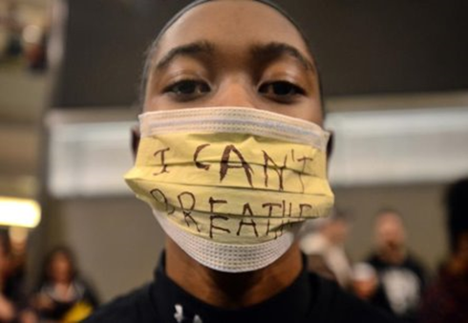

MAIN: Remember to analyse a poem we need to follow certain steps.
- Explore connotations of the title.

- Read the poem at least twice and consider initial thoughts.

- Identify the poet’s ideas.

- Analyse the poet’s use of language and structure.

- What’s the effect on the reader?
We are going to explore by exploding a quote. This means we are going to ask the five key questions to understand the writer’s meaning and intention.

“I can't breathe for your hate stifles me...​”
- What does the word ‘stifle’ mean? ​

- How does it fit in with other quotes, themes, or ideas in the scheme? What is the writer trying to achieve? ​

- Who Says it? ​Character? Narrator?

- ​Where does this quote show racism, displacement, and prejudice?

- How does it work? ​Is it a comparison? ​ Does it give a strong picture? Zoom in on a specific word or phrase. ​

“How long oh Lord, must I endure this constant hell? ​”
- What does the word ‘endure’ mean? ​

- How does it fit in with other quotes, themes, or ideas in the scheme? What is the writer trying to achieve? ​

- Who Says it? ​ Character? Narrator? ​

- How does this quote show racism, displacement, and prejudice? ​

- How does it work? Is it a comparison? Does it give a strong picture? Zoom in on a specific word or phrase.

Answer the question: How does Delaney show racism, prejudice, and displacement in her poem? ​
What a good example looks like:
​
Delaney uses emotive language to explore the theme of racism. For example, the speaker asks the rhetorical question ‘How long oh Lord, must I endure this constant hell?’ The use of religious imagery portrays the speaker addressing their ‘Lord’, yet also provides an emotive comparison when their life is described as a ‘constant hell’ as they feel displaced. By comparing her life to ‘hell’ the speaker may be implying how their life is cruel and painful, and implies she may be losing hope. The use of the verb ‘endure’ also suggests that she may be losing hope as it suggests her suffering is painful and sustained through prejudice. The emotional and tortured tone of the poem is continued throughout as the poem ends ‘Is my skin God's mistake?’ which leaves the reader saddened to feel the speaker may feel she is a mistake, rather than the conflict between races.​
When you are answering the question, consider the following:
What? ​
Is Delaney referring to think back to The Black Lives matter movement. ​
How​
Judicious quotation from the poem​
Why (Analysis)​
is this effective? ​How does the word ----- show racism and prejudice? ​
Multiple interpretations (Ambiguity)​
Why extended? ​
To theme, effect on reader, rest of the poem. ​

__________________________________________________________________________________________________________________________________________________________________________________________________________________________________________________________________________________________________________________________________________________________________________________________________________________________________________________________________________________________________________________________________________________________________________________________________________________________________________________________________________________________________________________________________________________________________________________________________________________________________________________________________________________________________________________________________________________________________________________________________________________________________________________________________________________________

Lesson 4 ‘Home’
DNA: What are the similarities in these pictures? ​ CHALLENGE: List 5 words associated with emotions that would best fit these images. ​
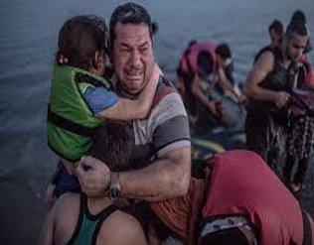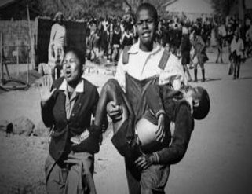
MAIN TASK: Read the poem ‘Home’
no one leaves home unless​
home is the mouth of a shark.​
you only run for the border​
when you see the whole city​
running as well.​
your neighbours running faster​
than you, the boy you went to school with​
who kissed you dizzy behind​
the old tin factory is​
holding a gun bigger than his body,​
you only leave home​
when home won't let you stay.​
no one would leave home unless home​
chased you, fire under feet,​
hot blood in your belly.​
it's not something you ever thought about​
doing, and so when you did -​
you carried the anthem under your breath,​
waiting until the airport toilet​
to tear up the passport and swallow,​
each mouthful of paper making it clear that​
you would not be going back.​
you have to understand,​
no one puts their children in a boat​
unless the water is safer than the land.​
who would choose to spend days​
and nights in the stomach of a truck​
unless the miles travelled​
meant something more than journey.​
no one would choose to crawl under fences,​
be beaten until your shadow leaves you,​
raped, then drowned, forced to the bottom of​
the boat because you are darker, be sold,​
starved, shot at the border like a sick animal,​
be pitied, lose your name, lose your family,​
make a refugee camp a home for a year or two or ten,​
stripped and searched, find prison everywhere​
and if you survive and you are greeted on the other side​
with go home blacks, refugees​
dirty immigrants, asylum seekers​
sucking our country dry of milk,​
dark, with their hands out​
smell strange, savage –​
look what they've done to their own countries,​
what will they do to ours?​
the dirty looks in the street​
softer than a limb torn off,​
the indignity of everyday life​
more tender than fourteen men who​
look like your father, between​
your legs, insults easier to swallow​
than rubble, than your child's body​
in pieces - for now, forget about pride​
your survival is more important.​
i want to go home, but home is the mouth of a shark​
home is the barrel of the gun​
and no one would leave home​
unless home chased you to the shore​
unless home tells you to​
leave what you could not behind, ​
even if it was human.​
no one leaves home until home​
is a damp voice in your ear saying​
leave, run now, i don't know what​
i've become. ​
The poem was written by Warsan Shire. Shire wrote the poem in 2009 after spending time with a group of young refugees who had fled troubled homelands including Somalia, Eritrea, Congo and Sudan. The group gave a “warm” welcome to Shire in their makeshift home at the abandoned Somali Embassy in Rome, Italy. She described their living conditions as cold and cramped. The night before she visited, a young Somali had jumped to his death off the roof. The encounter, she says, opened her eyes to the harsh reality of living as an undocumented refugee in Europe: “I wrote the poem for them, for my family and for anyone who has experienced or lived around grief and trauma in that way.”
TASK: Write a 15 word summary as to why she wrote her poem. ​
Text dependent questions:
- Who is the speaker? ​

- Why do you think the poet has used the juxtaposition between ‘home’ and ‘being chased’? What could this symbolise about racism? ​

- What is the effect of the listing used throughout the poem? ​

- What could the use of enjambment represent? ​

- How has the repetition of the pronoun ‘you’ affect the reader?

TASK: Complete the table, filling in the blanks.
Image​ | Quote​ | Technique​ | Meaning​
​ 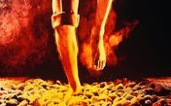 | “No one would leave home unless home​  chased you, fire under feet.” (Home)​  ​‘Scorched lands of my ancestors’ (I Can’t Breathe)​  ​ | ​  ​  Emotive language​  ​ | ​
​  ​ 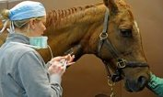  ​  ​ | “be sold,​  starved, shot at the border like a sick animal” (Home)​ | Sibilance​  ​  Simile​ | ​The metaphor suggests that people shared has negative spiritual connotations. The narrator is unsettled and no longer feels joy and happiness in her life. ​
​ | ​ | ​ | Home is compared to a gun and once more reminds the reader of the dangerous reality that staying home will ultimately lead to death. It also intensifies the idea of war, and link the line of the boy ‘holding a gun bigger than his body’​  ​  ​  ​  ​  ​  ​

PLENARY: What can you now understand by this image? ​
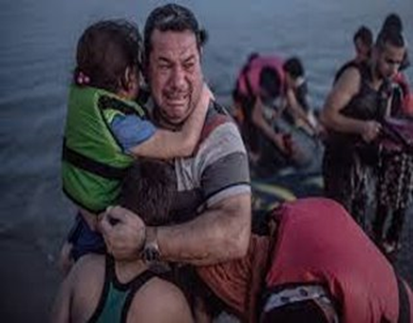

Lesson 5
DNA:
- What connectives show something is similar to something else? (e.g. similarly, in addition...)
- What connectives show something is different to something else? (e.g. however, in contrast...)

MAIN TASK: Comparison of “I Can’t Breathe” and “Home”
“No one would leave home unless home chased you, fire under feet.” (Home)
‘Scorched lands of my ancestors’ (I Can’t Breathe)
- What is similar and what is different about the poet’s ideas in these two lines from ‘I Can’t Breathe’ and ‘Home’?

Using your grids from yesterday you are going to complete a Demonstrate task that focuses on the similarities and any differences – you will need to use word consciousness and write two paragraphs
I have started you off, complete the gaps and carry it on

Shire presents the theme of racism by exploring how refugees are treated once they have escaped their country. The use of the quote ‘_________________’ Creates an image of ____________________________________ which shows injustice because…

This is similar to Delaney’s poem because she presents injustice in the quote…

PLENARY: Highlight where you used any of the connectives identified in the DNA.

Lesson 6
DNA: Can you name any inspirational leaders? What qualities do they all have?

MAIN TASK: Winston Churchill was Prime Minister during World War II.
He delivered this speech to encourage soldiers to keep fighting:
Even though large tracts of Europe and many old and famous States have fallen or may fall into the grip of the Gestapo and all the odious apparatus of Nazi rule, we shall not flag or fail. We shall go on to the end. We shall fight in France, we shall fight on the seas and oceans, we shall fight with growing confidence and growing strength in the air, we shall defend our island, whatever the cost may be. We shall fight on the beaches, we shall fight on the landing grounds, we shall fight in the fields and in the streets, we shall fight in the hills; we shall never surrender, and if, which I do not for a moment believe, this island or a large part of it were subjugated and starving, then our Empire beyond the seas, armed and guarded by the British Fleet, would carry on the struggle, until, in God's good time, the New World, with all its power and might, steps forth to the rescue and the liberation of the old.
TDQs:
Who is the speaker and what is their tone?

What is the effect of the writer’s deliberate use of repetition?

Why does Churchill use the listing of settings? What is the effect of this?

How has the writer structured the speech to make it inspirational?

What is the effect of using the phrase ‘our empire beyond the seas’ what does this suggest about Churchills view on Great Britain?

PLENARY: Sum up three reasons why this speech was persuasive.

Lesson 7
DNA: What emotions could you associate with this picture?
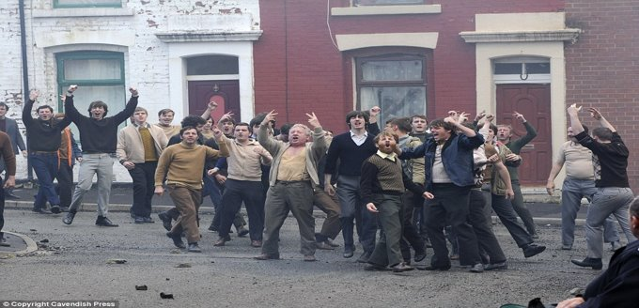
MAIN TASK: Cirian Carson was a young man in Belfast when the Troubles began in 1969. ‘The Troubles’ refers to almost 30 years of violence between the Nationalists (mainly Roman Catholic) who wanted independence from the UK and the unionists (mainly Protestants) who believed in strengthening the political ties between Northern Ireland and Britain. Armed paramilitary groups, including the Provisional Irish Republican Army (IRA), made Belfast a terrifying place to live between 1969 and 1997 and much of the violence took place around the Protestant Shankill Road and Catholic Falls Road areas. The British government claimed that its forces were in Northern Ireland to keep law and order, but Irish republicans objected strongly to the presence of the British soldiers.
The poem we are going to look at, Belfast Confetti, explores this time of violence and hardship.
https://www.bbc.co.uk/teach/class-clips-video/ciaran-carson-on-his-poem-belfast-confetti/z69rkmn - watch this video of the poet discussing his poem.

TDQs:
- Ciaran Carson states the importance of poetry telling a story. What is the story that he tells in this poem?

2. What do you understand by the title of the poem? Is the title ironic?

3. Consider the list of street names. Can you see any significance to their names?

4. Consider the length of the lines of the poem and how they change. Why do you think Ciaran Carson writes in this style?

5. What different emotions come across in the poem?

6. How does Carson build up a sense of panic and claustrophobia?

PLENARY: Do you still have the same response to the picture in the DNA now you know the context?

Lesson 8
DNA: What do you think the tone of today’s poem will be based on the image?
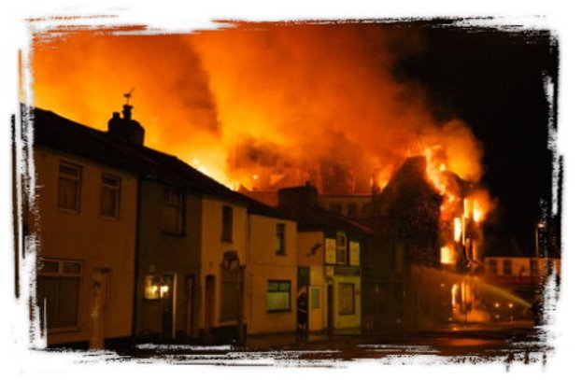
MAIN TASK: Read the poem Burning of the House and the notes around it

Write a What-How-Why response to the question “How are the writer’s feelings presented in Burning of the House?

What?
Is the message in ‘Burning of the house’
How
Judicious quotation from the poem
Why (Analysis)
is this effective?
How does the particular word ----- show racism and prejudice?
Multiple interpretations (Ambiguity)
Why extended?
To theme, effect on reader, rest of the poem

Stuck? Complete the gaps and carry it on

The writer presents their feelings of ____________ in the poem. The use of the quote ‘_________________’ Creates an image of ____________________________________ which shows their feelings because…

PLENARY: Give your work a WWW and EBI.

Lesson 9
DNA: List adjectives beginning with F,R and S to describe these images.
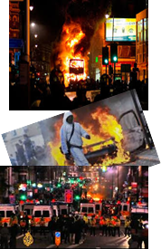
Challenge: What emotions do the images evoke?
You should now take some time to research what happened at Grenfell Tower before continuing with this lesson
Main Task: Read the poem and answer the Text-Dependent questions
The Firefighter
I’m staring blankly
Frankly I’m broken
My heart can’t be mended
Befriended or woken
An emptiness consumes me
In sorrow I’m soaked
My words can’t be heard
As I’m strangled and choked
As tears stripe each cheek
With a trail of sadness
My soul is stained black
With the screams. With the madness.
The pain of such tragedy
The waste of such life
The death of a husband, his children, his wife.
The stairs were too many
My breaths were too few
My body exhausted. Now mentally too.
The silence of death. My smoke stained hair
A hole in my soul that will never repair
The feeling of failure and pride that combine
To leave me confused and abused in my mind
My lips wet with tears. I am lost. There’s no plan.
Emotionally ruined. One broken man.
TDQs
Who is the speaker?

Why is the speaker’s perspective so powerful?

Why is black so significant here?

How do you feel after reading it? Why?

What is the significance of the sensory language?

Which 5 words stand out most? Why have you chosen these words?

Plenary: Give three things you have learned about Grenfell today.
Lesson 10
DNA: What is the purpose of a newspaper?
Challenge: List three reasons why someone might buy a newspaper.
Main Task: Write a letter to your MP. You live at Grenfell Tower and you are worried about your safety. Use your knowledge from your research and the success criteria below to help you.
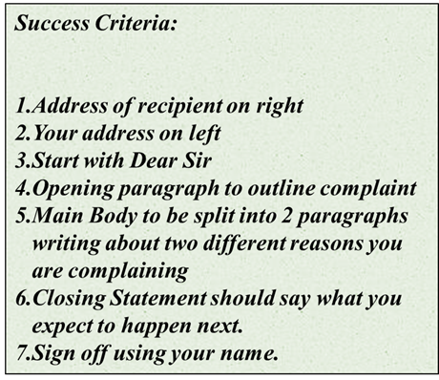

Plenary: Give yourself a WWW and EBI using the success criteria.

Lesson 11
DNA: Why would a group who were campaigning for change in the attitude towards ethnic minorities want Stormzy to make a song for them?

Read the Stormzy lyrics in the ‘Artists 4 Grenfell’ song and answer the Text-Dependent questions
Yeah, I don't know where to begin
So I'll start by saying I refuse to forget you
I refuse to be silenced
I refuse to neglect you
That's for every last soul up in Grenfell
Even though I've never even met you
Cuh that could've been my mum's house
Or that could've been my nephew
Now, that could've been me up there
Waving my white plain tee up there
With my friends on the ground trying a see up there
I just hope that you rest and you're free up there
I can't feel your pain but it's still what it is
Went to the block just to chill with the kids
Troubled waters come running past
I'ma be right there just to build you a bridge, yo
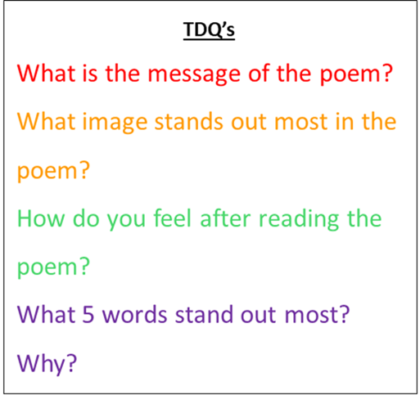

Plenary: Write a short paragraph on the message behind the song and how it supports equality.

Lesson 12
DNA: Make a list of comparison connectives e.g. ‘However…’
Main Task: Complete 3 to 4 ‘What, How, Why’ paragraphs in response to the question below. Use the steps and sentence starters below to help you.
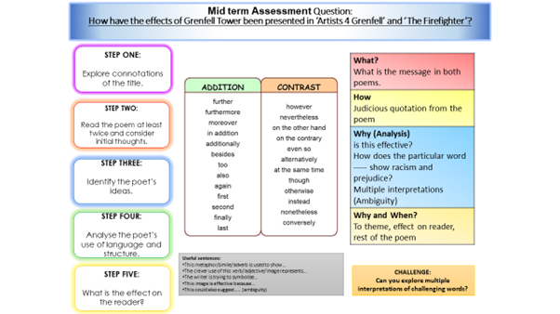

Plenary: Give yourself a WWW and EBI using the success criteria.

Lesson 13
DNA: What is your first reaction to this image?
Challenge: What does the word terrorism mean?
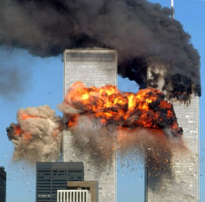

TASK: Watch the news report: https://www.youtube.com/watch?v=8lMmVo1me2s
then answer the questions:
- How many planes were involved in the attack?
- How many people died?
TASK: Read the poem below called Out of The Blue. It is written from the point of view of somebody trapped inside one of the Twin Towers on September 11th 2001.
Out of the Blue
You have picked me out.
Through a distant shot of a building burning
you have noticed now
that a white cotton shirt is twirling, turning.
In fact I am waving, waving.
Small in the clouds, but waving, waving.
Does anyone see
a soul worth saving?
So when will you come?
Do you think you are watching, watching
a man shaking crumbs
or pegging
out washing?
I am trying and trying.
The heat behind me is bullying, driving,
but the white of surrender is not yet flying.
I am not at the point of leaving, diving.
A bird goes by.
The depth is appalling. Appalling
that others like me
should be wind-milling, wheeling, spiralling, falling.
Are your eyes believing,
believing
that here in the gills
I am still breathing.
But tiring, tiring.
Sirens below are wailing, firing.
My arm is numb and my nerves are sagging.
Do you see me, my love. I am failing, flagging.

TASK: Answer the questions below about Out of the Blue.
- What is the significance of the verb ‘picked’?
- Why does Armitage use the metaphor ‘white cotton shirt’ and ’the white of surrender’ what do they both symbolise?
- What tone is created with the repetition of the questioning?
- What does the metaphor ‘heat behind me is bullying’ suggest about the environment?
- What do the verbs suggest about what is happening?

PLENARY: How do these words below link to conflict?
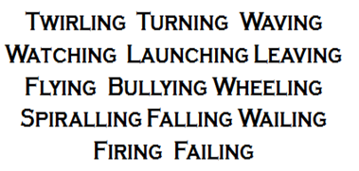

Lesson 14
DNA: Based on yesterday’s learning what is so powerful about this picture?
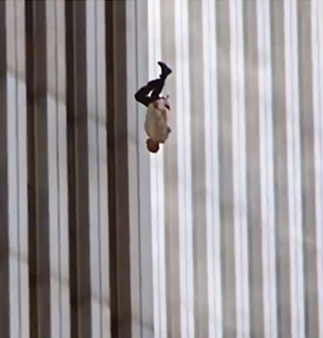
TASK: Underline the following in the extract below:
- MAPSO (Metaphor, Alliteration, Personification, Simile and Onomatopoeia.
- Punctuation for effect
- -ly/-ing sentence starters

Bullying heat forces itself closer towards the windows. Encroaching towards every last soul in the building, the smoke forms an impenetrable army. Slowly, rhythmically, hopelessly, the small white t-shirt twirls through the smoke. Like a desperate wave of a white flag, the pain of surrender is clear for everyone to see. As the twirls slow, the t-shirt stops. Lifeless, lost, longing: the white beacon of hope seems to disappear. Suddenly, the T-shirt gains new momentum. Mesmerizingly, I gaze back up. My eyes follow the opposite turns of the cotton dove.
TASK: Write a detailed description of the ‘falling man’. Describe the setting in detail to build a picture of the chaotic scene before the man is forced to jump.
Success Criteria:
- MAPSO (Metaphor, Alliteration, Personification, Simile and Onomatopoeia.
- Punctuation for effect
- -ly/-ing sentence starters
CHALLENGE:
Encroaching: An approaching invading
- Impenetrable: Murky / Opaque, unable to see through
- Mesmerizing: Hypnotizing

Lesson 15
DNA: What can we infer about this location based on the picture?
Where do we think it is?
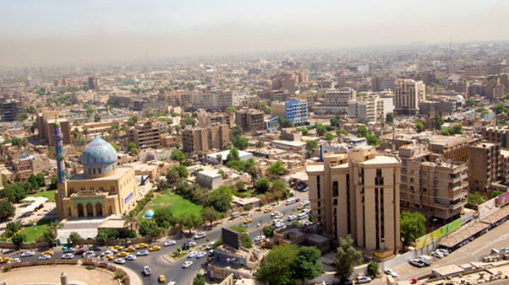
TASK: Read the poem below called Yellow Palm and answer the questions below it.
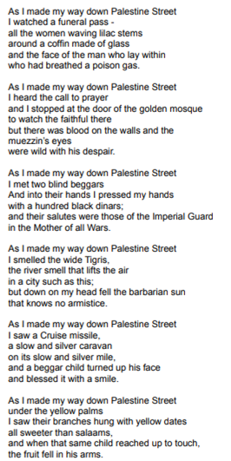

- How does the poem relate to the theme of conflict?

- What do you think is the poet’s message?

- How is this place presented in the poem? What are your initial thoughts?

- What is happening in the poem? What is it about?

TASK: Find quotations that show the city is steeped in violence.
Next to your quotations, write down what the poet is trying to say about the consequences of conflict.

Lesson 16
DNA: What are your thoughts on this picture? Why is it wrong? What does it tell us about the effect of conflict on civilians? How can we relate it to the poem ‘The Yellow Palm’?
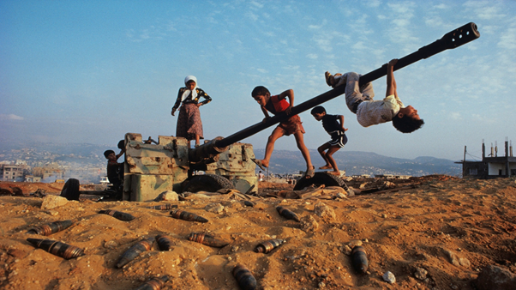

TASK:
- How do you think the poet is trying to make a reader feel when they read ‘The Yellow Palm’? Explain your ideas using quotations from the text.
- How does the writer use language to make the reader feel sorry for those on Palestine Street?
Make sure you use quotations in your work and make reference to the text using the correct subject terminology.

Lesson 17– World War 1 Poetry
DNA:
Look at the below examples of WW1 propaganda.
1) What is the aim of the propaganda?
2) Why do you think the words you/your are repeated across all three?
3) In your opinion, is this propaganda effective? Why/why not?
Challenge: Can you identify any other ways these posters try to persuade their viewers?
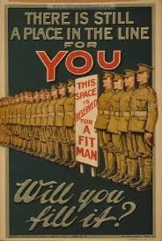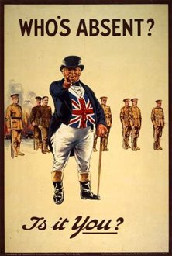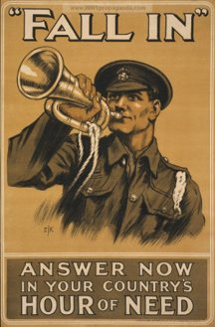

We are going to look at two poems by famous writer Siegfried Sassoon.
Sassoon fought in WW1 and, at first, was an exemplary soldier. He won the Military Cross for bravery.
However, after the death of a friend, Sassoon fell ill. When he recovered, he refused to fight and was sent to Craiglockhart, a hospital for soldiers struggling with the impacts of war. Sassoon did return to fight, but he was inspired to write poems so that the British public knew the truth.

TASK: SUICIDE IN THE TRENCHES
Look at the title of this task and the images below.
1) What kind of tone do you think will be created in the poem?
2) By talking mainly about death in the poems, what might Sassoon be trying to say about War?
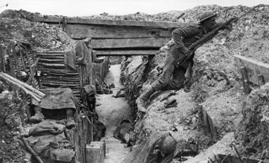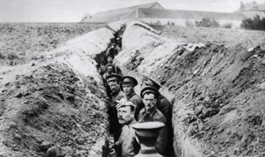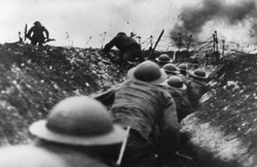
TASK 2: Read the poem below and answer the questions underneath.

Suicide in the Trenches – Siegfried Sassoon
^{I knew a simple soldier boy}
Who grinned at life in empty joy,
Slept soundly through the lonesome dark,
And whistled early with the lark.
In winter trenches, cowed and glum,
With crumps and lice and lack of rum,
He put a bullet through his brain.
^{No one spoke of him again.}
You smug-faced crowds with kindling eye
Who cheer when soldier lads march by,
Sneak home and pray you'll never know
The hell where youth and laughter go.
1a) What do you notice about the structure of the poem? Consider the length and number of stanzas, and whether there is any rhyme. Why might Sassoon have structured the poem this way?
2) Why do you think Sassoon chooses the noun “boy” rather than “man” in Line 1? What kind of emotions might he want to create?
3) Why does Sassoon tell us about the boy grinning and whistling? What does this tell us about the boy at first?
4) Look at these words from Stanza 2: “winter”, “lice”, “bullet”. What connotations / ideas do these words create.
^{Winter:}
^{Lice:}
^{Bullet:}
5) What happens in the second stanza? How is the tone of the second stanza different to the first? Explain your answer.
6) Who do you think the poet is talking to in the final stanza when he says “you”? Why might he use this word?

PLENARY: Now that you’ve read Sassoon’s poem, do you think he would have agreed with this poster?
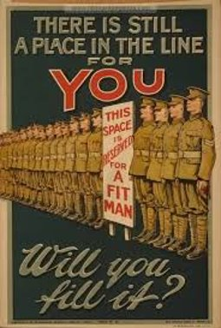

Lesson 18: Reality of Boy Soldiers
DNA: Look at the men in this photo. How old do you think they are? Do you think it is right or wrong that they are going to war? Explain why.
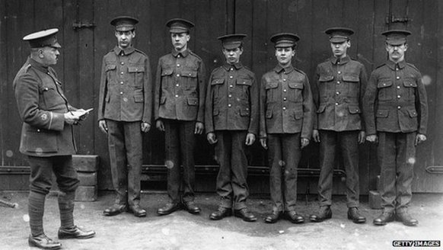
TASK:
Read the extract and answer the questions that follow.
Nearly 250,000 teenagers would join the call to fight. The motives varied and often overlapped - many were gripped by patriotism, sought escape from grim conditions at home or wanted adventure.
"It was obvious they weren't 19," says historian Richard Van Emden, "but you'd have a queue of men going down the road, you're getting a bounty for everyone who joins up, are you really going to argue with a young lad who's enthusiastic, who's keen as mustard to go, who looks maybe pretty fit, pretty well. Let's take him."

- How did the teenagers of the 1910s view war when they were signing up? How does this link to Sassoon’s poem?

- Many boys ”sought escape from grim conditions at home.” Why does this line make their decision to join the war particularly upsetting and ironic?

- ”It was obvious they weren’t 19.” How do you think these teenagers felt when they realized the truth of war?

TASK 2: Each of these quote explosions are taken from the poem we read last lesson – Suicide in the Trenches.
Choose three questions from each one and answer them below.

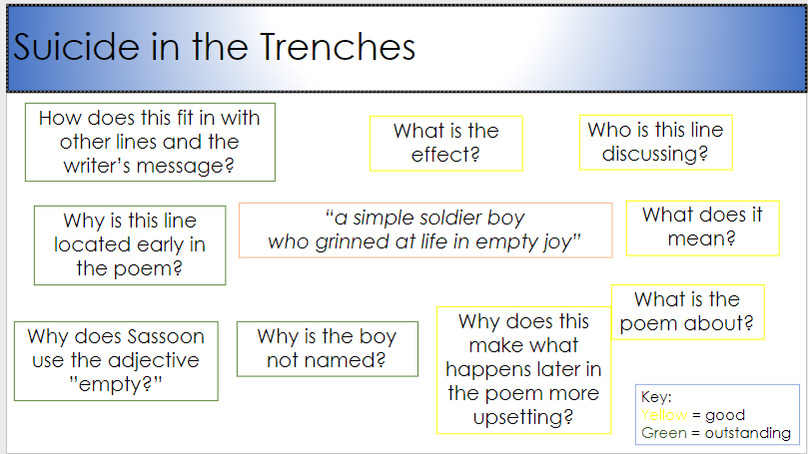

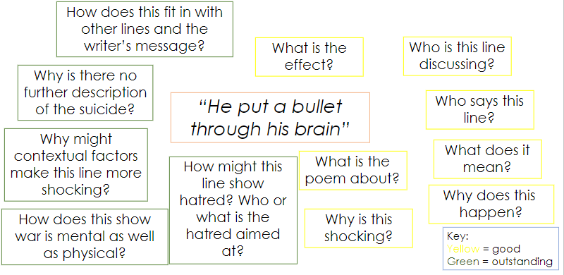

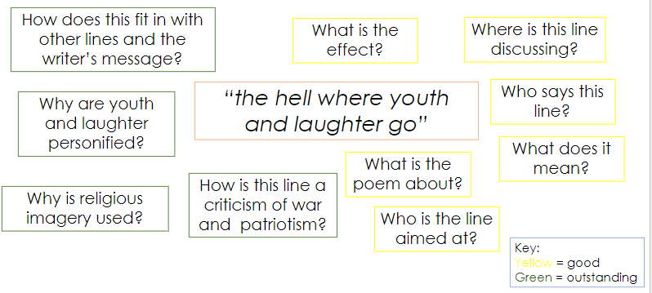
PLENARY:
“he mobilises language and sends it into battle”
Somebody said this about Winston Churchill during WW2.
Could this quote also apply to Siegfried Sassoon? What battle is Sassoon fighting?

Lesson 19: Attack
DNA: Look at the quote below.
How must the person saying this feel?
Using your knowledge of ”Suicide in the Trenches,” what might be happening?
What does this suggest about war?
“O Jesus, make it stop!”

TASK: During an attack in WW1,soldiers would have to exit the trenches to fight. This was called going “over the top.”
Watch the video, then answer the questions:
https://www.youtube.com/watch?v=g0V1yRrjMmM&feature=youtu.be

- How are the soldiers feeling at the start of the video?
- Why does one soldier kiss his wedding ring?
- Does this seem like a good way to fight? Why/why not?

TASK 2: Read the poem below and answer the questions that follow. Alternatively, listen to a reading here: https://www.youtube.com/watch?v=r6D3OUJk3rs
^{Attack – Siegfried Sassoon}
At dawn the ridge emerges massed and dun
In the wild purple of the glow'ring sun,
Smouldering through spouts of drifting smoke that shroud
The menacing scarred slope; and, one by one,
Tanks creep and topple forward to the wire.
The barrage roars and lifts. Then, clumsily bowed
With bombs and guns and shovels and battle-gear,
Men jostle and climb to, meet the bristling fire.
Lines of grey, muttering faces, masked with fear,
They leave their trenches, going over the top,
While time ticks blank and busy on their wrists,
And hope, with furtive eyes and grappling fists,
Flounders in mud. O Jesus, make it stop!

^{Analysis:}
1) Find one quote that shows the shocking conditions of the trench area. Explain the impact of your chosen quote.

2) List any colours in the poem. Label your poem to explain what the colours might represent in the poem.

3) List any words that link to fear. Why do you think these are included and what Sassoon is saying about war.

3) Read the last line. Why do you think Sassoon ends with this line? Is the war only physical?

PLENARY:
How might ‘Attack’ be a criticism of heroism (acting like a hero)? Explain your answer.

Lesson 20: WW1 Poetry
DNA: Propaganda and other government messages encouraged people to go to war.
How might Sassoon’s quotes below persuade people that war was not as exciting and noble as the propaganda suggested?
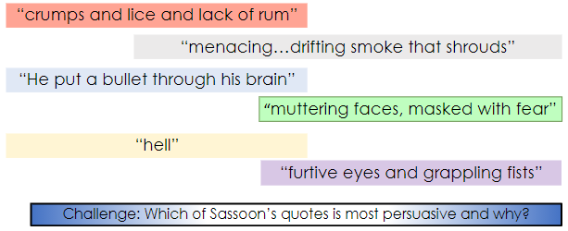
TASK: Using one of the poems we have looked at in the last two lessons, answer this Demonstrate question:
Demonstrate: How does Sassoon depict the horrors of war in his poetry?
CHALLENGE: Compare both poems in your answer.
SUPPORT: Use these sentence stems to help you:
What: In the poem, ____________, Sassoon depicts war as...
How: For example, in the quote “......”, he suggests...
The metaphor / simile / adverb in this quote is trying to show...
The clever use of this adjective / noun / emotive language tells us...
This image is effective because...
Why: Sassoon might be trying to symbolise...
^{He wants the reader to...}
^{Your answer:}
Plenary: Check your demonstrate task. Have you remembered to use capital letters and full stops? Have you identified a key word or technique and explained it?

