**Q1.** The image below shows a lorry.

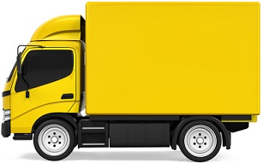

(a)  The brakes of the lorry are in a poor condition.

What effect will the condition of the brakes have on thinking distance and the braking distance of the lorry?

Thinking distance ____________________________________________________

___________________________________________________________________

Braking distance _____________________________________________________

___________________________________________________________________

**(2)**

(b)  Using a hand-held mobile phone while driving is illegal in the United Kingdom.

The table below shows the effect of using a mobile phone on thinking distance.

|  |  |
| --- | --- |
|  | **Thinking distance** |
| Not using a mobile phone | 19 m |
| Using a mobile phone with hands-free kit | 23 m |
| Using a hand-held mobile phone | 27 m |

Explain why driving while using a hand-held mobile phone is more dangerous than using a mobile phone with a hands-free kit.

Use data from the table above.

___________________________________________________________________

___________________________________________________________________

___________________________________________________________________

___________________________________________________________________

___________________________________________________________________

___________________________________________________________________

___________________________________________________________________

**(4)**

**Q2.**

(a)  **Figure 1** shows the distance-time graph for a car travelling at 15 m/s

**Figure 1**

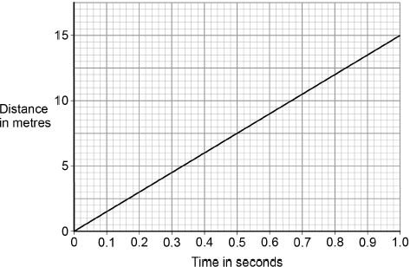

When the driver is tired, his reaction time increases from 0.50 seconds to 0.82 seconds.

Determine the **extra** distance the car would travel before the driver starts braking.

___________________________________________________________________

___________________________________________________________________

___________________________________________________________________

Distance = _______________________ m

**(2)**

(b)  When the brakes are used, the temperature of the brakes increases.

Explain why. Use ideas about energy in your explanation.

___________________________________________________________________

___________________________________________________________________

___________________________________________________________________

___________________________________________________________________

**(2)**

(d)  **Figure 2** shows how the thinking distance, braking distance and stopping distance for a car vary with the speed of the car.

**Figure 2**

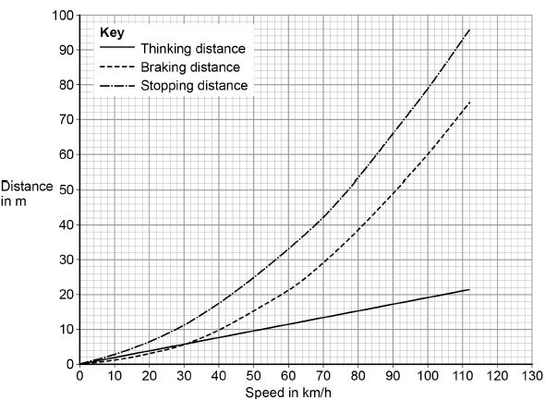

Describe the relationships shown in **Figure 2**

You should include factors that would affect the gradient of the lines.

___________________________________________________________________

___________________________________________________________________

___________________________________________________________________

___________________________________________________________________

___________________________________________________________________

___________________________________________________________________

___________________________________________________________________

___________________________________________________________________

___________________________________________________________________

___________________________________________________________________

___________________________________________________________________

**(6)**

Mark schemes

**Q1.**

(a)  thinking distance stays the same

**1**

braking distance increases

**1**

(b)  reaction time is increased by using a mobile phone

**1**

hand-held mobile phones increase the thinking distance more than hands-free phone

*allow thinking distance is increased by using a mobile phone*

**1**

by 4 m more than the hands-free phone

**1**

*allow* ***2*** *marks for a hand-held mobile phone doubles the increase of the thinking distance*

so overall stopping distance increases

**1**

**[6]**

**Q2.**

(a)  either:

7.5 (m) **and** 12.3 (m) from the graph

**or**

15 (m/s) × 0.32 (s) using speed

*allow 7.5 (m) and between 12.2 (m) and 12.4 (m)*

**1**

extra distance = 4.8 (m)

**1**

*an answer between 4.7 (m) and 4.9 (m) scores* ***2*** *marks*

(b)  there is a decrease in kinetic energy of the car

*allow work is done by friction (on the brakes)*

**1**

so this (causes) the internal / thermal energy store of the brakes to increase

**1**

(c)  192 − u2 = 2 × 2 × 84

**1**

u2 = 192 − (2 × 2 × 84)

**1**

u = 5 (m/s)



**1**

*an answer of 5 (m/s) scores 3 marks*

(d)  **Level 3:** Scientifically relevant facts, events or processes are identified and given in detail to form an accurate account.

**5−6**

**Level 2:** Scientifically relevant facts, events or processes are identified and their relevance is clear. The account is not fully accurate.

**3−4**

**Level 1:** Facts, events or processes are identified and simply stated but their relevance is not clear.

**1−2**

**No relevant content**

**0**

**Indicative content**

•   use of drugs, alcohol, tiredness and distractions would increase the thinking distance

•   thinking distance increases with speed

•   thinking distance is directly proportional to speed

•   use of drugs, alcohol, tiredness and distractions would increase the gradient of thinking distance

•   poor brakes, poor tyres, wet / icy roads and mass would increase the braking distance

•   braking distance increases with speed

•   braking distance increases at an increasing (accept greater) rate (with speed)

•   poor brakes, poor tyres, wet / icy roads and mass would increase the gradient of braking distance

•   braking distance is directly proportional to speed squared

•   stopping distance = thinking distance + braking distance

•   factors that increase thinking and / or braking distance would increase the gradient of stopping distance

•   stopping distance increases at an increasing (accept greater) rate (with speed)

**[13]**