Composition Tips and Hints
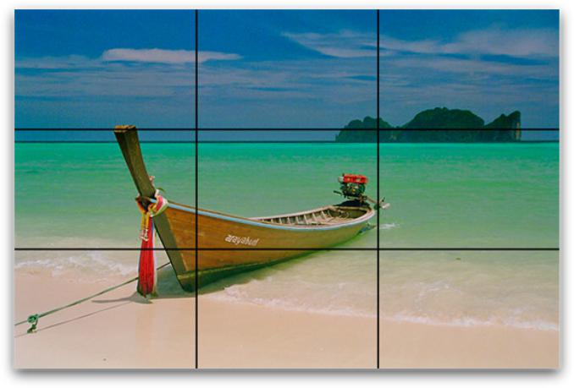

Rule of Thirds

This is probably the first compositional rule that any photographer comes across, and that’s for a very good reason – it’s simple and it works.

The basic premise is that you divide your camera’s frame up into thirds and plant key objects in these lines, and the composition will work better.


Balance

Balance is a compositional technique in photography that juxtaposes images within a frame so that the objects are of equal visual weight. When different parts of a photo command your attention equally, perfect balance is achieved.

In photography, there are two main techniques of balance you should be aware of: formal and informal.

formal

Informal

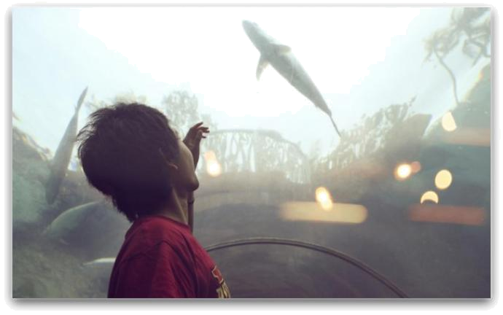

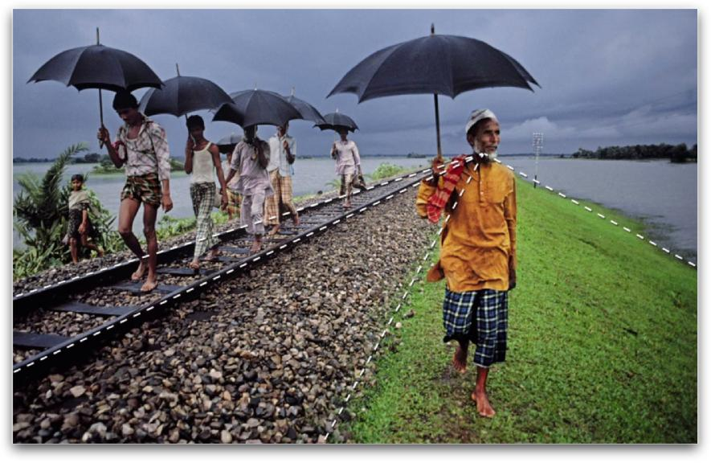
Leading Lines

A leading line paves an easy path for the eye to follow through different elements of a photo. Usually they start at the bottom of the frame and guide the eye upwards and inwards, from the foreground of the image to the background, typically leading toward the main subject.

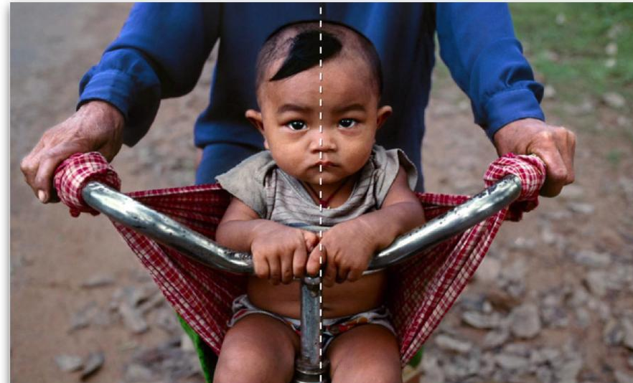
Symmetry

Sometimes the most stunning shot is the one when you put the main point of interest slap bang in the middle of your shot and where there’s real symmetry in the image.

Pattern | emphasize | Broken
When it comes to capturing repetition in photography a | emphasize | Broken
couple of techniques come to mind – you can either
emphasize it or break it.
To emphasize pattern try filling your frame with a
repetitive pattern to give the impression of size and large
numbers. To break pattern try including a contrasting
object (colour, shape, texture) or removing one of the
repeating objects.
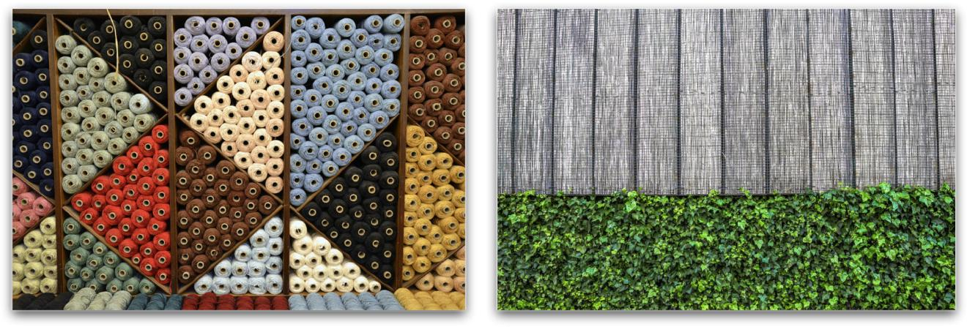

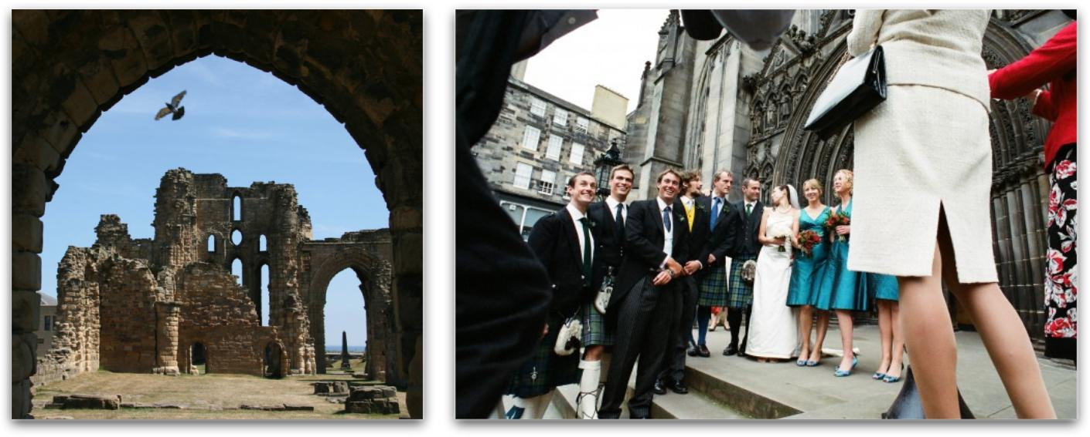
Framing

Framing is the technique of drawing attention to the subject of your image by blocking other parts of the image with something in the scene.
Frames for photographs come in all shapes and sizes and can include shooting through overhanging branches, shooting through windows, using tunnels, arches or doorways – you can even use people (for example shooting over shoulders or between heads)

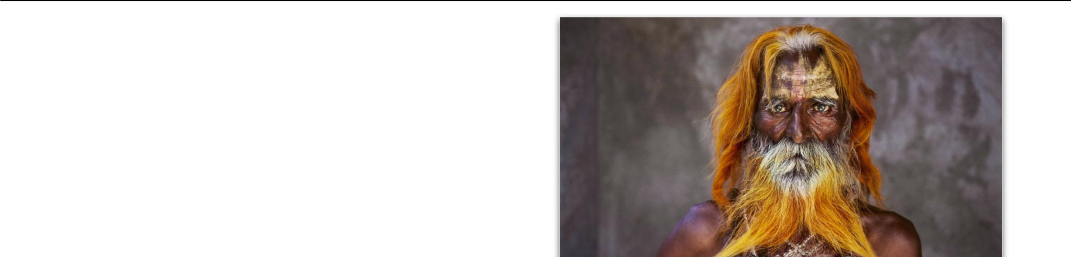

Filling the frame

While empty spaces can be used effectively in photos to create stunning results you’re much more likely to get a ‘wow’ from those looking at your photos if your shots are filled with interest.

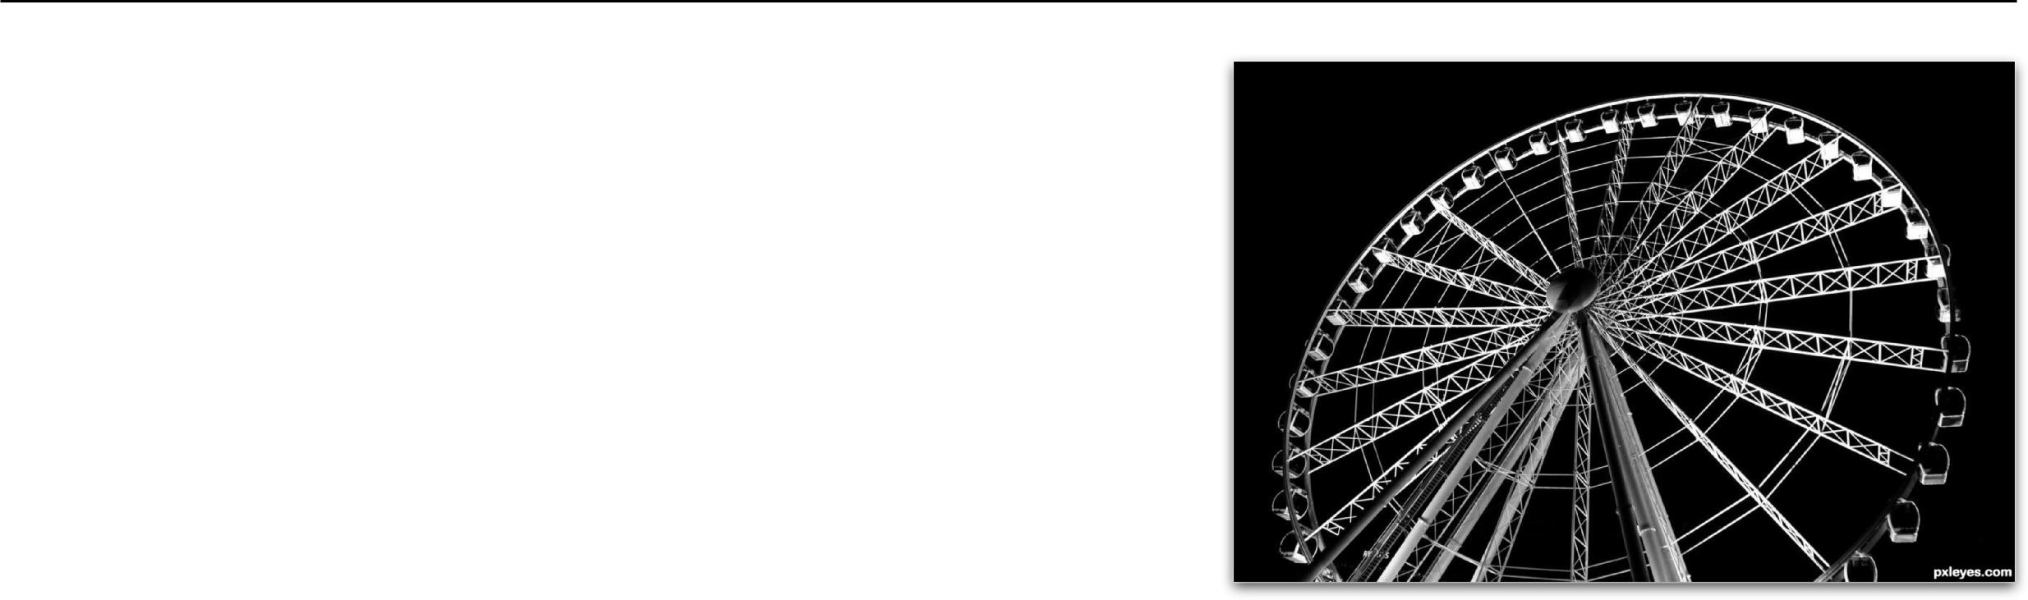
Angles and Perspective

The height from which you shoot can be a significant factor in how your images appear. If you want to emphasize height and power in a scene, get low to the ground and tilt the camera slightly up. People will look more important and prominent, and objects like trees or mountains will look even larger.

Shooting from a high camera angle on the other hand makes everything feel smaller and diminished in power. If the shooting height becomes extreme enough the image can even tend to take on an abstract and graphic feeling.

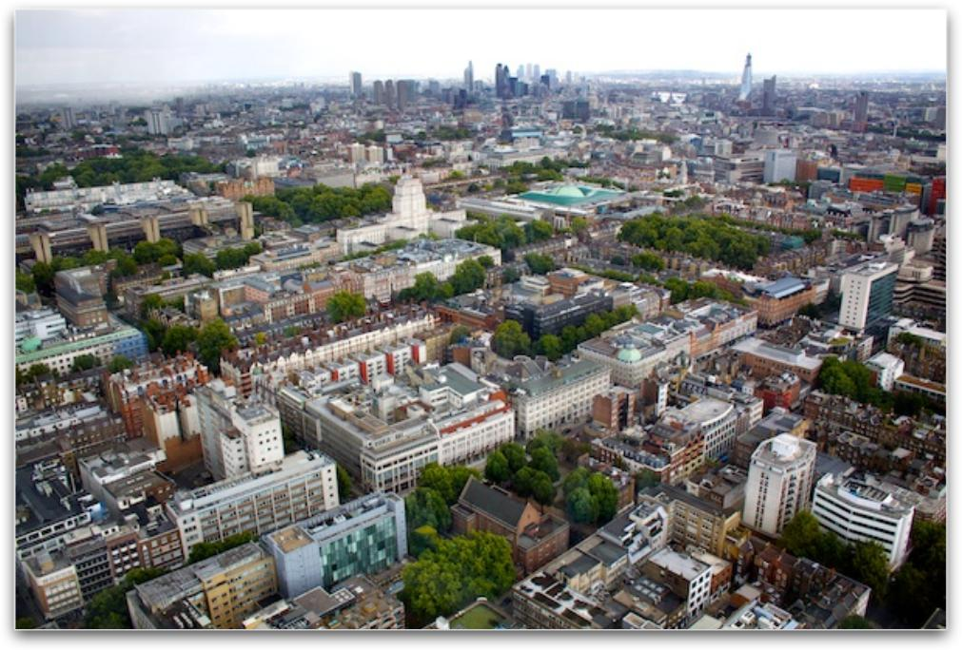
Horizons

When a frame is being divided by a single, dominant line, it’s more often than not, a horizon, as they’re fairly common in outdoor photography, particularly landscapes.

Depth of Field | Shallow | Deep
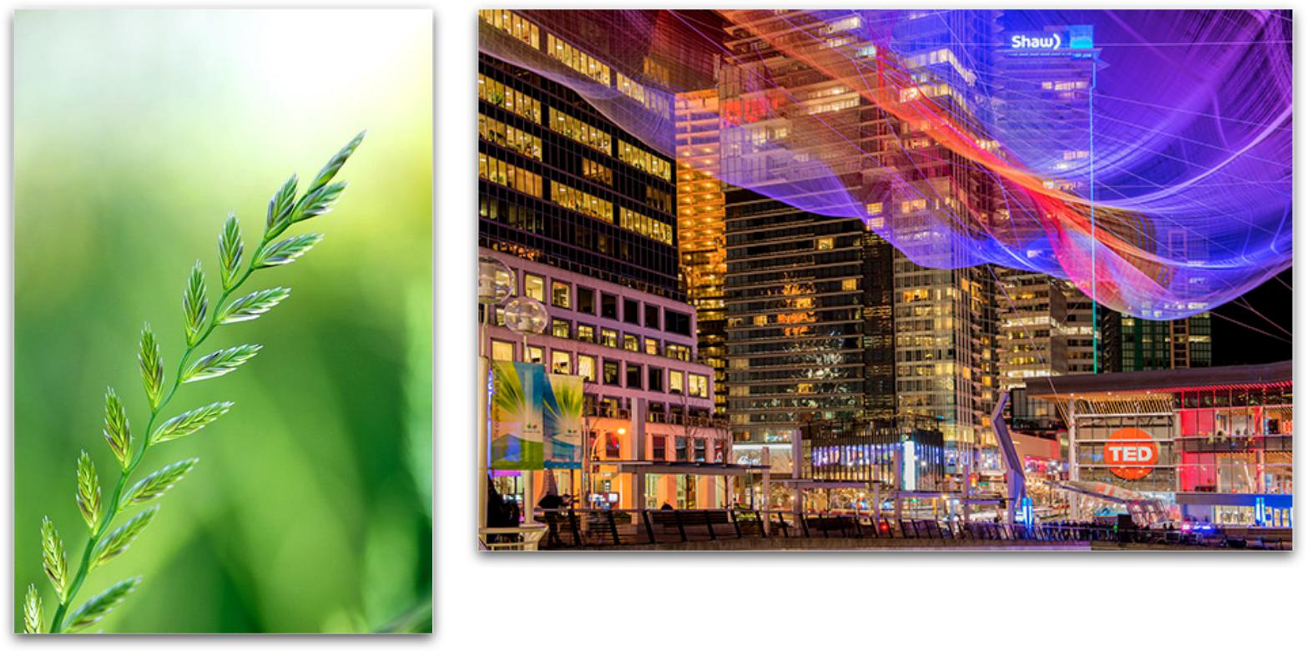
Shallow depth of field = blurred background and close up in focus (where you want your viewer to look).

Deep depth of field = all in focus.
In landscape photography, you will want a deep depth of field.

Use your depth of field to determine where you want your viewers to look.
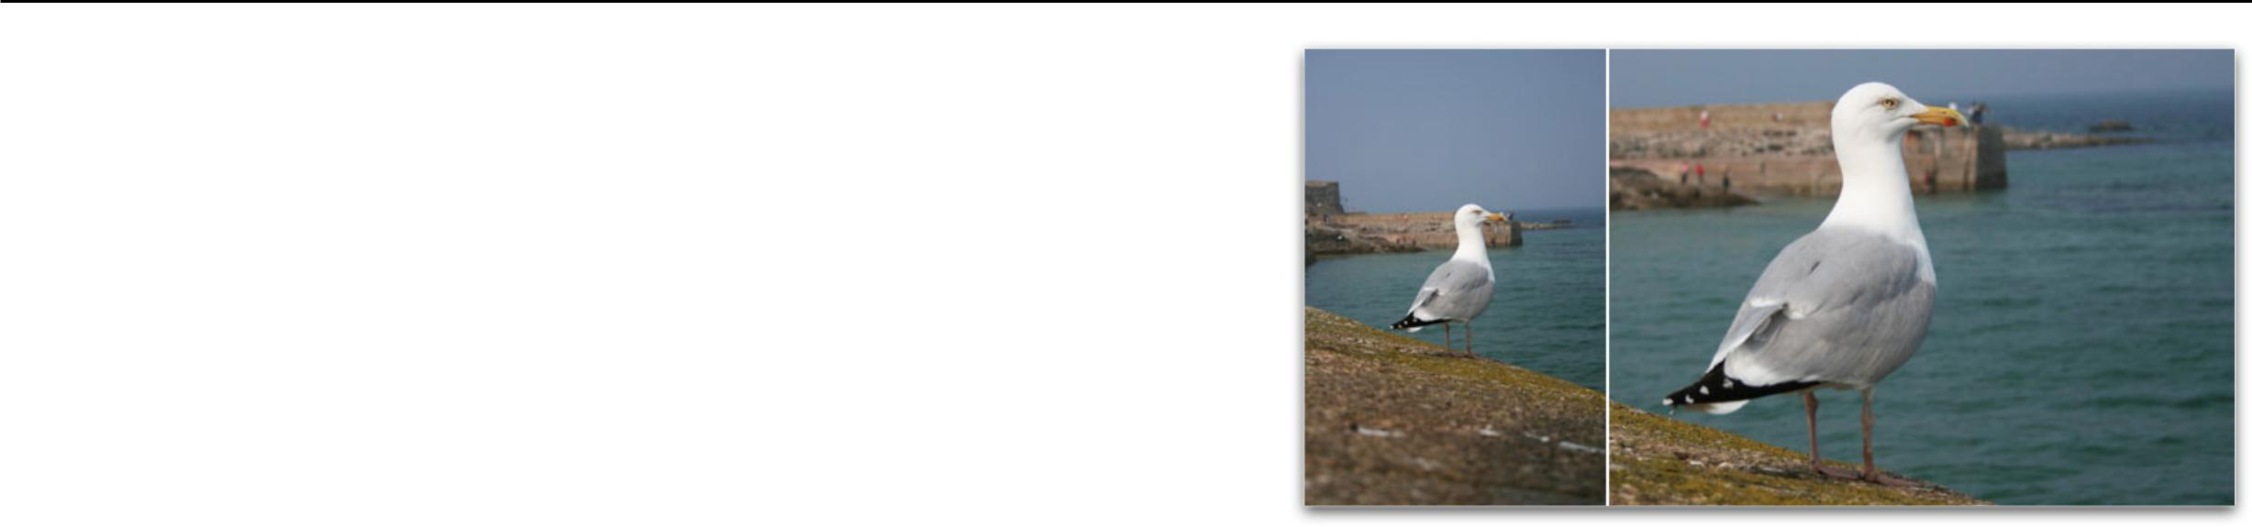

Cropping

Cropping, or removing certain portions of a photograph, has been around since the beginning of photography.

Before you discard that photograph you think of as boring or uninteresting, try cropping the image to see if you can pull something out that wasn’t there before.

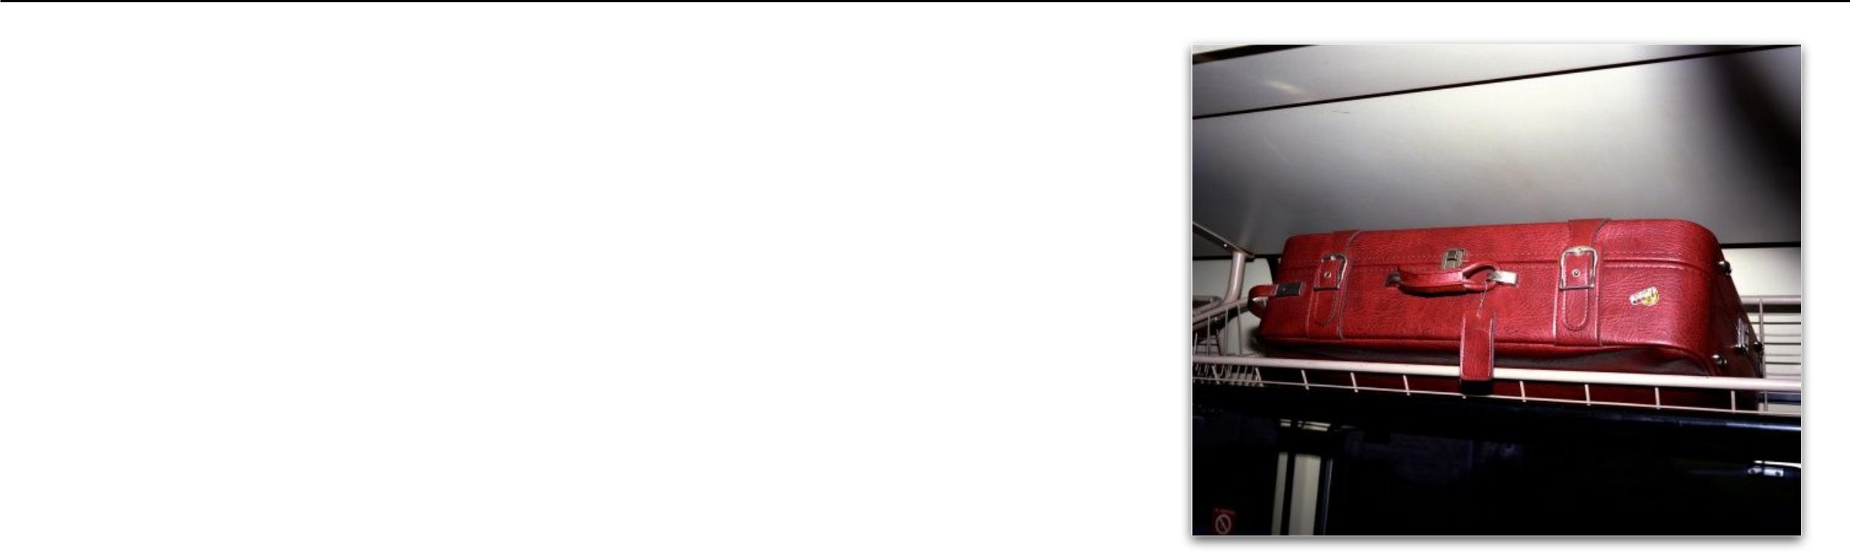
Colour

The colours in an image and how they are arranged can make or
break a shot.

Bright colours can add vibrancy, energy and interest – however in the wrong position they can also distract viewers of an image away from focal points.

Colours also greatly impact ‘mood’. Blues and Greens can have a calming soothing impact, Reds and Yellows can convey vibrancy ad energy etc.

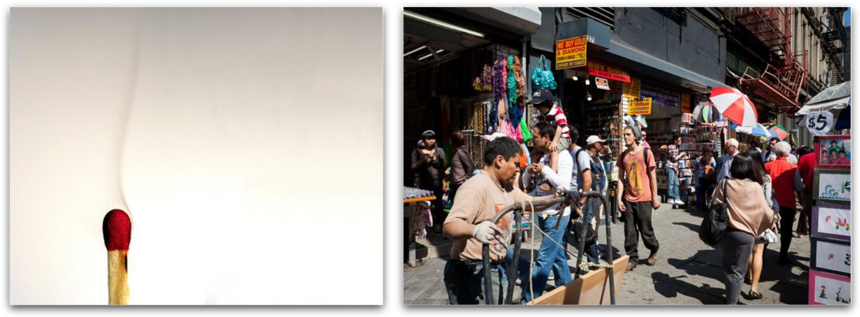
Minimalist Versus Maximalist Minimalist Maximalist

Minimalist refers to keeping a photograph very simple, such as an image with a single subject and a pleasing and calm background. This can create a very powerful and graphic design.

Maximalist on the other hand refers to a chaotic image, with a lot of elements competing with, and playing off of each other. However, within the chaos there is balance.

