Pressure in Liquids
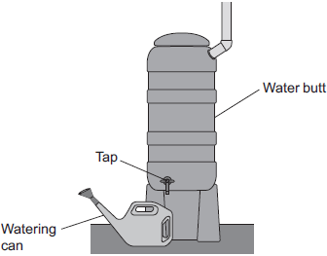
Q1.The diagram shows a water butt used to collect rainwater.

A tap allows water to be collected from the water butt in a watering can.
(a) If the tap was placed higher up on the water butt, what difference would it make to the rate of flow of water from the tap?
Explain your answer.
........................................................................................................................
........................................................................................................................
........................................................................................................................
........................................................................................................................
(2)
(b) A hosepipe is now attached to the tap. The hosepipe takes water to where it is needed.
A gardener did an investigation to see how the rate of flow of water through a hosepipe, from a water butt, varies with the length of the hosepipe.
His results are shown in below table.
 | Length of hosepipe in metres | Water collected in 10 seconds in cm³
 | 2.0 | 500
 | 3.0 | 500
 | 4.0 | 500
 | 5.0 | 500
 | 10.0 | 250
 | 15.0 | 170
(i) What conclusions can you make based on the results in the table above?
...............................................................................................................
...............................................................................................................
...............................................................................................................
(2)
(ii) Suggest further readings that should be taken to improve the investigation.
Give reasons for your answers.
...............................................................................................................
...............................................................................................................
...............................................................................................................
...............................................................................................................
...............................................................................................................
(4)
(Total 8 marks)
Q2.Some students fill an empty plastic bottle with water.
The weight of the water in the bottle is 24 N and the cross-sectional area of the bottom of the bottle is 0.008 m².
(a) Calculate the pressure of the water on the bottom of the bottle and give the unit.
.........................................................................................................................
.........................................................................................................................
Pressure = ........................................
(3)
(b) The students made four holes in the bottle along a vertical line.
They put the bottle in a sink. They used water from a tap to keep the bottle filled to the top.
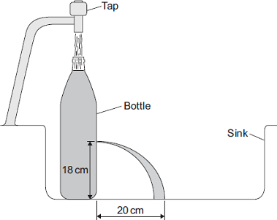
The students measured and recorded the vertical heights of the holes above the sink.
They also measured the horizontal distances the water landed away from the bottle.
A pair of measurements for one of the holes is shown in the diagram.
The complete data from the experiment is shown in the table.

 | Hole | Vertical height  in cm | Horizontal distance  in cm
 | J | 24 | 15
 | K | 18 | 20
 | L | 12 | 30
 | M | 6 | 40

(i) Which hole is shown in the diagram?
Draw a ring around the correct answer.

 | J | K | L

(1)
(ii) On the diagram, draw the path of the water coming out of hole M.
Use the information in the table to help you.
(2)
(c) Suggest one problem that might arise from trying to collect data from a fifth hole with a vertical height of 1 cm above the sink.
.........................................................................................................................
.........................................................................................................................
(1)
(Total 7 marks)

M1.(a) rate of flow of water less
1
because pressure is less
or
because force acting is less
or
because height of water above tap is less
1
(b) (i) at short lengths water collected is the same
accept rate of flow for water collected
1
at longer lengths water collected decreases as the length of pipe increases
if no other mark gained allow as the length increases the flow decreases for 1 mark
1
(ii) max 4 marks
take more readings to calculate a mean (1)
take more readings is insufficient
to reduce effect of random errors (1)
or
take more readings between 5.0 m and 10.0 m (1)
see where the change occurs (1)
or
take more readings above 15.0 m (1)
accept take more readings at longer lengths
to see if trend continues (1)
maximum of 2 marks for more readings and max 2 for reasons
4
[8]
M2.(a) 3000
correct substitution of 24 / 0.008 gains 1 mark provided no subsequent steps are shown
2
N / m² or Pa
1
(b) (i) K
accept ringed K in
table
1
(ii) water exiting bottle one-third of vertical height of K
allow less than half vertical height of spout shown, judged by eye
1
water landing twice the distance of the spout shown in the diagram
accept at least one and a half times further out than spout shown, judged by eye
do not accept water hitting the side of the sink
ignore trajectory
1
(c) water will land on the (vertical) side of the sink
accept sink not long / wide / big enough or
water will dribble down very close to the bottle or
that part of the bottle is curved
do not accept goes out of the sink
1
[7]

