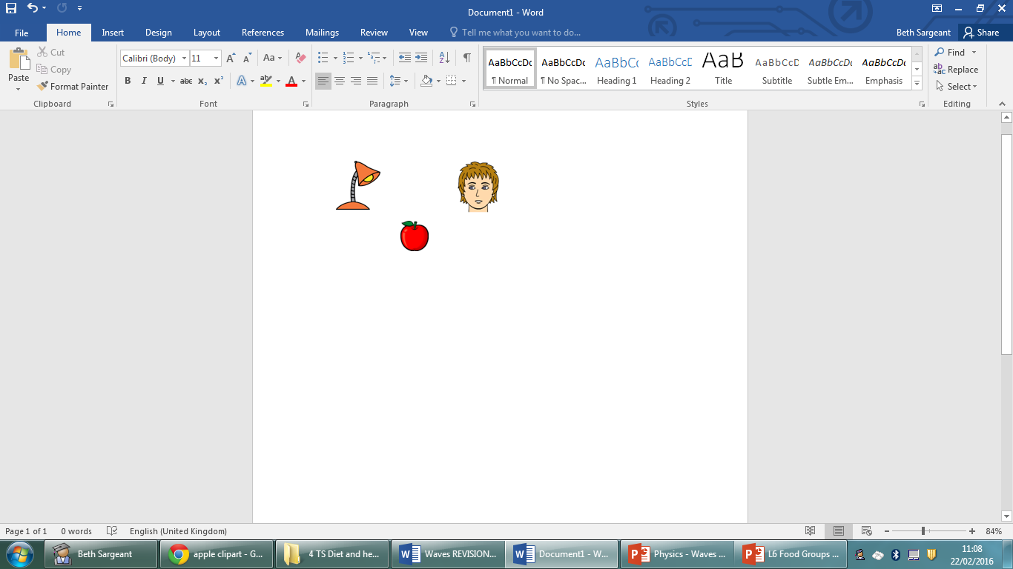

Draw **light rays** to show how the boy sees the apple:

Labels to include:

Reflected/refracted rays

Angle of incidence

Angle of reflection/refraction

Normal

Colour in the **primary colours of light** and the colours they can make when **mixed**:

What is the unit for frequency?

How does a **microphone** work?

Complete the diagram to show the **dispersion of light** through a **prism** *(angles do not need to be accurate):*

Draw and label a **light ray** being refracted when entering a **glass block**:

Draw and label a **light ray** being **reflected** off a plane **mirror**:

Labels to include:

Peak/crest

Trough

Amplitude

Wavelength

What do waves transfer?

Describe the movement of particles in:

**Transverse** waves

**Longitudinal** waves

Describe how **sound travels** from a guitar to your **ear**:

How could you make a note on the guitar… …**higher in pitch?**

**…louder?**

Label the parts of the **ear**: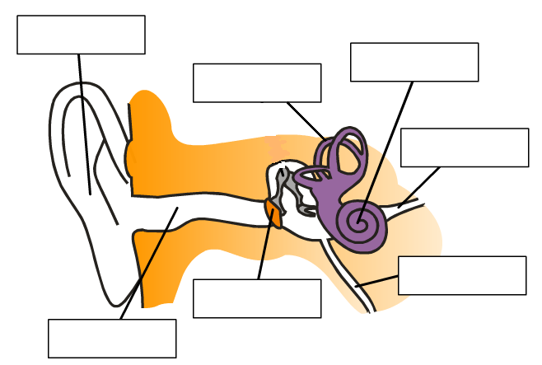

Draw and Label a **transverse** wave:

**Translucent**

**Transparent**

**Opaque**

Define

Waves

Describe the following waves (use the terms

**amplitude, wavelength** and **frequency**:

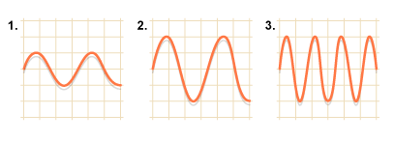

1……………………………

……………………………..

2……………………………

……………………………..

3……………………………

……………………………..