Q1. (a) Complete the following sentence.
The momentum of a moving object has a magnitude, in kg m/s,
and a _________________________ .
(1)
(b) A car being driven at 9.0 m/s collides with the back of a stationary lorry.
The car slows down and stops in 0.20 seconds. The total mass of the car and driver is 1200 kg.
Calculate the average force exerted by the lorry on the car during the collision.
Show clearly how you work out your answer.
___________________________________________________________________
___________________________________________________________________
Force = _________________________ N
(2)
(c) Within 0.04 s of the car hitting the back of the lorry, the car driver's airbag inflates.
The airbag deflates when it is hit by the driver’s head.
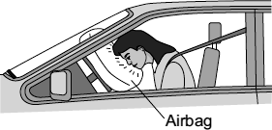
Use the idea of momentum to explain why the airbag reduces the risk of the drive sustaining a serious head injury.
___________________________________________________________________
___________________________________________________________________
___________________________________________________________________
___________________________________________________________________
___________________________________________________________________
___________________________________________________________________
(3)
(Total 6 marks)

Q2.The arrows in the diagram represent the horizontal forces acting on a motorbike at one moment in time.
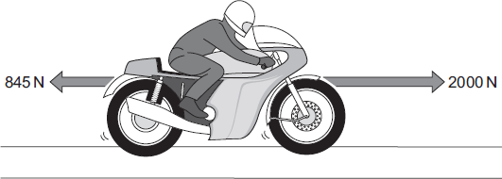
(a) The mass of the motorbike and rider is 275 kg.
Calculate the acceleration of the motorbike at this moment in time.
Show clearly how you work out your answer.
___________________________________________________________________
___________________________________________________________________
___________________________________________________________________
___________________________________________________________________
___________________________________________________________________
Acceleration = ______________________________ m/s²
(3)
(b) A road safety organisation has investigated the causes of motorbike accidents.
The main aim of the investigation was to find out whether there was any evidence that young, inexperienced riders were more likely to be involved in an accident than older, experienced riders.
Data obtained by the organisation from a sample of 1800 police files involving motorbike accidents, is summarised in the table.

Size of motorbike  engine | Percentage of all  motorbikes sold | Total number in  the sample of 1800  accident files
up to 125 cc | 36 | 774
126 to 350 cc | 7 | 126
351 to 500 cc | 7 | 162
over 500 cc | 50 | 738
Most of the motorbikes with engines up to 125 cc were ridden by young people.
The motorbikes with engines over 500 cc were ridden by older, more experienced riders.

(i) In terms of the main aim of the investigation, is this data valid?
Draw a ring around your answer. NO YES
Explain the reason for your answer.
______________________________________________________________
______________________________________________________________
______________________________________________________________
______________________________________________________________
(2)
(ii) The organisation concluded that:
“Young, inexperienced riders are more likely to be involved in a motorbike accident than older, experienced riders”.
Explain how the data supports this conclusion.
______________________________________________________________
______________________________________________________________
______________________________________________________________
______________________________________________________________
(2)
(c) Of particular concern to motorbike riders is the design of steel crash barriers. Riders falling off and sliding at high speed into a steel support post are often seriously injured.
One way to reduce the risk of serious injury is to cover the post in a thick layer of high impact polyurethane foam.
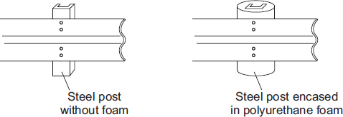
(i) Use the ideas of momentum to explain how the layer of foam reduces the risk of serious injury to a motorbike rider sliding at high speed into the support post.
______________________________________________________________
______________________________________________________________
______________________________________________________________
______________________________________________________________
______________________________________________________________
(3)
(ii) Crash barrier tests use dummies that collide at 17 m/s with the barrier. Each test costs about £12 000. New safety devices for crash barriers are tested many times to make sure that they will improve safety.
Do you think that the cost of developing the new safety devices is justified?
Draw a ring around your answer. NO YES
Give a reason for your answer.
______________________________________________________________
______________________________________________________________
(1)
(Total 11 marks)

Mark schemes
Q1.
(a) direction
1
(b) 54 000
allow 1 mark for calculating and identifying momentum as 10 800
or
allow 1 mark for correct substitution into second equation
ie 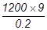
2
(c) increases the time taken (for head) to stop
accept increases impact time
do not accept reference to slowing down time unless qualified
1
decreases rate of change in momentum
accept reduces acceleration / deceleration
accept increases the time taken to reduce momentum to zero is worth 2 marks
reduces momentum is insufficient
1
reduces the force (on the head)
1
[6]
Q2.
(a) 4.2
2 marks for correct substitution and transformation, ie 1155/275
allow 1 mark for correct resultant force with a subsequent incorrect method, ie 1155
allow 1 mark for an incorrect resultant force with a subsequent correct method,
eg answers of 7.27 or 10.34 gain 1 mark
3
(b) (i) YES
marks are for the explanation
any two from:
• data (from police files) can be trusted
• data answers the question asked
allow a conclusion can be made from the data
• large sample used
NO
any two from:
• the sample is not representative
• the sample size is too small
• accident files do not indicate age / experience of riders
an answer YES and NO can score 1 mark from each set of mark points
2
(ii) more accidents with motorbikes up to 125 cc
accept for 2 marks an answer in terms of number of under 125 cc to accidents ratio compared correctly with number of over 500 cc to accidents ratio
1
even though there are fewer of these bikes than bikes over 500 cc
1
(c) (i) increases the time taken to stop
accept increases collision time
1
decreases rate of change in momentum
accept reduces acceleration / deceleration
accept 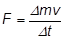
reduces momentum is insufficient
1
reduces the force (on the rider)
1
(ii) YES
any sensible reason, eg:
the mark is for the reason
• cannot put a price on life / injury
accept may save lives
• fewer (serious) injuries
accept reduces risk of injury
• reduces cost of health care / compensation
NO
any sensible suggestion, eg:
• money better spent on …
needs to be specific
• total number of riders involved is small
1
[11]

