Types of joints
Movements available &
select 2 movements to give a SE for
Types of muscles
Paper 1 Topics
As we go through this content make some SMALL key notes

Gaseous exchange
Functions of:
Red blood cells, white blood cells, platelets, Plasma

Short term effects of exercise

Long term effects of exercise
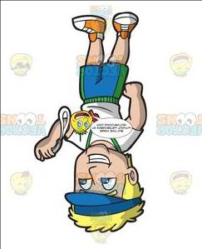
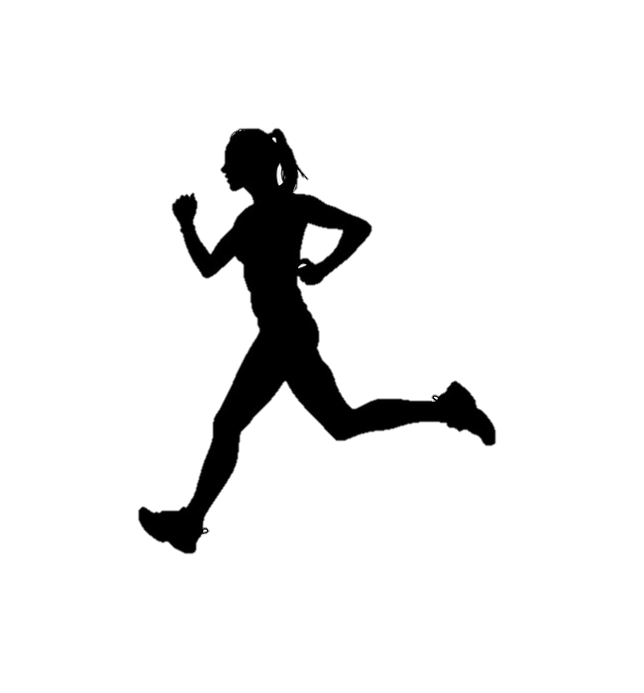
Vascular shunting
Location of the respiratory system
Reducing the risk of injury (injury prevention)

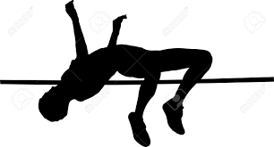
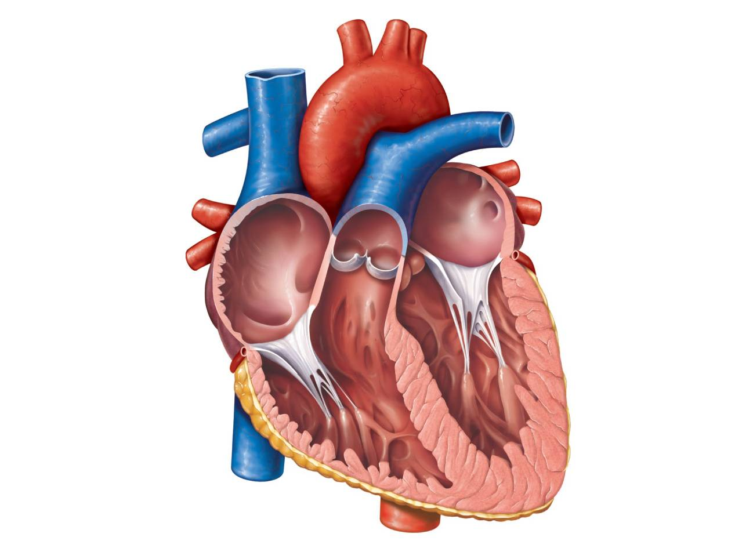
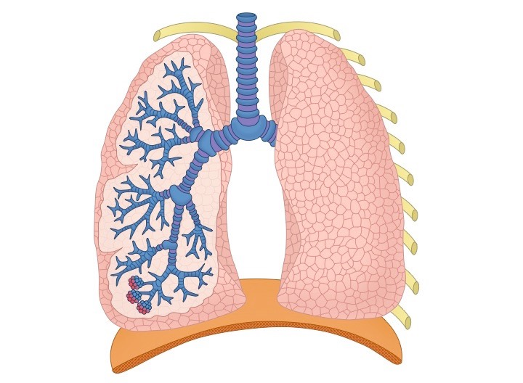
Location of heart components

