**Annotating A Contact Sheet**

AO3

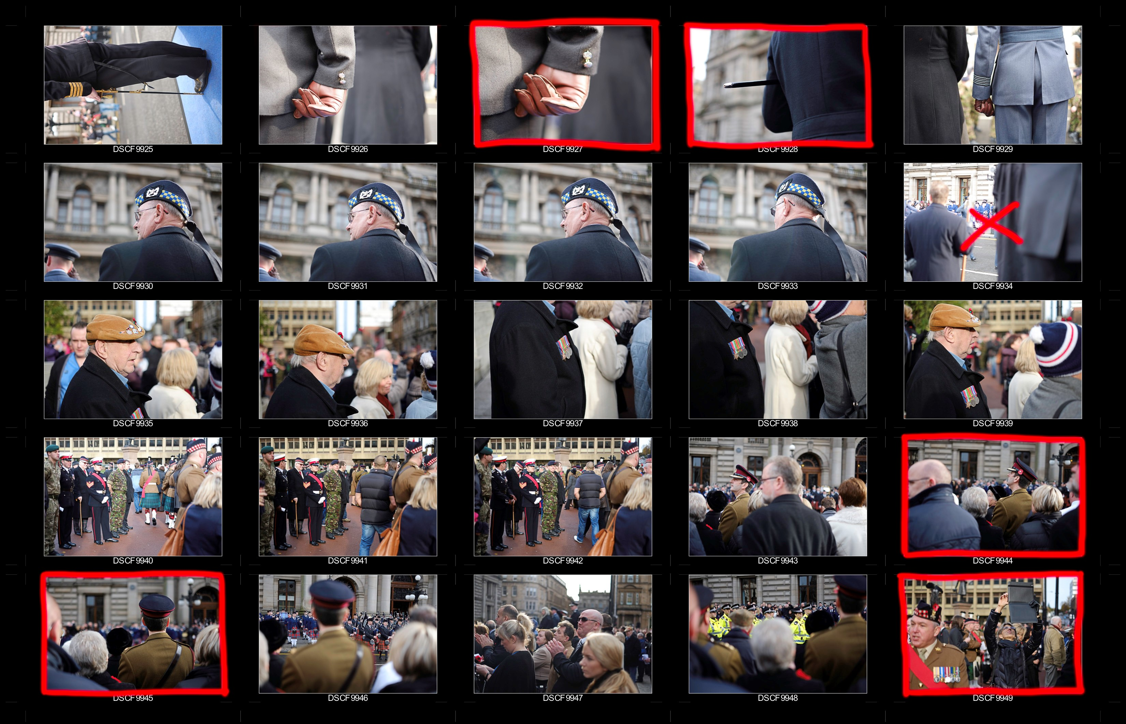

The camera was set to f2 to get a

shallow depth of field

A simple compostion using the rule of

thirds

One of my favourite images from the

shot is this one because I like the way

that the soldier is the only spot of colour

in the image and so draws your eye to him

I experimented with slighly different

angles for these 4 images. I dont think

that any of them are very effective,

they do not have enough interest in them

# Camera Settings

Discuss where your camera settings have affected your photo – is the ISO to high and the image is too dark, slow shutter speed and your camera is blurred

Crop Lines

Draw on to your contact sheet to show where you would like to crop your subject matter/composition to make the photo look better

Techniques

Note down any composition rules, shadow effects and lighting methods used in your images

Best and Worst

Highlight your best images by drawing around them and adding notes to explain why these are the most effective. Cross through any images that you feel are out of focus.

Tick with a green pen and cross with a red pen next to each photo

# Summary

Make notes on the following:

What were your intentions for the shoot?

What are the successful elements/ what did not work as well?

Link your work back to your photographer you looked at. How well did you manage to capture elements of their work in yours?

What could you do to improve or develop your ideas from this shoot?