**Lexia Log in Help sheet.**

To access Lexia from home :

Log into the school website from home : [www.thelinkacademy.org.uk](http://www.thelinkacademy.org.uk)

On the home screen : 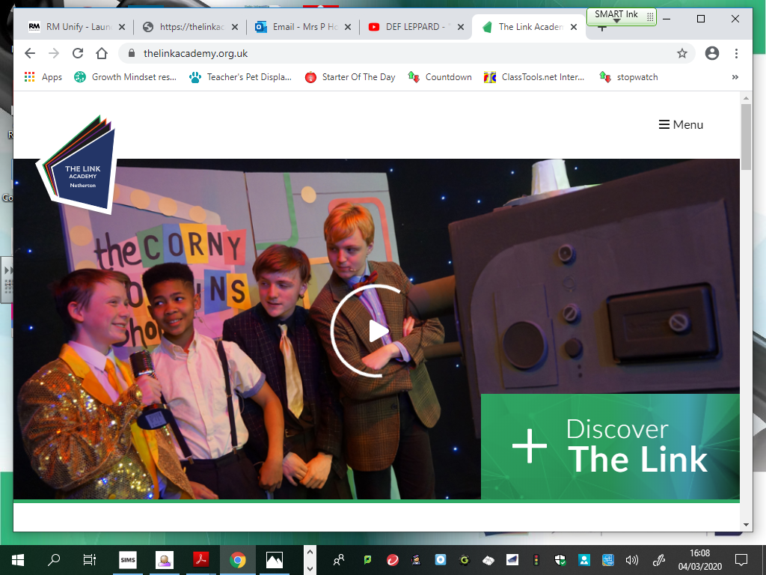 click on the menu tab at the top

From the drop down menu, select the envelope icon :

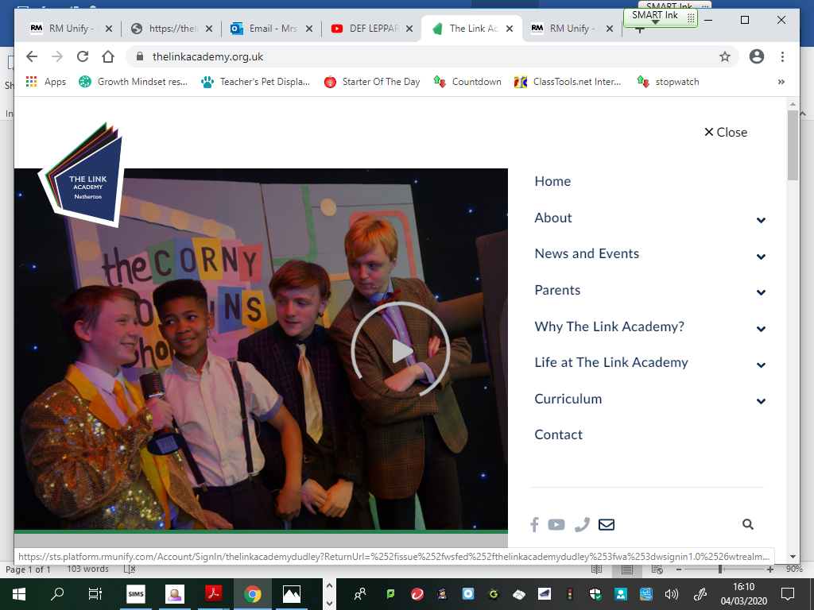 This will bring up the RM unify page used at school for accessing the Lexia site.

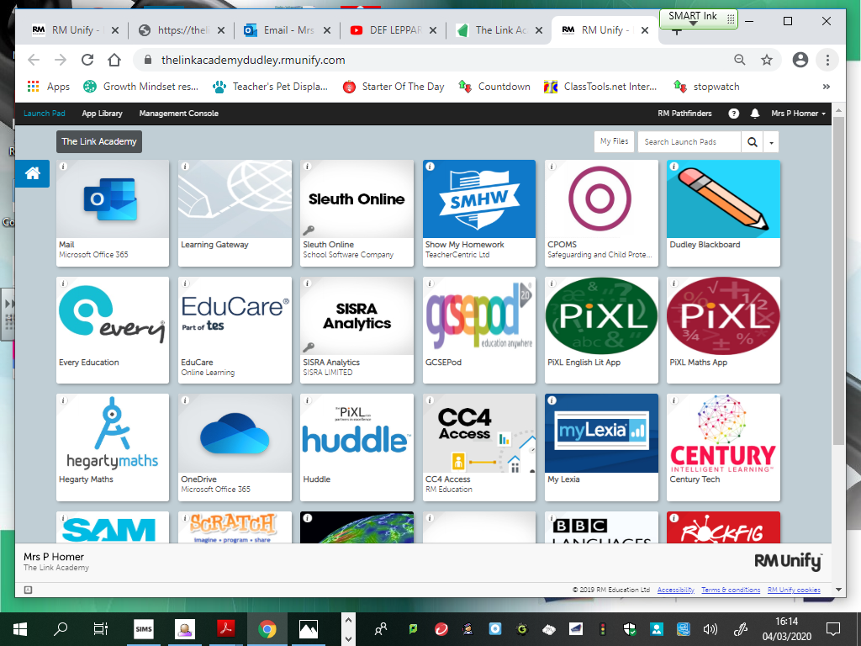 on here, you will find the tile for Lexia – click on this and use the normal login details to access the site. (The Lexia tile may be slightly different in appearance to this image.)

Username : (use the same login as used at school for Lexia)

Password : ( the password is the same : dobxxxxxx – eg dob010101)

Follow the instructions to complete tasks – there is an expectation of a minimum of 145 minutes to be completed in a week.