GCSE History
AQA 8145 9-1
Britain: Health and the People
Homework Booklet
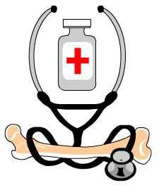
Name:____________________
Teacher:__________________
Week 1 - 1000-1450: The Middle Ages: Medicine Stands Still

10 Point Summary:
- Religion played a massive part in people’s lives, so many believed God was responsible for causing and curing disease.
- Learned ideas about medicine were largely based on Ancient Greek and Roman ideas, particularly two men – Hippocrates and Galen.
- The Four Humours were the most widely held belief about health. If your humours were out of balance you could get ill. You needed to balance them to be cured.
- The Four Humours are blood, phlegm, yellow bile and black bile.
- Doctors were for the wealthy. Ordinary people would visit a barber-surgeon or apothecary.
- Many cures were herbal, though bleeding was also common to balance your humours.
- The Church was important in setting up hospitals and caring for the sick.
- Disease spread quickly in towns which were smelly, dirty and over-crowded.
- Arab medicine was far more advanced than European at this time. Muslim writers such as Avicenna were responsible for saving the works of Hippocrates and Galen which were later translated back for use in Europe, as well as adding their own work.
- The biggest health crisis in the Medieval world was the Black Death, 1348-51 in Britain. It is estimated one third of the population was killed.

Complete the table with information about:
Hippocrates | Galen
Annotate the diagram with information about the Four Humours:

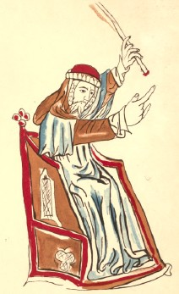
This is John Ardene. Find out how he contributed to Medieval medicine and bullet point your findings:

People in the Middle Ages believed the following things made them ill. Add detail about each idea:

Belief | Detail
God

Bad smells

Everyday life

The Supernatural

The Four Humours

What do each of these images tell us about diagnosis and treatments during the Middle Ages?

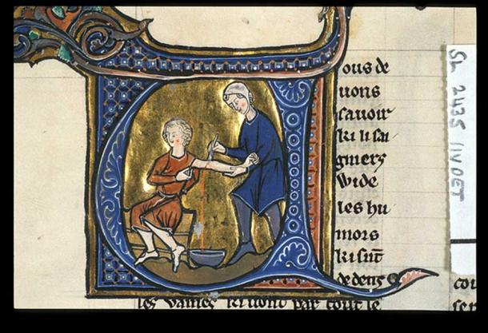  Blood-letting in the 13th century. | 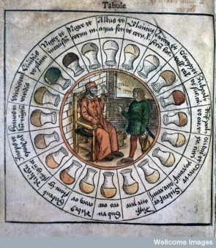  Urine chart used by physicians.
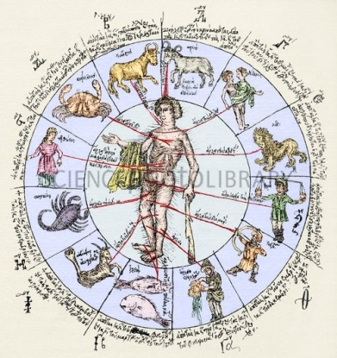 Greek zodiac chart from the 15th century.

What were ‘simples’?

What was an apothecary?

What was a barber-surgeon?

Explain the significance of the Church for Medieval medicine.

Explain how war helped medicine to progress during the Middle Ages.

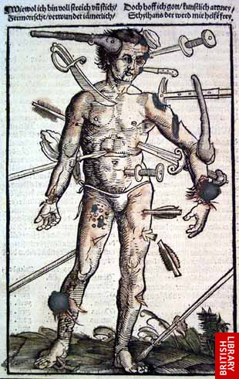
A wound-man,1517,designed
to help army surgeons.
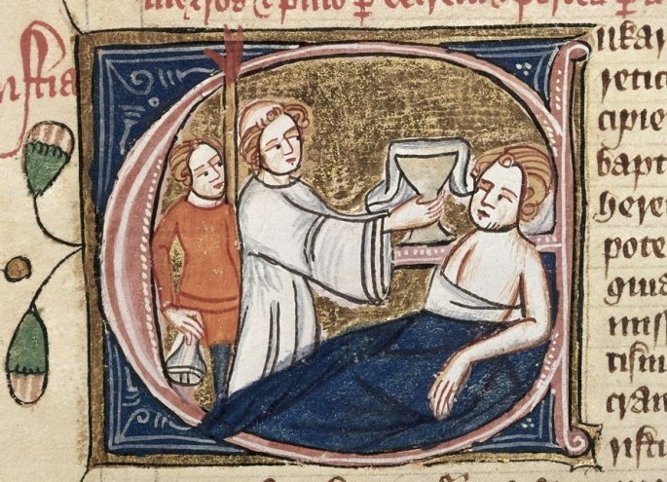
What can you learn about Medieval hospitals from looking at this source?

What are the limitations of the source?

Medieval Surgery
Add to this image to show examples of important individuals, methods of diagnosis, cures and conditions in Medieval medicine:

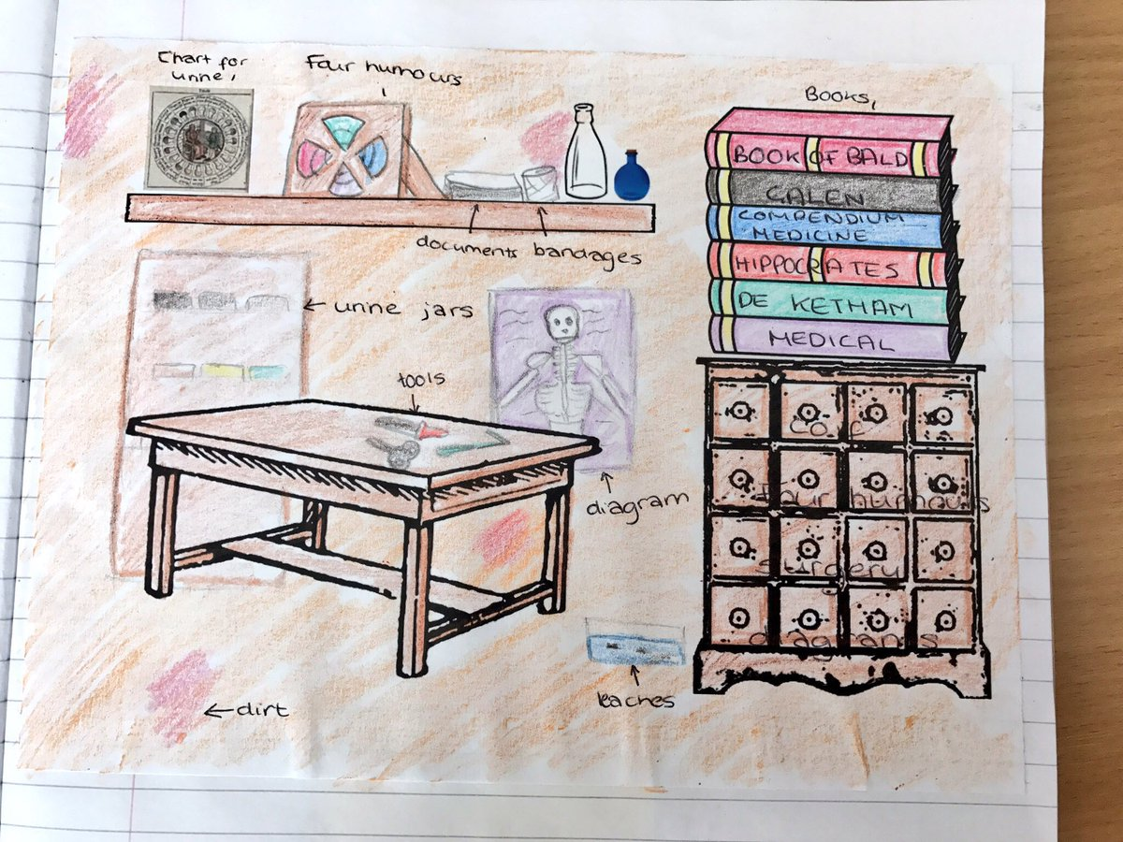

Public Health in the Middle Ages
Look at these sources and decide which one:
• Shows that the level of public health declined in the medieval period.
• Suggests the link between health and hygiene had been realised.

Source A
Almost all the floors are of clay and rushes from the marshes, so carelessly renewed that the foundation sometimes remains for twenty years, harbouring there below, spittle and vomit and urine of dogs and men, beer that hath been cast forth, remnants of fishes and filth unnamable.
Taken from a letter by Erasmus, a Dutch visitor to England, in 1524, describing the floors inside houses.

Source B
Item, that so much dung and filth of the garbage and entrails be cast and put into ditches, rivers, and other waters... so that the air there is grown greatly corrupt and infected, and many maladies and other intolerable diseases do daily happen... it is accorded and assented, that the proclamation be made as well in the city of London, as in other cities, boroughs, and towns through the realm of England, where it shall be needful tha all they who do cast and lay all such annoyances, dung, garbages, entrails, and other ordure, in ditches, rivers, waters, and other places aforesaid, shall cause them utterly to be removed, avoided, and carried away, every one upon pain to lose and forfeit to our Lord the King [the sum of 20 pounds...
Parliamentary statute of 1388.

The Black Death, 1348
Ideas about causes:  God is terrible towards the sons of men. He often allows plagues, miserable famines, conflicts, wars and other forms of suffering to arise, and uses them to terrify and torment people and so drive out their sins. And so the people of England are to be oppressed by the plague.  From a monk’s letter to the Bishop of London, 1348. | Treatments:
Prevention:

In the space below, add a summary diagram or notes about health during the Middle Ages:

Week 2 - 1450-1800: The Beginnings of Change

10 Point Summary:
- The Renaissance (meaning re-birth) was a time of discovery and development in art, culture, religion, literature and science. It began in the mid-fifteenth century in Europe.
- Two inventions were important for medical developments: the microscope and the printing press.
- Vesalius (1514-64) challenged the ideas of Galen by studying anatomy and correcting Galen’s mistakes.
- Paré (1510-90) is often known as the ‘father of modern surgery’. He experimented widely and wrote a lot to educate others. He used ligatures to seal a wound.
- Harvey (1578-1657) discovered that blood circulated round the body and used experiments to show the function of the heart and veins.
- However, changes in knowledge were slow to reach everyday practice. Many people rejected the new ideas and continued with their medieval cures.
- Doctors and surgeons began to be more qualified and regulated, with an improvement in their status. However, many people continued to use ‘quack’ doctors.
- An increasing number of hospitals were set up to treat the sick.
- Edward Jenner discovered a vaccination for smallpox in 1798. He found that people who were given a dose of cowpox didn’t catch smallpox.
- His ideas were slow to catch on, but smallpox was such a dangerous disease that in 1853 the government made it compulsory for all children to be vaccinated against smallpox.

Create a basic mindmap of the developments that took place during the Renaissance. Colour code them to show the influence of different factors (e.g. war, religion, government, individuals etc).

Explain the significance of:
Vesalius to the development of knowledge of anatomy and surgery.

Paré to the development of surgery.

Who do you think had the greater impact: Vesalius or Paré?

How did William Harvey prove Galen wrong?

Why was this important for the development of medicine?
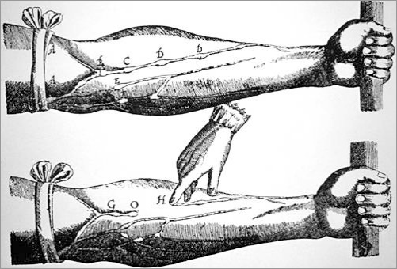

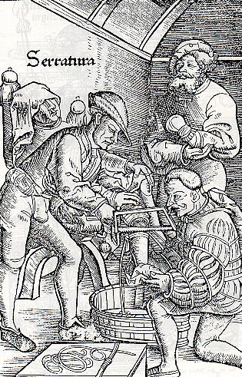
How useful is this source for learning about surgery? Does it help us to understand why surgery was so dangerous at this time?

Who was John Hunter and how did he help medicine?

What was ‘Quackery’?

What was the ‘Foundling’ Hospital?

The Plague, 1665
In _______, around _____________ people died of the Plague in __________ - nearly _______ of the population. Most doctors ______ as they feared for their lives. ___________ people left the city and went to the ___________. People had lots of theories about its causes, and noticed the ________ and ___________ parts of London were more affected. The ________ and the _________ introduced measures to try to prevent the spread of the disease, including ________ dogs and cats, lighting __________ to get rid of ‘bad’ air, and saying public ___________ twice a week.
country 25% dirtier 100,000 fled Mayor fires 1665 London killing wealthy poorer King prayers

Explain the significance of Edward Jenner in the development of vaccinations.
[8 marks]
Think of two reasons why Jenner and his discovery (during the 1790s) were significant (why they changed medicine), and develop each with explanation and facts.
First reason for significance:

Development:

Second reason for significance:

Development:

Week 3 - c.1750-1900: A Revolution in Medicine
- Remember the Industrial Revolution? Well, there was a revolution in medicine too!
- The nineteenth century saw massive population growth – from 16.3 million in 1801 to 41.6 million in 1901.
- Three people made major scientific discoveries for medicine: Louis Pasteur, Robert Koch and Paul Ehrlich. They paved the way for further developments.
- Pasteur discovered germ theory – the idea that disease is called by germs. Koch invented a way to stain bacteria so you could see them and identify which bacteria caused different diseases. Ehrlich invented ‘magic bullets’, drugs which could target specific organisms in the body.
- The discovery of germs led to improvements in cleanliness in hospitals. Lister began to use carbolic spray during operations as an antiseptic.
- Anaesthetics were also developed to make surgery and childbirth less painful.
- Once surgery was pain free and patients were likely to survive, new techniques could be developed.
- Rapid growth in towns led to initial public health problems, including diseases such as cholera.
- Reform and improvements came, including the development of a sewage system and clean water.
- The government worked to improve public health, with Public Health Acts in 1848 and 1875.

Life in towns
Annotate this picture with information about conditions in towns during the Industrial Revolution.
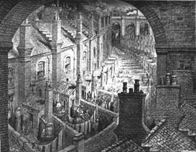
Scientific Revolution
Storyboard the discoveries of the following scientists to show how their discoveries helped health and medicine to progress.
Louis Pasteur, 1822-95

Robert Koch, 1843-1910

Paul Ehrlich, 1954-1915

Hospitals during the 1800s
This is a painting by Luke Fildes, called The Doctor, from 1891.
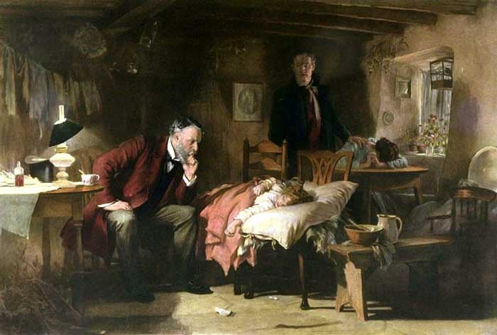
- Label the victim, the parents, and the physician.

- What tools is the physician using to help treat the child?

- How useful is a painting like this as evidence of medicine in the 19th century?

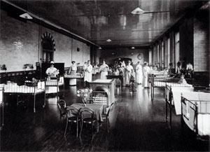
Great Ormond Street Hospital, London. Built in 1875.
What would it be like to be a patient in this hospital ward?

Was Florence Nightingale significant?
To be significant, an individual can do any of the following things. Can you identify how Florence Nightingale achieved any of these?
Changed events at the time they lived.

Improved (or made worse!) lots of people’s lives.

Changed people’s ideas.

Had a long-lasting impact on their country or the world.

Were a really good (or very bad) example to other people of how to live or behave.

A revolution in surgery
What can you find out about these people? Bullet-point your findings:
Elizabeth Garrett Anderson | Sophia Jex-Blake

James Simpson
Summarise the importance of James Simpson’s use of ether in no more than 50 words.

Joseph Lister
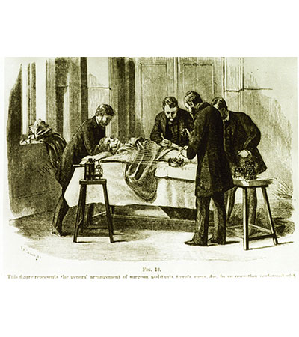
Annotate the image to explain how Joseph Lister’s use of carbolic acid helped improvement and progress with surgery.

What is aseptic surgery?

How is the work of Robert Koch linked to aseptic surgery?

Who was Charles Chamberland and how did his discovery enable aseptic surgery?

Public Health during the 1800s
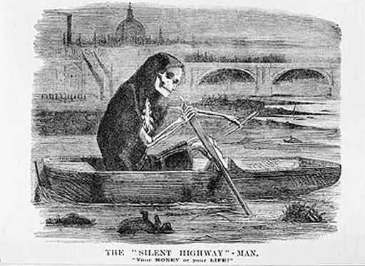
What can you learn about public health from looking at this cartoon (published in 1858)?

57% of children died before they reached the age of 5.
Common diseases included typhoid, typhus, diarrhoea, smallpox, tuberculoses (TB/consumption), scarlet fever, whooping cough, measles and chickenpox.

There were cholera epidemics during 1831-32, 1848, 1854, and 1866.

John Snow

How do the images below link to tell the story of John Snow’s discovery about the causes of cholera?

700

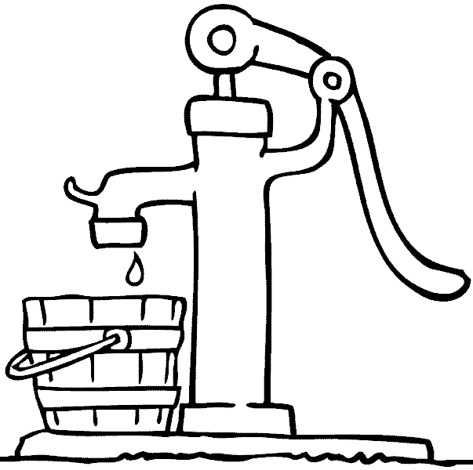

How did this help to challenge ideas about how disease was spread?

Considering change and continuity over time

Complete the following venn diagrams to show similarities and differences between:

Week 4 - 1900-: Modern Medicine
- Alexander Fleming worked on developing penicillin – an antibiotic which could kill bacteria and cure disease.
- World War One and its horrific injuries led to developments in plastic surgery, skin grafts and reconstruction.
- The National Health Service was set up in 1948, offering free healthcare to all.
- Alternative medicine, including herbal remedies, acupuncture, aromatherapy and reflexology, offer a different approach to pills and drugs.
- X-ray technology was developed in the early 20th century to allow doctors to easily see inside patients.
- Many new surgical procedures have been developed, including transplants, heart pacemakers, hip replacements and test tube babies. Keyhole surgery is now common.
- There are debates about whether science and technology is taking us too far and there is a risk we could end up ‘playing God’, with experiments in cloning and sterilisation taking place.
- The Liberal Government of 1906 – 14 passed a series of laws to improve the health and well-being of the people, including introducing National Insurance (1911) and banning back to back houses (1909).
- Nowadays we have new concerns – obesity, unhealthy lifestyles, smoking, alcohol and the risk that ‘super-bugs’ will develop which can’t be killed by antibiotics.
- Many diseases have been wiped out altogether in Britain, but research continues in the battle against diseases such as cancer and new threats appear in the media, such as swine flu or the Zika virus.

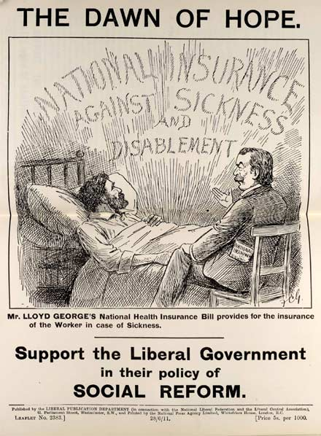
National Insurance Act

What can you see in the evidence?

What do you think is the message?

How does this link with your own knowledge?

Challenge: How useful is the source or finding out about the National Insurance Act?

How did war in the 20th Century contribute to the development of medicine?

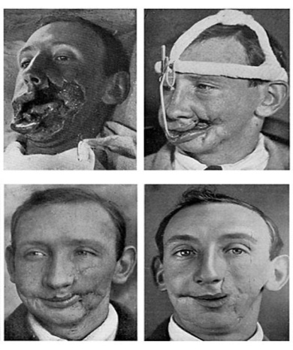

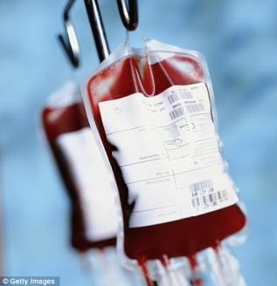

Penicillin
Who do you think should take the most credit for the use of penicillin in our health care?
Alexander Fleming | Florey and Chain
My final decision and reasons

The NHS
Label the cartoon with:
- What you can see
- What you think the message is
- How your knowledge helps you to understand what the cartoon is about.

