1. The speed of an object is a measure of how:
A far it is travelling.
B fast it is travelling.
C long it is travelling.
D high it is travelling.
[1]

2. A train travelled a distance of 80 km in 2 hours. Its speed was:
A 0.1 km/h. B 40 km/h.
C 20 km/h. D 10 km/h.
[1]

3. The average speed of something is:
A its fastest speed.
B the total distance it travels divided by the time taken.
C its slowest speed.
D its speed limit.
[1]

4. If a car travels at 50 mph for 4 hours, what distance will it travel?
A 50 miles B 100 miles
C 40 miles D 200 miles
[1]

5. Two cars are travelling in the same direction on a road. The blue car is travelling at 25 m/s in front of the red car, which is travelling at 30 m/s. What is their relative speed?
______________________________________________________________________________________________
[1]

6. The graph below is a distance–time graph for a remote control car.
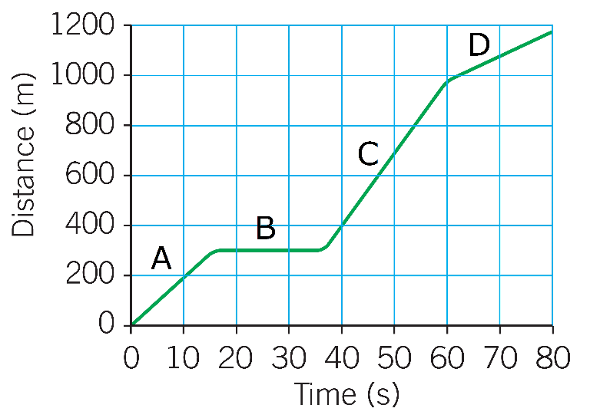
(a) State the section of the graph (A, B, C, or D) where the car is stationary (not moving).
___________________________________________________________________________________________
[1]
(b) State the section of the graph (A, B, C, or D) where the car is moving the slowest.
___________________________________________________________________________________________
[1]
(c) Explain your answer to part (b).
___________________________________________________________________________________________
[1]
(d) Calculate the average speed of the car over the whole journey.

________________________________________________________________________________________
________________________________________________________________________________________
Average speed = ______________________ m/s
[3]
Total: _____ /10

