Mind Mapping
Influence Analysis
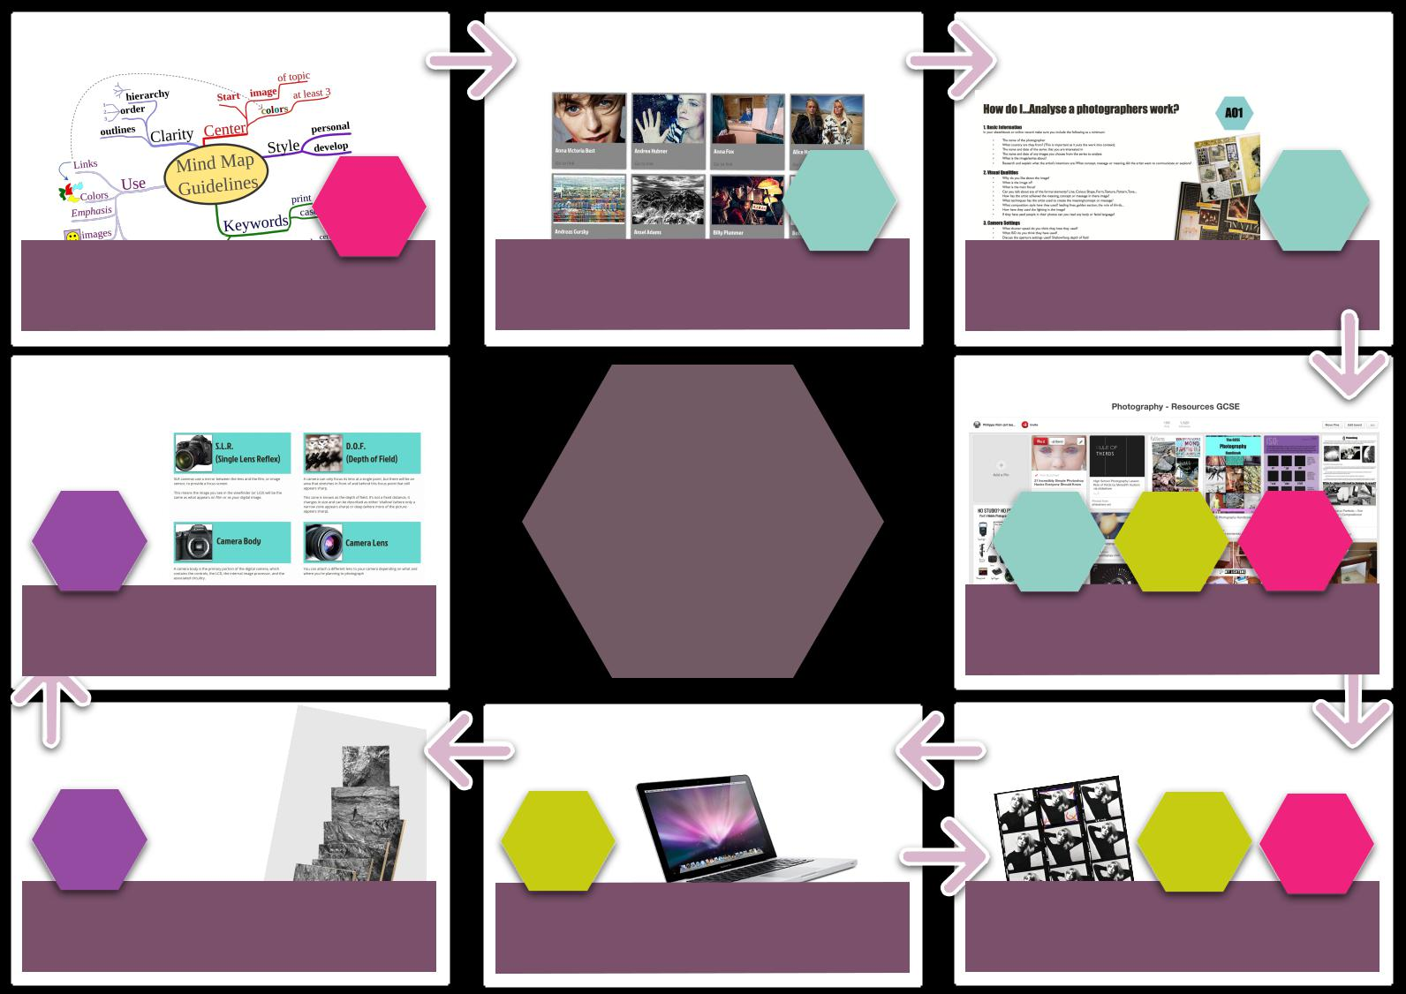

AO3

Develop ideas based on your
theme using a mind map.

Evaluation

AO4

Use the evaluation writing frame

to assess your final outcome.

Final Outcome

AO4

Produce a final outcome, this may be a large

photographic print or something more

creative.

AO1

Research and collect influential images by

other photographers/artists that you like.

Present these as an artist investigation page.

GSCE

Photography
Process

Development

AO2

Experiment, vary, change, adapt and play with

your images (vary colours, materials,

technique, composition and image choice)

AO1

Choose a specific image (that you will base

your own work on) and use the writing frame

to perform an analysis on it.

Research

AO1 AO2 AO3

Source other information to help you with

your outcome (computer manipulation

methods, lighting, camera techniques).

Photo Shoot

AO2 AO3

Take photographs that link in some way to the

orginal work that inspired you. Always shoot

15 to 20 frames to make a contact sheet

